|  |
| --- |
| **E:\My Documents\Desktop\Logo_FPT_University_doc.jpg** |
| Capstone Project Document |
|  |
|  |
| **Rental House Finding System Team | FPT University** |
| **Hanoi, 15th Jan 2013** |

|  |
| --- |
|  |

Table of Contents

[A. Capstone Project Introduction 6](#_Toc353968148)

[I. Project Information 6](#_Toc353968149)

[II. Purposes 6](#_Toc353968150)

[III. Background 6](#_Toc353968151)

[IV. Literature Review of Existing Systems 6](#_Toc353968152)

[V. Our Proposal 9](#_Toc353968153)

[VI. Products 9](#_Toc353968154)

[B. Capstone Project Document 10](#_Toc353968155)

[I. Problem Definition 10](#_Toc353968156)

[1. Project Name 10](#_Toc353968157)

[2. Problem Abstract 10](#_Toc353968158)

[3. Project Overview 10](#_Toc353968159)

[II. Project organization 12](#_Toc353968160)

[1. Software Process Model 12](#_Toc353968161)

[2. Roles and Responsibilities 13](#_Toc353968162)

[3. Tools and Techniques 14](#_Toc353968163)

[III. Project management plan 15](#_Toc353968164)

[IV. Tasks 15](#_Toc353968165)

[1. Task Sheet: Assignments and Timetable 18](#_Toc353968166)

[2. All Meeting Minutes 18](#_Toc353968167)

[V. Coding Convention 18](#_Toc353968168)

[C. Software Requirement Specification 18](#_Toc353968169)

[I. User Requirement Specification 18](#_Toc353968170)

[1. Visitor Requirements 19](#_Toc353968171)

[2. Registered user requirements 19](#_Toc353968172)

[3. Administration requirements 19](#_Toc353968173)

[4. System Requirement 19](#_Toc353968174)

[5. Post Requirement 20](#_Toc353968175)

[6. Ranking Requirement 20](#_Toc353968176)

[7. Search Requirement 21](#_Toc353968177)

[II. System Requirement Specification (Specific Requirements) 22](#_Toc353968178)

[1. External Interface Requirements 22](#_Toc353968179)

[2. Non-functional Requirements 60](#_Toc353968180)

[Usability 60](#_Toc353968181)

[Reliability 60](#_Toc353968182)

[Availability 61](#_Toc353968183)

[Security 61](#_Toc353968184)

[Maintainability 61](#_Toc353968185)

[Portability 62](#_Toc353968186)

[Performance 62](#_Toc353968187)

[D. Software Design Specification 62](#_Toc353968188)

[I. Design Overview 62](#_Toc353968189)

[II. System Architectural Design 63](#_Toc353968190)

[1. Overall System Architecture 63](#_Toc353968191)

[2. Web Application Architecture 63](#_Toc353968192)

[III. Detailed Design 66](#_Toc353968193)

[1. Class Diagram 66](#_Toc353968194)

[2. Sequence Diagram 94](#_Toc353968195)

[IV. Database Design 100](#_Toc353968196)

[1. ERDs 100](#_Toc353968197)

[2. Tables 100](#_Toc353968198)

[3. AdvanceSearchScore 101](#_Toc353968199)

[4. Answer 101](#_Toc353968200)

[5. Badwords 101](#_Toc353968201)

[6. BadWordTypes 102](#_Toc353968202)

[7. Categories 102](#_Toc353968203)

[8. ConfigurationRHFs 102](#_Toc353968204)

[9. Contacts 102](#_Toc353968205)

[10. Districts 102](#_Toc353968206)

[11. EmailTemplates 103](#_Toc353968207)

[12. Facilities 103](#_Toc353968208)

[13. FacilityTemplates 103](#_Toc353968209)

[14. Favorites 104](#_Toc353968210)

[15. Locations 104](#_Toc353968211)

[16. Payments 104](#_Toc353968212)

[17. Postimages 104](#_Toc353968213)

[18. PostLocations 105](#_Toc353968214)

[19. Posts 105](#_Toc353968215)

[20. PostStatus 106](#_Toc353968216)

[21. Provinces 106](#_Toc353968217)

[22. Questions 106](#_Toc353968218)

[23. ReportedPosts 106](#_Toc353968219)

[24. Roles 107](#_Toc353968220)

[25. UserLogs 107](#_Toc353968221)

[26. Users 107](#_Toc353968222)

[E. Software Testing Description 108](#_Toc353968223)

[I. Introduction 108](#_Toc353968224)

[1. System Overview 108](#_Toc353968225)

[2. Test Approach 108](#_Toc353968226)

[II. Test Plan 108](#_Toc353968227)

[1. Features to be tested 108](#_Toc353968228)

[2. Features not to be tested 110](#_Toc353968229)

[III. Test Cases 111](#_Toc353968235)

[IV. Appendix A: Test Logs 164](#_Toc353968239)

[1. Test Results 164](#_Toc353968240)

[2. Bug Lists 164](#_Toc353968241)

[F. Capstone Project User Manual 167](#_Toc353968242)

[I. Visitor 167](#_Toc353968243)

[1. Search 167](#_Toc353968244)

[2. Advanced Search 167](#_Toc353968245)

[3. View Post Detail 168](#_Toc353968246)

[4. Add Post 169](#_Toc353968247)

[5. Edit Post 170](#_Toc353968248)

[6. Delete Post 171](#_Toc353968249)

[7. Renew Post 172](#_Toc353968250)

[8. Register 172](#_Toc353968251)

[II. User 173](#_Toc353968252)

[1. Login 173](#_Toc353968253)

[2. Logout 174](#_Toc353968254)

[3. Edit user profile 174](#_Toc353968255)

[4. Change password 176](#_Toc353968256)

[5. Recover password 176](#_Toc353968257)

[6. View favorite list 177](#_Toc353968258)

[7. Add favorite 177](#_Toc353968259)

[8. Remove favorite 177](#_Toc353968260)

[9. Compare 178](#_Toc353968261)

[10. Manage post 180](#_Toc353968262)

[11. Manage payment 180](#_Toc353968263)

[G. Appendix 180](#_Toc353968264)

[I. References 180](#_Toc353968265)

# Capstone Project Introduction

## Project Information

* Project name: **Rental House Finding System**
* Project code: **RHF**
* Product type: **Website**
* Timeline: **from Jan 2013 to Apr 2013**

## Purposes

This project is registered and implemented as the capstone project for the team members. The first purpose is to fulfill the requirements from FPT University studying program. The second purpose is to create a complete product for going live.

## Background

Nowadays, in the big cities such as Hanoi and Ho Chi Minh have many job opportunities, good infrastructures, universities and living standard. Therefore, a large number of people and students come from other provinces to work and study. The need of finding a house for lease is definitely becoming very popular and necessary.

Normally, people spend lots of time for asking friends or try to go around and around to find a suitable flat.

Coming with the fast developing of communication technology, other people could also find house by surfing websites on the Internet. There is a lot of information on the Internet. However, there are still lots of unnecessary information, out of date information of rental rooms, flats, and houses. As a result, people must spend lots of time for searching suitable one.

Base on ideas of building web application to help people find their suitable rental house and creating the connection between house owners and renters. Our website will help renters to find house for lease more easily and efficiently, the lords have a faster & better way to approach their potential renters.

Hopefully, our website will be a bridge of connecting between house owners and people who want to lease the house.

## Literature Review of Existing Systems

Currently, there are some popular systems with quite similar services in comparison to our system, both in Vietnam and worldwide such as: <http://www.xomtrosv.com>, <http://www.nhatroviet.com> & <https://www.padmapper.com>

**XomtroSV.com**: In overview, this website has supported users quite well with many general features of a standard advertisement website; however:

* + - Website does not have comparing between similar topics.
    - It does not have view history and save favorites function.
    - It supports Google map but with limitation function implemented on this.

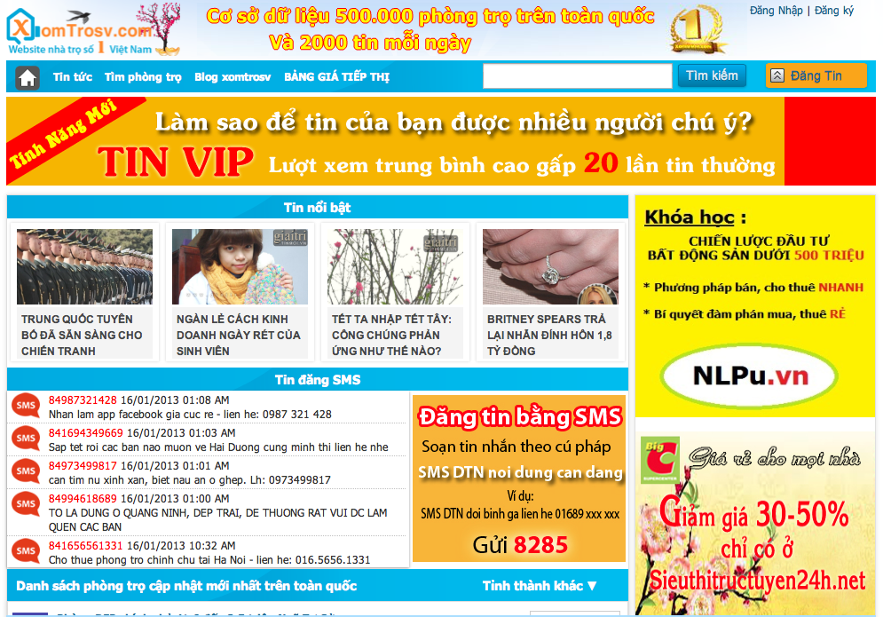

**nhatroViet.com**:

* + - Each post has enough information: address, room type, date, rent, electric and water fees, contacts, etc.
    - Suggestion shows rooms on the same district.
    - Provide more related information that user may need:
      * News related to room seeking, giving user more information.
      * Can search for buses by number or by route.
    - No bookmark and rating
    - Google Map implementation has bug
    - Suggestion doesn’t show rooms on the same district, which helps users compare among candidate selections.

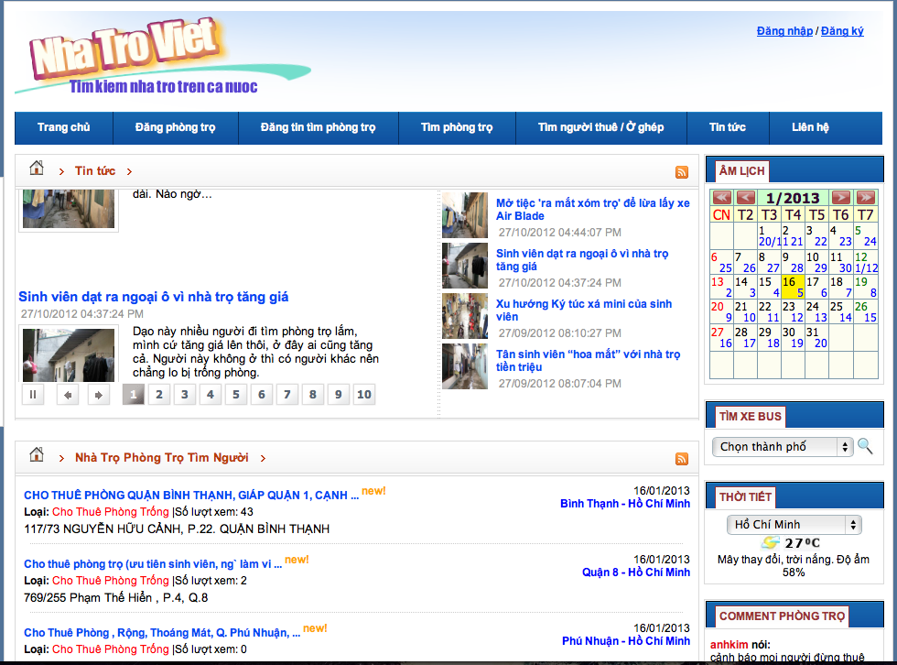

**Padmapper.com**:

* + - It has visual interaction:
      * Support of nearly full screen map.
      * Have markers on the map, which helps users identify the location better.
      * It has visual scrolls for users to set range of their search.
    - Favorite list for users to refer later.
    - No comparison functions between 2 or more positions.
    - No suggestion for other places near selected positions such as universities, markets, and hospitals…

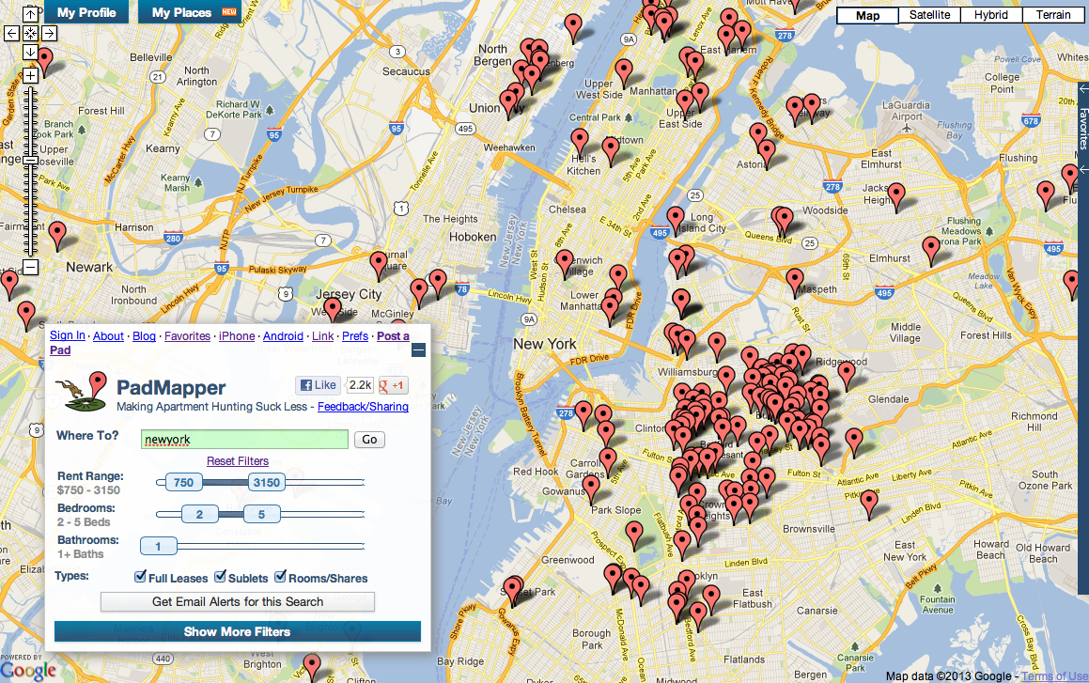

## Our Proposal

The idea of creating a website supports finding rental house is not new. However, our website has a proposal brings better & faster way of searching, better user experiences. We focus on the following points:

* + Quick search function: should be faster, more efficient with suggestion of good and suitable houses, flats for users.
  + Advanced Search: focus on users who know well their needs and want to find the best ones for them with their own evaluation of necessary living conditions.
  + Visualization: Improve the interaction between users and visual maps in friendly & direct ways.
  + Simple flows of interaction: between user and website which helps users approached main functions faster and more easily with implementation of Google Map Api, OpenID, simple SMS post activation…

## Products

The main product of this project is a website as mentioned above. Users will use the website to search, compare, and decide to contact the house owner. Besides, user also save favorite, share, Q&A, review, updates post and so on.

# Capstone Project Document

## Problem Definition

### Project Name

The formal and official name for this Capstone Project is Rental House Finding System. The product name is “<http://www.5house.us>”, but it might be changed in developing process.

### Problem Abstract

After doing research and survey, the authors of this product realized that it’s necessary to build a system for Vietnamese users to find a house for lease, which is really high on demand now, especially, in big cities.

Currently, there are currently some other products providing quite the same services, however all of them have own advantages and disadvantages. The purpose of this project is to create a product that overcomes all those disadvantages and becomes a useful and effective tool to finding a house for lease.

Once completed, the product should possess the following characteristics:

+ Friendly interface, easy to use, can be used by all levels, all kinds of Internet users.

+ The main flow of searching for seeker and new posting for house owner should be simple and quick.

+ Quick Search and Advanced Search function support many extra options, full text search and suggestion for user the most suitable houses, flats …

+ Having a good initial database with a considerable amount of information about house for lease.

### Project Overview

#### Proposed System

The main system will be a website. The system will provide the following main features in front-end:

* Everyone can visit the site and search houses for lease.
* Search function: Full text search with suggestion.
* Advanced Search function: detail search with extra options and demand evaluation.
* Register new account & manage account profile with user control panel.
* Add a post to favorite list.
* Compare between houses in favorite list.
* All users can post a new topic about house for lease or share.
* All users can update and renew their house post.
* Some popular social networks may be integrated into the system for register, sharing and subscribing.

The back-end will allow the administrators to manage the most important activities as well as information on the site.

* Admin can manage all posts.
* Admin can manage house categories.
* Admin can manage locations in the system: add, edit, and delete locations.
* Admin can manage all provinces, cities.
* Admin can manage payment.
* Admin can manage all reported bad posts.
* Admin can manage all type of users.
* Admin can manage all bad words, bad word type of post filter.
* Admin can manage the weight of extra options in Advanced Search mode.

#### Boundaries of the System

The system under development of this Capstone Project will include:

* The complete website
* All the process documents involved

#### Development Environment

Below is the list of hardware and software requirements needed for development environment:

##### Hardware requirements:

* + Personal computers for developing with the minimum configuration: 2 Gb of RAM, 50 Gb of hard disk, Pentium dual core 2.0 GHz.
  + A server computer for testing with the minimum configuration: 2 Gb of RAM, 50Gb of hard disk, Core 2 Duo 2.0 GHz.

##### Software requirements:

* + Operating System: Windows XP, 7/Windows Server 2008
  + Web Server: IIS 7
  + Framework: ASP.NET MVC3
  + IDE: MS Visual Studio 2010 SP1
  + DBMS: MS-SQL 2008
  + Source Control: GoogleCode & TortoiseSVN
  + API: GoogleMapsAPIv3, Facebook API

## Project organization

### Software Process Model

The process model used for developing this project is Waterfall model.

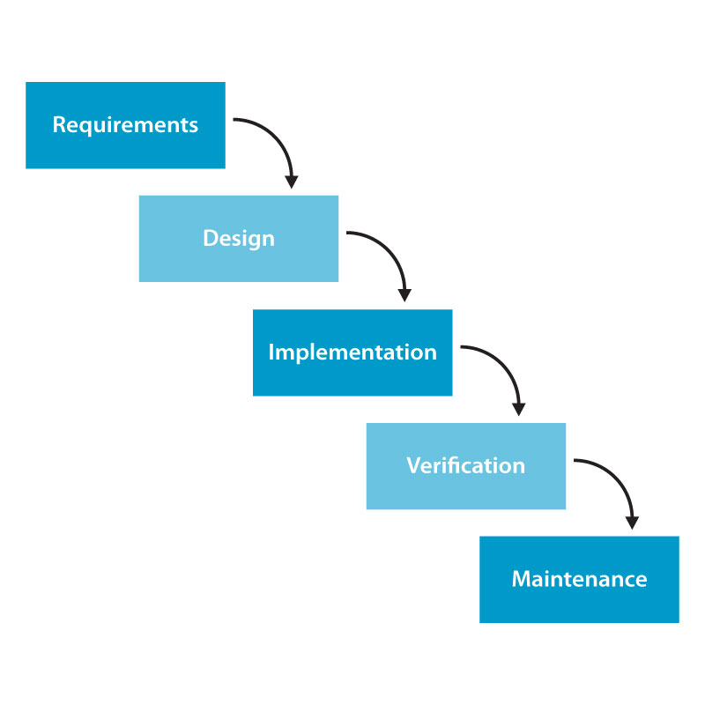

All the phases in the waterfall models are included in the scope of this project and are the responsibilities of the team.

### Roles and Responsibilities

|  |  |  |  |
| --- | --- | --- | --- |
| No | **Full name** | **Role** | **Responsibilities** |
| 1 | Nguyễn Việt Nam | PM, Designer, Developer | * Create project plan * Managing process * Create document, reports * GUI Design * Deployment |
| 2 | Cao Quốc Hưng | Tech Lead, Developer | * Create detail system design * Coding * Unit testing * Managing configuration * Deployment |
| 3 | Trần Thị Bích | Tester, BA | * Clarifying requirements * Create document, reports * Creating test plan and system test cases * System testing |
| 4 | Võ Hoàng Việt | Developer | * Create document, reports * Create detail system design * Coding * Unit testing |
| 5 | Nguyễn Tiến Chung | Developer | * Create document, reports * Coding * Unit testing * Deployment |

### Tools and Techniques

* Front-end technologies: ASP.NET MVC3, MS-SQL, Ajax, jQuery, Google Map API, Facebook API, SMS Web Service
* Tools: MS Visual Studio 2010 SP1, MS-SQL 2008, MS Office 2007, Adobe Photoshop CS6.
* Architecture and design patterns: MVC

## Project management plan

## Tasks

|  |  |  |  |  |  |  |
| --- | --- | --- | --- | --- | --- | --- |
| **ID** | **Task** | **Description** | Deliverables | Resources Needed **(Human/Duration)** | Dependencies and Constraints | Risks |
|  | Create project plan | Create project plan: Prepare plan for Capstone Project. | In the first stage, plan is about all overview of project. Divide project into small stages with corresponding duration.  After unifying all stages of project, creating plan for each stage: scope, resource, schedule, deadline…  **Deadline:** 11st Jan 2013 | All members must discuss about plan, to ensure that each stage fits time, resource of project.  **Duration:** about 1 week. | None | None |
|  | Create Software Requirements Specification | Create Software Requirement Specification (SRS) document | Software Requirement Specification included all Use Cases of Software product. It can be update during project, if necessary.  **Deadline:** 29th Jan 2013 | 5 persons/2 weeks | None | Due to time constrain, the team cannot make a deep research and wide survey to collect information about end-user’s needs. Almost requirements come from team members, conflicts may happen regularly. |
|  | Create Software Design Description | Create Software Design Description: Architecture design, detailed design, diagrams and design specification | **Deadline:** 1st Mar 2013 | 5 persons/2 weeks | Depends on the completion of SRS | Risks may include choosing inappropriate architecture and design patterns, causing the system hard to maintain, or causing high coding efforts. |
|  | Design Database | Create database design (logical and physical) | Logical database design: all tables and their relationship.  Physical database design: database in SQL Server 2008  **Deadline:** 19th Feb, 2013 | 5 persons/2 weeks | Depends on the completion of SRS | SRS may not be detailed enough to capture the business rules, causing the database design to be inappropriate or will be changed much in the future. |
|  | Layout Design | Design GUI for all interfaces of website. | HTML layout and CSS files  Images of all GUI  **Deadline:** 3rd Mar 2013 | 3 persons/1 week | None | None |
|  | Create System Test Cases | Create system test cases following SRS | **Deadline:** 2nd Apr 2013 | 1 person/2 weeks | Finish SRS | Lack test cases |
|  | Coding | Implement the system to reflect the requirements with output is: source code of the project, unit test reports | **Output:** Source code of the project, unit test reports.  Executable programs and source code before 2nd Apr 2013. | 5 persons/5 weeks | Finish of SRS, SDD, and Database design | Lack of Technical knowledge  Lack of experience in project management  Lack of skill to find and fix bug  Unit test may not be performed thoroughly causing spending more efforts in system test phase  May lack of time to implement all the requirements |
| Execute unit testing | Developer execute unit testing, follow System test cases | **Deadline**: 7th April 2013 | 4 persons | Finish coding process  Finish System Test cases | Lack of test cases  Lack of testing skill |
|  | System Test | Perform system test for the system | **Output:** System test report  **Deadline**: 14th April 2013 | 5 persons/2 weeks | Finish Coding  Finish System Test cases  Finish Unit testing | Lack of professional testers in team  Developers are also responsible for system testing, which may lead to compromise  Lack of skill on inputting data to test  Lack of skill in using test tool to test performance of website |
|  | Deployment | Deploy the system to the Internet  Output: Running website with domain and hosting | **Output:** Running website with domain and hosting  Before 18th Apr, 2013 | 2 persons/3 days | Coding and system test are finished, initial data is inputted | None |

### Task Sheet: Assignments and Timetable

Please refer RHF\_Master\_Plan.mpp for more detail.

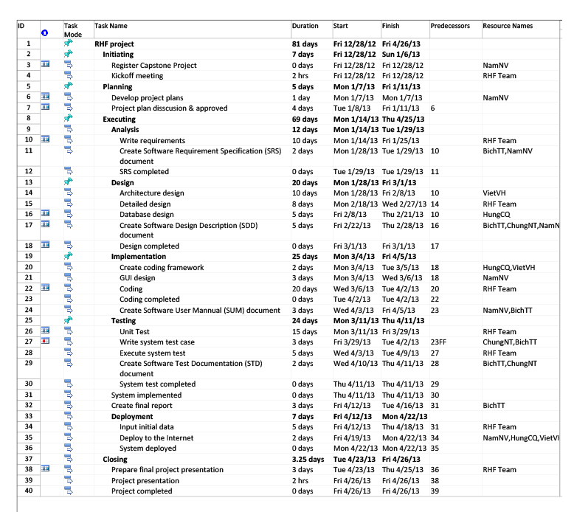

### All Meeting Minutes

Refer external documents.

## Coding Convention

Follow C# Standard Coding Convention at:

<http://msdn.microsoft.com/en-us/library/ff926074.aspx>

# Software Requirement Specification

## User Requirement Specification

There are 3 main actors which system supports:

* **Visitors**: don’t have account on system. In general, they should be people who need to search house for lease.  
  However, they could also people who have few properties and want a fast post method, in short time, a limitation of steps and without registration.
* **Registered Users**: have account on system. In general, they should be house owners or people who have a large number of properties and need a workspace to control all their posts, messages, favorites, payments.
* **Administrator**: The full power user of the system who has all functions of normal user and has an admin control panel to manage all configuration of system.

### Visitor Requirements

* Visitors can create accounts to become a registered user. Email address, mobile phone and password are required to register. Each email can only register once.
* Visitors can also use Open ID to login into website such as Yahoo, Google, and Facebook.
* Visitor can post new house for lease with less functions comparing to registered users (they don’t have user workspace to control all their account activities easily).
* Visitors can view detail info of all houses for lease posts, which match their search and need.
* Visitors can add and delete a post they like to their favorite list.
* Visitors can compare two or three information of house for lease after adding them to favorite list.
* Visitors can search house for lease by using Quick Search and Advanced Search (with many options for users who know well about their needs.)
* Visitor can share their favorite post to others using many popular social networks.
* Visitor can send question to the owner of a post

### Registered user requirements

* Registered users have full functions of Visitor.
* Registered users can post new house for lease.
* Registered users can view; edit and delete their posts, which were posted by themself.
* Registered users can renew their post when their post was hidden. (After amount of time).
* Registered users can edit individual information such as: name, telephone, address….
* Register users can report if topic as spam to administrator.

### Administration requirements

* Admin has full power in the system.
* Admin can view a list of all nearby places in the system, add locations and delete locations.
* Admin can view a list post on the website, add, edit or delete post, expired date
* Admin can view a list of report topics, decide they are spam or not to remove or edit.
* Admin can view all payments from users in system
* Admin can manage all categories of houses, flats for lease.
* Admin can add, edit, delete and list all locations (city, district, and province).

### System Requirement

* System will auto hide the topic post after amount of time posted.
* System will auto send active require SMS to poster’s mobile phone and/or email in order to approve the post to the website.
* System will auto immediately active the post after poster send payment SMS successfully.
* System will auto filter all post with bad words to blacklist before sending active require SMS to posters and waiting for manual check from admin. After getting approve from admin, system auto send active SMS as normal.

### Post Requirement

* Title: subject of the post. (Required)
* Type: type of house for lease. There are 4 types: house for lease, rental room, finding other to rent together, room remise(Required)
* City: the city of house. (Required)
* District: the district of house. (Required)
* Detail address: the detail address of house.
* Price: price to rent. (Required)
* Area: total area. (Required)
* Contact telephone: the phone number of person, who have house for lease. (Required)
* Contact email
* Instant Message: IM, Skype
* Water fee: fee for water service.
* Electricity fee: fee for electricity service.
* Private toilet: available or not.
* Internet: available or not.
* Motor parking: available or not.
* Garage for car: available or not.
* Air conditioner: available or not.
* Bedroom with beds: available or not.
* Cable TV: available or not.
* Kitchen: private cooking allow or not.
* Security: protected by guard or not.
* Time of door closing: 22h, 22h30, 23h, 23h30, 24h or not regulation.
* Image: pictures of house.
* Location in map: the location of house on map.
* View: the number of visitor and user view this post.
* Description: more description of house for lease.

### Ranking Requirement

**Main objective**: This ranking function will help system order the result list from user’s search processes.

We have the followings information fields of a house or flat: (\*)

* Category (type of house or flat)
* Provinces
* District
* Street
* Detail address number
* Title of post
* General description
* Nearby places

Firstly, depending on each specific demand, user must choose at least house category and province where they want to find.

The district field is optional which user can choose finding in all districts or each individual district.

Secondly, with the remaining criteria, we define a specific point for each corresponding field (score) and their working method is as follows:

* When the user does not enter a keyword to search, then the point will not be used, and the system will find all posts which satisfy the condition of province & district fields.
* However, if the user enters any keyword on search textbox, the system will use the Fulltext Search feature in Microsoft SQL Server to find in all above fields (\*). Especially, the Freetextable ranking method (based on Okapi BM25 formula) of Fulltext Search is applied into system to calculate the corresponding rank for each field. After having the rank of each corresponding point, system will use these to multiply with field scores that have been specified before in order to form the final score.

🡺 The returned results will be sorted by descending order of final score.

Finally, an administrator can arbitrarily change the score of each field to fit the needs of each period.

*Ref: Fulltext search ranking calculated system of MS SQL:* [*http://msdn.microsoft.com/en-us/library/ms345119*](http://msdn.microsoft.com/en-us/library/ms345119)*(SQL.90).aspx*

### Search Requirement

There are 2 kinds of search in the website: Quick Search and Advanced Search:

#### Quick Search

This is a main region on the home page and is displayed as a bar and is accessible from every page. The users will choose the category of house for lease they want to search and the area they want to find places in. The search area fields will automatic title suggestion.

#### Advanced Search

This function provides users more options to make search result become more precise. It is extremely effective for users who know well their needs. These options are:

* Specific location: province, city, and streets.
* Specific price and area.
* Specific interior utility with need evaluation for user. They can define the priority of each item.

**The main objective**: Find all the posts satisfying all above options and arrange them in order from highest to lowest based on the criteria set by users themselves.

There are four levels of user’s interest in each criterion:

* Do not care: x points
* Low: y points
* Medium: z points
* High: w points

Users will choose their level of interest corresponding to each criterion, and then the system will return 1 list of posts which have points calculated based on their interest level.

The algorithm here should find all satisfied post with fast speed but still remain precise handling.

**Algorithm description:**

The formula:

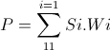

P: final point of a post in result list

Si: 1 if criterion selected

0 if otherwise

Wi: Weighted points of each criterion (configurable)

## System Requirement Specification (Specific Requirements)

### External Interface Requirements

#### User Interfaces

Interface needs to attract the attention of users to the product image. Website should have the background simple, less color, less attention but that also shows clear boundaries between each section. The look and feel of this website should be based on user requirements. Page layout and navigation should be as intuitive and easy as possible.

The overuse of product images should not increase the time in which a page downloads, which has a negative impact on usability.

#### Hardware Interfaces

RHF website needs to run are the peripheral devices mouse and keyboard with internet connection.

#### Software Interfaces

|  |  |  |
| --- | --- | --- |
| Software name | Version | Source |
| .NET Framework | 4.0 | Microsoft |
| SQL Server | 2008 R2 | Microsoft |
| Visual Studio | 2010 | Microsoft |
| MVC | 3.0 | Microsoft |
| Firefox | 3.6 or higher | Mozilla |
| Internet Explorer | 9.0 or higher | Microsoft |
| Chrome | 20 or higher | Google |

#### System Features

This section will describe the system being built through a list of Use cases. First, we will have an over-view of the whole system and what it will do through a use case diagram. There’re 3 main actors: User (consist of Visitor & Registered User) and Administrator.

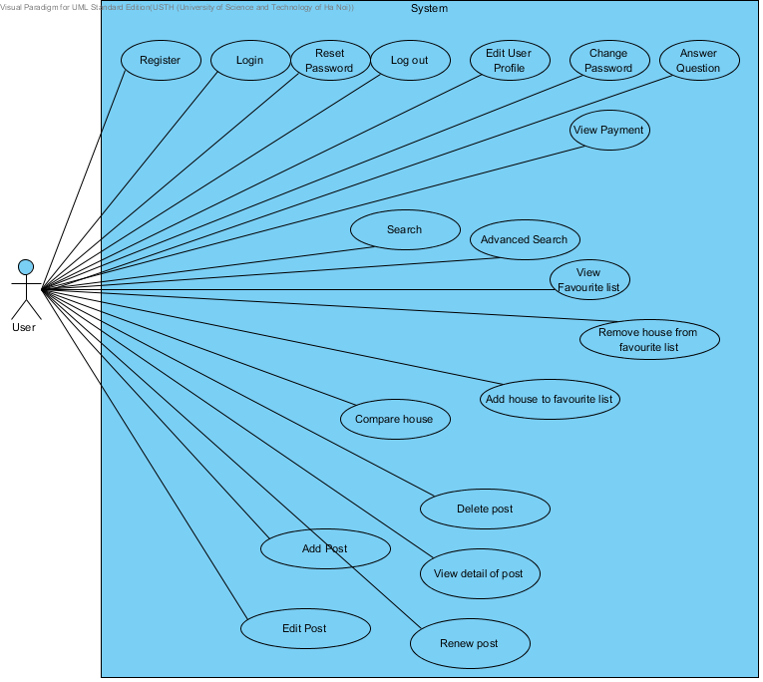

Figure: All User usecase diagram

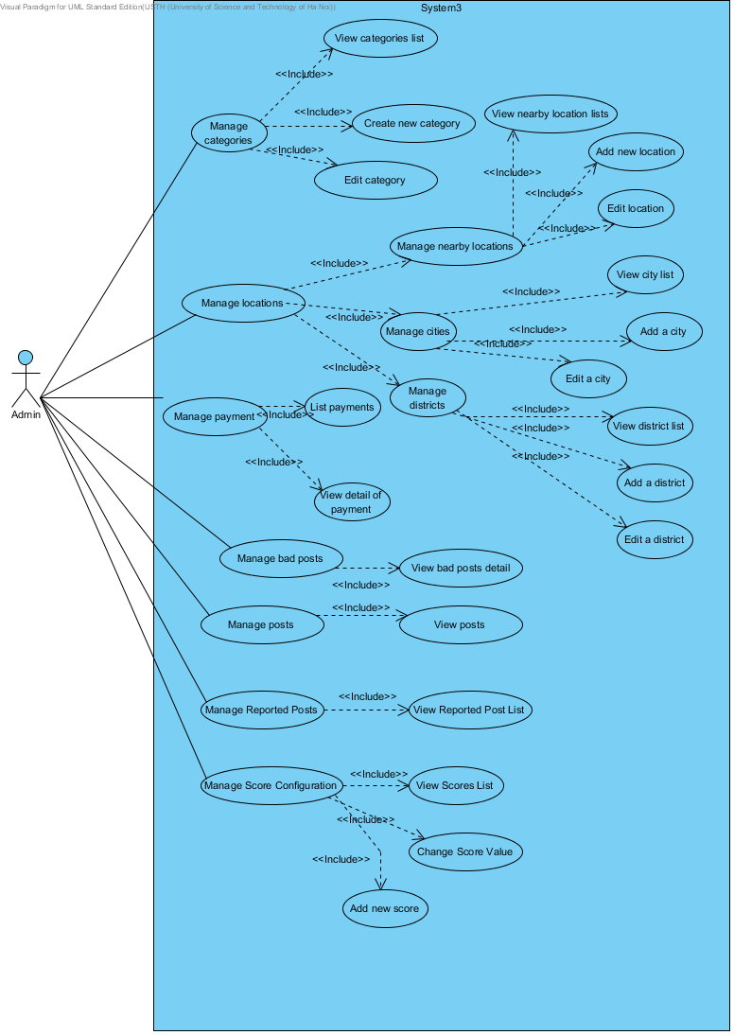

Figure: All admin usecase diagram

|  |  |  |  |
| --- | --- | --- | --- |
| **Id** | **Name** | **Use-case No** | **Page** |
| **1** | Search | UC001 | 25 |
| **2** | Advanced Search | UC002 | 26 |
| **3** | Register | UC003 | 27 |
| **4** | Delete Post | UC004 | 28 |
| **5** | Edit Post | UC005 | 29 |
| **6** | Renew post | UC006 | 30 |
| **7** | Add post | UC007 | 30 |
| **8** | <Registered User> Edit User Profile | UC008 | 32 |
| **9** | <Registered User> Remove house from favorite list | UC009 | 33 |
| **10** | <Registered User> Add house to favorite list | UC010 | 34 |
| **11** | <Registered User> Compare house | UC011 | 34 |
| **12** | <Registered User> View detail of post | UC012 | 35 |
| **13** | <Registered User> Answer Question | UC013 | 36 |
| **14** | <Registered User> View Payment | UC014 | 37 |
| **15** | <Registered User> View Favorite list | UC015 | 37 |
| **16** | <Registered User> Reset Password | UC016 | 38 |
| **17** | <Registered User> Delete post | UC017 | 39 |
| **18** | <Registered User> Edit post | UC018 | 40 |
| **19** | <Registered User> Log Out | UC019 | 41 |
| **20** | <Registered User> Login | UC020 | 41 |
| **21** | <Registered User> Change Password | UC021 | 42 |
| **22** | <Admin> Add new score | UC022 | 43 |
| **23** | <Admin> Change score value | UC023 | 44 |
| **24** | <Admin> View scores list | UC024 | 45 |
| **25** | <Admin> View reported post list | UC025 | 45 |
| **26** | <Admin> Edit location | UC026 | 46 |
| **27** | <Admin> Add new location | UC027 | 46 |
| **28** | <Admin> View nearby location lists | UC028 | 47 |
| **29** | <Admin> View posts with filter | UC029 | 48 |
| **30** | <Admin> Manage posts | UC030 | 48 |
| **31** | <Admin> View detail of payment | UC031 | 49 |
| **32** | <Admin> List payments | UC032 | 49 |
| **33** | <Admin> Manage bad posts | UC033 | 50 |
| **34** | <Admin> Edit category | UC034 | 50 |
| **35** | <Admin> Create new category | UC035 | 51 |
| **36** | <Admin> View categories list | UC036 | 52 |
| **37** | <Admin> Manage categories | UC037 | 52 |
| **38** | <Admin> View bad post detail | UC038 | 53 |
| **39** | <Admin> Edit a district | UC039 | 54 |
| **40** | <Admin> Add a district | UC040 | 55 |
| **41** | <Admin> View district list | UC041 | 56 |
| **42** | <Admin> Edit city | UC042 | 57 |
| **43** | <Admin> Add a city | UC043 | 58 |
| **44** | <Admin> View city list | UC044 | 59 |

##### 

##### UC001: Search

###### Use Case Descriptions

|  |  |
| --- | --- |
| **Search** | |
| Use Case ID | UC001 |
| Primary Actor | Visitor, Registered User, Administrator |
| Brief Description | This is one of the main functions of the system. User only needs to input some keywords in order to find the best house suitable for their need. The search result will be filtered and marked on the map to support visitor, user find the right flat as quick as possible. |
| Goal | Search for suitable houses with input keyword. |
| Triggers | N/A |
| Preconditions | User have selected type of house they want to find. |
| Main success scenario | |  |  |  | | --- | --- | --- | |  | **Actor Input** | **System Response** | | 1 | User selects type of house which they want to search & enters any keyword to the search text box and click "Tìm kiếm" button or press "Enter". |  | | 2 |  | Display search result. | |
| Alternative Scenario - Suggestion | |  |  |  | | --- | --- | --- | |  | **Actor Inpu** | **System Response** | | 1 | Enter keywordinto search text box. |  | | 2 |  | The system displays instantly suggestions of matching posts | | 3 | Choose one of the suggestions n list. |  | | 4 |  | Display search result in paging. | |
| Author | Vietvh |
| Date | 28/1/2013 |

##### UC002: Advanced Search

###### Use Case Descriptions

|  |  |
| --- | --- |
| **Advanced Search** | |
| Use Case ID | UC002 |
| Primary Actor | Visitor, Registered User, Administrator |
| Brief Description | This is one of the main functions of the system. User who knows their needs clearly and want to do a detail search with exact return result. |
| Goal | Search for suitable houses with detail information |
| Triggers | N/A |
| Preconditions | User click on Advanced Search button |
| Main success scenario | |  |  |  | | --- | --- | --- | |  | **Actor Input** | **System Response** | | 1 | User click "Tìm kiếm nâng cao" button or link |  | | 2 |  | Displa advanced search page. | | 3 | User fill all necessary information |  | | 4 |  | Display result in paging. | |
| Alternative Scenario - Suggestion | |  |  |  | | --- | --- | --- | |  | **Actor Input** | **System esponse** | | 1 | User click "Tìm kiếm nâng cao" button or link. |  | | 2 |  | Display advanced searchpage. | | 3 | User fill all necessary information and click other link or click "Hủy" |  | | 4 |  | Close advanced search page. | |
| Post-conditions | Redirect user to result page |
| Author | Vietvh |
| Date | 28/1/2013 |

##### UC003: Register

###### Use Case Descriptions

|  |  |
| --- | --- |
| **Register** | |
| Use Case ID | UC003 |
| Primary Actor | Visitor |
| Brief Description | Visitor can create new account to use more functions as a registered user. |
| Goal | Registered new account for visitor. |
| Triggers | User click on Register button. |
| Preconditions |  |
| Main success scenario | |  |  |  | | --- | --- | --- | |  | **Actor Input** | **System Response** | | 1 | click "Đăng ký" |  | | 2 |  | Display form register. | | 3 | Enter necessary and mandatory information & click "Đăng kí" button |  | | 4 |  | Redirect to previous page and logged user into system | |
| Alternative Scenario - Suggestion | |  |  |  | | --- | --- | --- | |  | **Actor Input** | **System Response** | | 1 | click "Đăng ký" |  | | 2 |  | Display form register. | | 3 | Enter necessary and mandatory information & click other link |  | | 4 |  | Close form and redirect to target page | |
| Post-conditions | Redirect user to previous page |
| Exceptions | |  |  |  | | --- | --- | --- | |  | **Actor Input** | **System Response** | | 1 | click "Đăng ký" |  | | 2 |  | Display form register. | | 3 | Enter any information incorrect or missing mandatory fields |  | | 4 | Click "Đăng ký" button |  | | 5 |  | Display error mesage beside wrong fields. | |
| Author | Vietvh |
| Date |  |

##### UC004: Delete post

###### Use Case Descriptions

|  |  |
| --- | --- |
| **Delete Post** | |
| **Use Case ID** | UC004 |
| **Primary Actor** | Visitor |
| **Brief Description** | This use case allows user to delete their post |
| **Goal** | Visitor deletes a specific post successfully. |
| **Triggers** | Visitor accesses to link page edit post and enter correct code. |
| **Preconditions** | Visitor has it own private code to access edit page |
| **Main success scenario** | |  |  |  | | --- | --- | --- | |  | **Actor Input** | **System Response** | | 1 | Click "Xóa" button |  | | 2 |  | Display confirmation popup window | | 3 | Click "Xác nhận" |  | | 4 |  | Delete post from system and display "Xóa bài đăng thành công" message | |
| **Alternative Scenario** | |  |  |  | | --- | --- | --- | |  | **Actor Input** | **System Response** | | 1 | Click "Xóa" button |  | | 2 |  | Display confirmation popup window | | 3 | Click "Hủy" button |  | | 4 |  | Close confirmation popup window | |
| **Post Conditions** | Redirect user to main manage page. |
| **Date** | 28/1/2013 |

##### UC005: Edit Post

###### Use Case Descriptions

|  |  |
| --- | --- |
| **Edit Post** | |
| **Use Case ID** | UC005 |
| **Primary Actor** | Visitor |
| **Brief Description** | When visitor wants to edit his/her posts |
| **Goal** | Visitor change post detail successfully. |
| **Triggers** | Visitor access edit page and enter right code |
| **Preconditions** | N/A |
| **Main success scenario** | |  |  |  | | --- | --- | --- | |  | **Actor Input** | **System Response** | | 1 | Visitor accesses edit page and enter right code |  | | 2 |  | Display detail post editing page | | 3 | Edit post information |  | | 4 |  | Validate and save new information into system | |
| **Alternative Scenario** | |  |  |  | | --- | --- | --- | |  | **Actor Input** | **System Response** | | 1 | Visitor accesses edit page and enter right code |  | | 2 |  | Display detail post editing window | | 3 | Edit post information and click "Hủy" |  | | 4 |  | Close detail post editing window | |
| **Exceptions** | |  |  |  | | --- | --- | --- | |  | **Actor Input** | **System Response** | | 1 | Visitor accesses edit page and enter right code |  | | 2 |  | Display detail post editing window | | 3 | Fill in wrong post information or missing mandatory fields |  | | 4 |  | Validate & display error messages | |
| **Post Conditions** | Redirect user to home page. |
| **Author** | NamNV |
| **Date** | 28/1/2013 |

##### UC006: Renew post

###### Use Case Descriptions

|  |  |
| --- | --- |
| **Renew post** | |
| Use Case ID | UC006 |
| Primary Actor | Visitor, Registered User, Administrator |
| Brief Description | This use case allow user to renew a post which they had posted before the post is expired. |
| Goal | Allow user renewing a post |
| Triggers | User receive SMS or email which describes how to renew their post |
| Preconditions | N/A |
| Main success scenario | |  |  |  | | --- | --- | --- | |  | **Actor Input** | **System Response** | | 1 | Visitor sends SMS to payment portal following guide in SMS from system |  | | 2 |  | Send SMS to user to inform about payment success and active post | |
| Exceptions | |  |  |  | | --- | --- | --- | |  | **Actor Input** | **System Response** | | 1 | Visitor sends wrong SMS to payment portal following guide in SMS from system |  | | 2 |  | Send SMS to user to inform about error | |
| Post Conditions | Visitors can renew a post |
| Author | Vietvh |
| Date | 28/1/2013 |

##### UC007: Add Post

###### Use Case Descriptions

|  |  |
| --- | --- |
| **Add Post** | |
| **Use Case ID** | UC007 |
| **Primary Actor** | Visitor, Registered User, Administrator |
| **Brief Description** | This use case allows user to add new post of their rental house |
| **Goal** | User adds new post successfully. |
| **Triggers** | N/A |
| **Preconditions** | N/A |
| **Main success scenario** | |  |  |  | | --- | --- | --- | |  | **Actor Input** | **System Response** | | 1 | Click "Đăng bài mới" button |  | | 2 |  | Display adding new post page | | 3 | Fill in new post information and click "Đăng tin ngay" |  | | 4 |  | Validate, save into system and send SMS notify user | |
| **Alternative scenario** | |  |  |  | | --- | --- | --- | |  | **Actor Input** | **System Response** | | 1 | Logged into system and click "Tạo bài mới" |  | | 2 |  | Display adding new post form | | 3 | Fill in right information and click"Hủy" button |  | | 4 |  | Close new post page and redirect user to previous page | | 5 |  |  | |
| **Alternative Scenario** | |  |  |  | | --- | --- | --- | |  | **Actor Input** | **System Response** | | 1 | User logged into system successfully |  | | 2 | Click "Đăng bài mới" button |  | | 3 |  | Display adding new post form | | 4 | Fill in new post information and click "Đăng bài ngay!" |  | | 5 |  | Validate and save into system and send SMS notify user. | |
| **Exceptions** | |  |  |  | | --- | --- | --- | |  | **Actor Input** | **System Response** | | 1 | Click "Đăng bài mới" button |  | | 2 |  | Display adding new post form | | 3 | Fill in wrong information or missing mandatory fields |  | | 4 |  | Validate & display error messages | |
| **Post Conditions** | Redirect user to new post page. |
| **Author** | NamNV |
| **Date** | 28/1/2013 |

##### UC008: <Registered User> Edit User Profile

###### Use Case Descriptions

|  |  |
| --- | --- |
| **Edit User Profile** | |
| **Use Case ID** | UC008 |
| **Primary Actor** | Registered User, Administrator |
| **Brief Description** | When user wants to edit his/her account information. |
| **Goal** | User changes account information successfully. |
| **Triggers** | User clicks on their account link button on top of any page. |
| **Preconditions** | User had logged into system. |
| **Main success scenario** | |  |  |  | | --- | --- | --- | |  | **Actor Input** | **System Response** | | 1 | Click "Thông tin tài khoản" link & click "Thay đổi thông tin" button |  | | 2 |  | Display detail account editing window | | 3 | Edit account informtion |  | | 4 |  | Validate and save new information into system | |
| **Alternative Scenario** | |  |  |  | | --- | --- | --- | |  | **Actor Input** | **System Response** | | 1 | Click "Thông tin tài khoản" link & click "Thay đổi thông tin" button |  | | 2 |  | Display detail account editing window | | 3 | Edit account information and click "Hủy" |  | | 4 |  | Close detail account editing window | |
| **Exceptions** | |  |  |  | | --- | --- | --- | |  | **Actor Input** | **System Response** | | 1 | Click "Thông tin tài khoản" link & click "Thay đổi thông tin" button |  | | 2 |  | Display detail account editing window | | 3 | Fill in wrong account informationor missing mandatory fields |  | | 4 |  | Validate & display error messages | |
| **Post Conditions** | Redirect user to main user workspace. |
| **Author** | NamNV |
| **Date** | 28/1/2013 |

##### UC009: <Registered User> Remove house from favorite list

###### Use Case Descriptions

|  |  |
| --- | --- |
| **Remove house from favourite list** | |
| Use Case ID | UC009 |
| Primary Actor | Registered User |
| Brief Description | This use case allows user to remove a house from their favorite list which they don't want to follow anymore. |
| Goal | Allow user removing house from favorite list |
| Triggers | N/A |
| Preconditions | User logged into system successfully and user had added at least 1 post to favorite list |
| Main success scenario | |  |  |  | | --- | --- | --- | |  | **Actor Input** | **System Response** | | 1 | Select an item in favorite list and click "Xóa" button |  | | 2 |  | Display message "Bạn có chắc chắn muốn xóa bài đang quân tâm này?" | | 3 | User click "Đồng ý" |  | | 4 |  | Delete that item which user had chosen | |
| Alternative Scenario - Suggestion | |  |  |  | | --- | --- | --- | |  | **Actor Input** | **System Response** | | 1 | Select an item in favorite list and click "Xóa" button |  | | 2 |  | Display message "Bạn có chắc chắn muốn xóa bài đang quân tâm này?" | | 3 | User click "Hủy" |  | | 4 |  | Delete that item which user had chosen | |
| Post-conditions | Reload the favourite list |
| Author | Vietvh |
| Date | 28/1/2013 |

##### UC010: <Registered User> Add house to favorite list

###### Use Case Descriptions

|  |  |
| --- | --- |
| **Add house to favourite list** | |
| Use Case ID | UC010 |
| Primary Actor | Registered User |
| Brief Description | This use case allow user to add a post to favorite list in order to view later or compare between many posts to define the pros and cons of candidates. |
| Goal | Allow user to add a post to favorite list |
| Triggers | N/A |
| Preconditions | User had logged into system succesfully, done a search process with result and in a post detail page |
| Main success scenario | |  |  |  | | --- | --- | --- | |  | **Actor Input** | **System Response** | | 1 | Click "Quan tâm" button on top of a post |  | | 2 |  | Add that post to favorite list and display message "Tin đăng đã được cho vào khu vực quan tâm". | |
| Author | Vietvh |
| Date | 28/1/2013 |

##### UC011: <Registered User> Compare house

###### Use Case Descriptions

|  |  |
| --- | --- |
| **Compare House** | |
| Use Case ID | UC011 |
| Primary Actor | Registered User |
| Brief Description | This use case allows user to compare 2 - 3 house posts which they are considering the pros and cons of them. |
| Goal | User can compare 2 - 3 house posts |
| Triggers | N/A |
| Preconditions | Favourite list has at least 2 items |
| Main success scenario | |  |  |  | | --- | --- | --- | |  | **Actor Input** | **System Response** | | 1 | Choose 2 - 3 items on favorite list and click "So sánh" button |  | | 2 |  | Display detail compare page for user | |
| Post-conditions | Display compare page |
| Exceptions | |  |  |  | | --- | --- | --- | |  | **Actor Input** | **System Response** | | 1 | Choose one item and click "So sánh" button |  | | 2 |  | Display error message "Bạn vui lòng chọn ít nhất 2 bài đăng để bắt đầu so sánh." | |
| **Exceptions** | |  |  |  | | --- | --- | --- | |  | **Actor Input** | **System Response** | | 1 | Choose over 3 items and click "So sán" button |  | | 2 |  | Display error message "Bạn vui lòng chọn từ 2 - 3 bài đăng để bắt đầu so sánh." | |
| Author | Vietvh |
| Date | 28/1/2013 |

##### UC012: <Registered User> View detail of post

###### Use Case Descriptions

|  |  |
| --- | --- |
| **View detail of post** | |
| Use Case ID | UC012 |
| Primary Actor | Visitor, Registered User, Administrator |
| Brief Description | This use case allow user to view detail of a post |
| Goal | Allow user view detail of a post |
| Triggers | N/A |
| Preconditions | User had done a search with return result |
| Main success scenario | |  |  |  | | --- | --- | --- | |  | **Actor Input** | **System Response** | | 1 | User clicks on hyperlink of a post in search result list |  | |
| Alternative Scenario | |  |  |  | | --- | --- | --- | |  | **Actor Input** | **System Response** | | 1 | User click on a markers on map |  | | 2 |  | Open the basic detail popup | | 3 | User click on "Chi tiết" button on basic detail popup |  | | 4 |  | Open detail page of specific post | |
| **Alternative Scenario** | |  |  |  | | --- | --- | --- | |  | **Actor Input** | **System Response** | | 1 | User click on favorite bar with favorite posts and click on specific post |  | | 2 |  | Display detail page of above post | |
| Exceptions | |  |  |  | | --- | --- | --- | |  | **Actor Input** | **System Response** | | 1 |  |  | |
| Post Conditions | User can view a specific post |
| Author | Vietvh |
| Date | 28/1/2013 |

##### UC013: <Registered User> Answer Question

###### Use Case Descriptions

|  |  |
| --- | --- |
| **Answer Question** | |
| **Use Case ID** | UC013 |
| **Primary Actor** | Registered User, Administrator |
| **Brief Description** | When user wants to answer an question from other user about their post |
| **Goal** | User answer question from others successfully |
| **Triggers** | User clicks on account link button on top of any page |
| **Preconditions** | User had logged into system. |
| **Main success scenario** | |  |  |  | | --- | --- | --- | |  | **Actor Input** | **System Response** | | 1 | Click "Tin nhắn" button |  | | 2 |  | Display message page | | 3 | select a conversation in the list & type answer and click "Gửi" |  | | 4 |  | Send emil, notification to question owner | |
| **Alternative Scenario** | |  |  |  | | --- | --- | --- | |  | **Actor Input** | **System Response** | | 1 | Click "Tin nhắn" button |  | | 2 |  | Display message page | | 3 | select a conversation in the list & type answer and click any other link |  | | 4 |  | Close question page and reirect to clicked link | |
| **Post Conditions** | Redirect user to user workspace. |
| **Author** | NamNV |
| **Date** | 28/1/2013 |

##### UC014: <Registered User> View Payment

###### Use Case Descriptions

|  |  |
| --- | --- |
| **View Payment** | |
| **Use Case ID** | UC014 |
| **Primary Actor** | Registered User, Administrator |
| **Brief Description** | When user wants view all his/her payment transaction. |
| **Goal** | User can view all payment transaction |
| **Triggers** | User clicks on account button link |
| **Preconditions** | User had logged into system. |
| **Main success scenario** | |  |  |  | | --- | --- | --- | |  | **Actor Input** | **System Response** | | 1 | Clic "Lịch sử giao dịch" button |  | | 2 |  | Display payment history page | | 3 | Click any title of field |  | | 4 |  | Sort result table follow clicked field | |
| **Post Conditions** | Redirect user to main user workspace. |
| **Author** | NamNV |
| **Date** | 28/1/2013 |

##### UC015: <Registered User> View Favorite list

###### Use Case Descriptions

|  |  |
| --- | --- |
| **View Favorite List** | |
| **Use Case ID** | UC015 |
| **Primary Actor** | Registered User, Administrator |
| **Brief Description** | When user wants view his/her favorite list |
| **Goal** | User can view all favorite list |
| **Triggers** |  |
| **Preconditions** | User had logged into system. |
| **Main success scenario** | |  |  |  | | --- | --- | --- | |  | **Actor Input** | **System Response** | | 1 | Click "Danh sách quan tâm" button |  | | 2 |  | Display favorite list popup | | 3 | Click X button on the right-top of popup |  | | 4 |  | Close favorite popup | |
| **Alternative Scenario** | |  |  |  | | --- | --- | --- | |  | **Actor Input** | **System Response** | | 1 | Click account link button |  | | 2 |  | Display user workspace | | 3 | Click "Danh sách quan tâm" tab |  | | 4 |  | Display favourite list | |
| **Post Conditions** | Redirect user to main workspace. |
| **Author** | NamNV |
| **Date** | 28/1/2013 |

##### UC016: <Registered User> Reset Password

###### Use Case Descriptions

|  |  |
| --- | --- |
| **Reset Password** | |
| **Use Case ID** | UC016 |
| **Primary Actor** | Registered User, Administrator |
| **Brief Description** | When user forgot his/her password and want to get it back |
| **Goal** | User reset password and getting new one. |
| **Triggers** | User clicks on reset password link in Login/Register page |
| **Preconditions** | User had registered account information. |
| **Main success scenario** | |  |  |  | | --- | --- | --- | |  | **Actor Input** | **System Response** | | 1 | Click reset password button |  | | 2 |  | Display reset password page | | 3 | Fill in account information |  | | 4 |  | Validate information, reset password and send email notification to user email. | |
| **Alternative Scenario** | |  |  |  | | --- | --- | --- | |  | **Actor Input** | **System Response** | | 1 | Click reset password button |  | | 2 |  | Display reset password page | | 3 | Fill in account information and click any other link |  | | 4 |  | Validate information, reset password and send email notification to user email. | |
| **Exceptions** | |  |  |  | | --- | --- | --- | |  | **Actor Input** | **System Response** | | 1 | Click reset password button |  | | 2 |  | Display reset password page | | 3 | Fill in wrong account information |  | | 4 |  | Validate & display error message | |
| **Post Conditions** | Redirect user to previous page. |
| **Author** | NamNV |
| **Date** | 28/1/2013 |

##### UC017: <Registered User> Delete post

###### Use Case Descriptions

|  |  |
| --- | --- |
| **Delete Post** | |
| **Use Case ID** | UC017 |
| **Primary Actor** | Registered User, Administrator |
| **Brief Description** | This use case allows user to delete their post |
| **Goal** | User deletes a specific post successfully. |
| **Triggers** | User logged into system and clicked account link |
| **Preconditions** |  |
| **Main success scenario** | |  |  |  | | --- | --- | --- | |  | **Actor Input** | **System Response** | | 1 | Click "Quản lý bài đăng" button |  | | 2 |  | isplay list of posts | | 3 | Click on any title of post |  | | 4 |  | Display detail inforation of a post | | 5 | Click on "Xóa" |  | | 6 |  | Display confirmation popup | | 7 | Click "OK" |  | | 8 |  | Delete post from system and display "Xóa bài đăng thành công" message | |
| **Alternative Scenario** | |  |  |  | | --- | --- | --- | |  | **Actor Input** | **System Response** | | 1 | Click "Quản lý bài đăng" button |  | | 2 |  | Diplay list of posts | | 3 | Click on any title of post |  | | 4 |  | Display detail information of a post | | 5 | Click on "Xóa" |  | | 6 |  | Display confirmation popup | | 7 | Click "Hủy" button |  | | 8 |  | Close onfirmation popup window | |
| **Post Conditions** | Redirect user to main manage page. |
| **Date** | 28/1/2013 |

##### UC018: <Registered User> Edit Post

###### Use Case Descriptions

|  |  |
| --- | --- |
| **Edit Post** | |
| **Use Case ID** | UC019 |
| **Primary Actor** | Registered User, Administrator |
| **Brief Description** | When user want to edit his/her posts |
| **Goal** | User change post detail successfully. |
| **Triggers** | User accessed user workspace |
| **Preconditions** | User logged into system |
| **Main success scenario** | |  |  |  | | --- | --- | --- | |  | **Actor Input** | **System Response** | | 1 | Click on "Quản lý bài đăng" button |  | | 2 |  | Display list of all posts | | 3 | Click on title of post user wants to edit |  | | 4 |  | Open Edit Post page | | 5 | Changes information |  | | 6 |  | Validate, save into system and notify user | |
| **Alternative Scenario** | |  |  |  | | --- | --- | --- | |  | **Actor Input** | **System Response** | | 1 | Click on "Quản lý bài đăng" button |  | | 2 |  | Display list of all posts | | 3 | Edit post information and click "Hủy" |  | | 4 |  | Close detail post editing page | |
| **Post Conditions** | Redirect user to user work space. |
| **Author** | NamNV |
| **Date** | 28/1/2013 |

##### UC0019: <Registered User> Log out

###### Use Case Descriptions

|  |  |
| --- | --- |
| **Log Out** | |
| **Use Case ID** | UC019 |
| **Primary Actor** | Registered User, Administrator |
| **Brief Description** | When user wants to log out from system to shut down current working session. |
| **Goal** | User logged out from system successfully. |
| **Triggers** | User clicks on "Đăng xuất" button |
| **Preconditions** | User had already logged into system |
| **Main success scenario** | |  |  |  | | --- | --- | --- | |  | **Actor Input** | **System Response** | | 1 | Click "Đăng xuất" button |  | | 2 |  | Logged user out from system | |
| **Post Conditions** | Redirect user to homepage |
| **Author** | NamNV |
| **Date** | 28/1/2013 |

##### UC020: <Registered User> Login

###### Use Case Descriptions

|  |  |
| --- | --- |
| **Login** | |
| **Use Case ID** | UC020 |
| **Primary Actor** | Registered User, Administrator |
| **Brief Description** | When user wants to login into system to use advance functions. |
| **Goal** | User logged into system successfully. |
| **Triggers** | User clicks on "Đăng nhập" button |
| **Preconditions** | User had registered account information. |
| **Main success scenario** | |  |  |  | | --- | --- | --- | |  | **Actor Input** | **System Response** | | 1 | Click "Đăng nhập" button |  | | 2 |  | Display login page | | 3 | Fill in account information |  | | 4 |  | Validate information an log user into system | |
| **Alternative Scenario** | |  |  |  | | --- | --- | --- | |  | **Actor Input** | **SystemResponse** | | 1 | Click "Đăng nhập" button |  | | 2 |  | Display login page | | 3 | Fill in account information and click any other link |  | | 4 |  | Close login/register popup window and redirect to page link user licked | |
| **Exceptions** | |  |  |  | | --- | --- | --- | |  | **Actor Input** | **System Response** | | 1 | Click "Đăng nhập" butto |  | | 2 |  | Display login page | | 3 | Fill in wrong account information |  | | 4 |  | Validate & display error message | |
| **Post Conditions** | Redirect user to current page. |
| **Author** | NamNV |
| **Date** | 28/1/2013 |

##### UC021: <Registered User> Change Password

###### Use Case Descriptions

|  |  |
| --- | --- |
| **Change Password** | |
| **Use Case ID** | UC021 |
| **Primary Actor** | Registered User, Administrator |
| **Brief Description** | When user want to change his/her password. |
| **Goal** | User changes account password successfully. |
| **Triggers** | User clicks on account link button. |
| **Preconditions** | User had logged into system. |
| **Main success scenario** | |  |  |  | | --- | --- | --- | |  | **Actor Input** | **System Response** | | 1 | Click "Thay đổi mật khẩu" button |  | | 2 |  | Display detail account password changing page | | 3 | Edit account password information |  | | 4 |  | Validate and save new password into system | |
| **Alternative Scenario** | |  |  |  | | --- | --- | --- | |  | **Actor Input** | **System Response** | | 1 | Click "Thay đổi mật khẩu" buttn |  | | 2 |  | Display detail account password changing page | | 3 | Edit account information and/or click "Hủy" |  | | 4 |  | Close detail account editing window | |
| **Exceptions** | |  |  |  | | --- | --- | --- | |  | **Actor Input** | **System Response** | | 1 | Click "Thay đổi mật khẩu" button |  | | 2 |  | Display detail accoun password editing window | | 3 | Fill in wrong account information or missing mandatory fields |  | | 4 |  | Validate & display error messages | |
| **Post Conditions** | Redirect user to main user work space. |
| **Author** | NamNV |
| **Date** | 28/1/2013 |

##### UC022: <Admin> Add new score

###### Use Case Descriptions

|  |  |
| --- | --- |
| **Add new Score** | |
| Use Case ID | UC022 |
| Primary Actor | Administrator |
| Brief Description | This usecase allow admin to add new score point for extra options |
| Goal | Add new score to database |
| Triggers | Click "Tạo mới" on "Trọng số các tiêu chí phụ" page |
| Preconditions | Logged successfully into the system as Administrator |
| Main success scenario | |  |  |  | | --- | --- | --- | |  | **Actor Input** | **System Response** | | 1 | Click "Tạo mới" button |  | | 2 |  | Display Add new score page | | 3 | Enter details, click "Tạo mới" |  | | 4 |  | Save changes to database, redirect to "Trọng số các tiêu chí phụ" page | |
| Alternative success scenario | |  |  |  | | --- | --- | --- | |  | **Actor Input** | **System Response** | | 1 | Click "Tạo mới" button |  | | 2 |  | Display Add new score page | | 3 | Click "Quay lại" button |  | | 4 |  | Redirect to "Trọng số các tiêu chí phụ" page | |
| Post-conditions |  |
| Author | ChungNT |
| Date |  |

##### UC023: <Admin> Change Score Value

###### Use Case Descriptions

|  |  |
| --- | --- |
| **Change Score Value** | |
| Use Case ID | UC023 |
| Primary Actor | Administrator |
| Brief Description | This usecase allows admin change score point for extra options |
| Goal | Modify scores value |
| Triggers | Go to "Trọng số các tiêu chí phụ" tab in Admin Control Panel |
| Preconditions | Logged successfully into the system as Administrator |
| Main success scenario | |  |  |  | | --- | --- | --- | |  | **Actor Input** | **System Response** | | 1 | Go to "Trọng số các tiêu chí phụ" tab |  | | 2 |  | Display a list of score values | | 3 | Modify values and click "Lưu thay đổi" |  | | 4 |  | Save changes to database | |
| Post-conditions |  |
| Author | ChungNT |
| Date |  |

##### UC024: <Admin> View Scores List

###### Use Case Descriptions

|  |  |
| --- | --- |
| **View Score List** | |
| Use Case ID | UC024 |
| Primary Actor | Administrator |
| Brief Description | This usecase allows admin to view all list of score configuration |
| Goal | View a list of score configuration |
| Triggers | Click on "Trọng số các tiêu chí phụ" tab in Admin Control Panel |
| Preconditions | Logged successfully into the system as Administrator |
| Main success scenario | |  |  |  | | --- | --- | --- | |  | **Actor Input** | **System Response** | | 1 | Click on "Trọng số các tiêu chí phụ" tab in Admin Control Panel |  | | 2 |  | Display a list of scores configuration | |
| Post-conditions |  |
| Author | ChungNT |
| Date |  |

##### UC025: <Admin> View Reported Post List

###### Use Case Descriptions

|  |  |
| --- | --- |
| **View reported post List** | |
| Use Case ID | UC025 |
| Primary Actor | Administrator |
| Brief Description | This usecase allows admin to view all reported posts |
| Goal | Display a list of all posts which were reported by user |
| Triggers | Click on "Bài bị report" tab on Admin Control Panel |
| Preconditions |  |
| Main success scenario | |  |  |  | | --- | --- | --- | |  | **Actor Input** | **System Response** | | 1 | Click on "Bài bị report" tab |  | | 2 |  | Display a list of reported post | | 3 |  |  | | 4 |  |  | |
| Author | ChungNT |
| Date |  |

##### UC026: <Admin> Edit location

###### Use Case Descriptions

|  |  |
| --- | --- |
| **Edit location** | |
| Use Case ID | UC026 |
| Primary Actor | Administrator |
| Brief Description | This usecase allows admin to add nearby locations |
| Goal | Modify an existing location's detail |
| Triggers | Click on an item's name in the location list on "Địa điểm phụ" page |
| Preconditions | Logged successfully into the system as Administrator |
| Main success scenario | |  |  |  | | --- | --- | --- | |  | **Actor Input** | **System Response** | | 1 | Click on an item's name on "Địa điểm phụ" page |  | | 2 |  | Display editing page | | 3 | Modify location's details, click "Lưu" |  | | 4 |  | Save change to database | |
| Post-conditions |  |
| Author | ChungNT |
| Date |  |

##### UC027: <Admin> Add new location

###### Use Case Descriptions

|  |  |
| --- | --- |
| **Add new location** | |
| Use Case ID | UC027 |
| Primary Actor | Administrator |
| Brief Description | This usecase allows admin to add new nearby locations |
| Goal | Add new location into database |
| Triggers | Click on "Tạo mới" button on "Địa điểm phụ" tab in Admin Control Panel |
| Preconditions | Logged successfully into the system as Administrator |
| Main success scenario | |  |  |  | | --- | --- | --- | |  | **Actor Input** | **System Response** | | 1 | Click to "Tạo mới" button |  | | 2 |  | Display Add new Location pag | | 3 | Enter new location details and click "Tạo mới" button |  | | 4 |  | Add new location to data base and redirect to "Địa điểm phụ" page | | 5 |  |  | |
| Alternative success scenario | |  |  |  | | --- | --- | --- | |  | **Actor Input** | **System Response** | | 1 | Click to "Tạo mới" button |  | | 2 |  | Display Add new Locatin page | | 3 | Click on "Quay lại" button |  | | 4 |  | Redirect to "Địa điểm phụ" page | |
| Post-conditions |  |
| Author | ChungNT |
| Date |  |

##### UC028: <Admin> View nearby location list

###### Use Case Descriptions

|  |  |
| --- | --- |
| **View nearby location list** | |
| Use Case ID | UC028 |
| Primary Actor | Administrator |
| Brief Description | This usecase allows admin to view all nearby locations |
| Goal | View a list of nearby locations which are currently existing in the database |
| Triggers | User go to the "Địa điểm phụ" tab in Admin Control Panel |
| Preconditions | User logged successfully into the system as Admin |
| Main success scenario | |  |  |  | | --- | --- | --- | |  | **Actor Input** | **System Response** | | 1 | Go to "Địa điểm phụ" tab in Admin Control Panel |  | | 2 |  | Display a list of all locations | |
| Post-conditions |  |
| Author | ChungNT |
| Date |  |

##### UC029:<Admin> View posts

###### Use Case Descriptions

|  |  |
| --- | --- |
| **View Posts** | |
| Use Case ID | UC029 |
| Primary Actor | Administrator |
| Goal | View list of post with filter |
| Trigger | Admin logged into admin page |
| Brief Description | This usecase allows admin to view list of all post on systems. |
| Alternative scenario | |  |  |  | | --- | --- | --- | |  | **Actor Input** | **System Response** | | 1 | Click to “Manage Post" button |  | | 2 |  | Redirect to Manage post detail page | | 3 | Select filter& click Search |  | | 4 |  | Show result posts | |
| Post-conditions |  |
| Business rules | Each page display 10 records |
| Author | ChungNT |
| Date |  |

##### UC030: <Admin> Manage posts

###### Use Case Descriptions

|  |  |
| --- | --- |
| **Manage Posts** | |
| Use Case ID | UC030 |
| Primary Actor | Administrator |
| Goal | View bad posts and help administrator or moderator review it |
| Trigger | Click to “Manage posts" menu and click to "Manage bad posts" submenu |
| Brief Description | Filter bad post function help administrator or moderator can view the post which contains some specified bad words and they can delete, edit or accept this posts |
| Preconditions | Successfully logged into the system with Admin role or Moderator role and accessed to Admin page and Manage bad posts page |
| Main success scenarios | |  |  |  | | --- | --- | --- | |  | **Actor Input** | **System Response** | | 1 | Click to “Manage posts" menu and click to "Manage bad posts" submenu |  | | 2 |  | Redirect to manage bad posts detail page | |
| Business rules | Each page display 10 records |
| Author | ChungNT |
| Date |  |

##### UC031: <Admin> View detail of payment

###### Use Case Descriptions

|  |  |
| --- | --- |
| **View detail of Payment** | |
| **Use Case ID** | UC031 |
| **Primary Actor** | Administrator |
| **Brief Description** | This usecase allow admin to view detail of SMS payment |
| **Preconditions** | Admin logged in to Admin Control Panel |
| **Main success scenario** | |  |  |  | | --- | --- | --- | |  | **Actor Input** | **System Response** | | 1 | Click on a hyperlink of a payment on payment list |  | | 2 |  | Open payment detail page of that specific payment | |
| Author | ChungNT |

##### UC032: <Admin> List payments

###### Use Case Descriptions

|  |  |
| --- | --- |
| **List payments** | |
| **Use Case ID** | UC032 |
| **Primary Actor** | Administrator |
| **Brief Description** | This usecase allow admin to view all SMS payment of all user |
| **Preconditions** | Admin logged in to Admin Control Panel |
| **Main success scenario** | |  |  |  | | --- | --- | --- | |  | **Actor Input** | **System Response** | | 1 | Click on Payment Management button |  | | 2 |  | Open payment management page with list of recent payments from user | |
| **Post Conditions** |  |
| **Author** | ChungNT |
| **Date** |  |

##### UC033: <Admin> Manage bad posts

###### Use Case Descriptions

|  |  |
| --- | --- |
| **Manage bad posts** | |
| Use Case ID | UC033 |
| Primary Actor | Administrator |
| Goal | View bad posts and help administrator or moderator review it |
| Trigger | Click to “Manage posts" menu and click to "Manage bad posts" submenu |
| Brief Description | Filter bad post function help administrator or moderator can view the post which contains some specified bad words and they can delete, edit or accept this posts |
| Preconditions | Successfully logged into the system with Admin role or Moderator role and accessed to Admin page and Manage bad posts page |
| Main success scenarios | |  |  |  | | --- | --- | --- | |  | **Actor Input** | **System Response** | | 1 | Click to “Manage posts" menu and click to "Manage bad posts" submenu |  | | 2 |  | Redirect to manage bad posts detail page | |
| Business rules | Each page display 10 records |
| Author | ChungNT |
| Date |  |

##### UC034: <Admin> Edit category

###### Use Case Descriptions

|  |  |
| --- | --- |
| **Edit category** | |
| Use Case ID | UC034 |
| Primary Actor | Administrator |
| Goal | Administrator can edit existing category |
| Trigger | Click to "Sửa" button |
| Brief Description | Administrator can update category information |
| Preconditions | Logged into the system with admin role and open Category Detail page |
| Main success scenarios | |  |  |  | | --- | --- | --- | |  | **Actor Input** | **System Response** | | 1 | Click to "Sửa" button |  | | 2 |  | Redirect to Edit category page | | 3 | Change some category information and click "Lưu" button |  | | 4 |  | Redirect to Manage Category page and display message “Sửa thành công” | |
| Exception | |  |  |  | | --- | --- | --- | |  | **Actor Input** | **System Response** | | 1 | Click to "Sửa" button |  | | 2 |  | Redirect to Edit category page | | 3 | Leave required fields blank and click "Lưu" button |  | | 4 |  | Displayed error message inform admin cant leave required fields blank | |
| Relationship | View category information use case |
| Post-conditions | Redirect to manage category page |
| Author | NamNV |
| Date |  |

##### UC035: <Admin> Create new category

###### Use Case Descriptions

|  |  |
| --- | --- |
| **Create new category** | |
| Use Case ID | UC035 |
| Primary Actor | Administrator |
| Goal | Administrator can create new category |
| Trigger | Click to “Thể loại” menu then click to “Thêm mới” sub menu |
| Brief Description | Administrator can create new category |
| Preconditions | Logged into the system with admin role and go to ManageCategories page |
| Main success scenarios | |  |  |  | | --- | --- | --- | |  | **Actor Input** | **System Response** | | 1 | Click to “Thêm mới” |  | | 2 |  | Redirect to create new category page | | 3 | Enter needed information then click "Thêm" |  | | 4 |  | Display message" Thêm thành công" and redirect to manage category page. | |
| Alternative scenario | |  |  |  | | --- | --- | --- | |  | **Actor Input** | **System Response** | | 1 | Click to “Thêm mới” |  | | 2 |  | Redirect to create new category page | | 3 | Lack required information then click "Lưu" or click "Quay lại danh sách" |  | | 4 |  | Display error message or redirect to manage category page | |
| Post-conditions | Open create new category page |
| Author | HungCQ |
| Date | Jan 21, 2013 |

##### UC036: <Admin> View categories list

###### Use Case Descriptions

|  |  |
| --- | --- |
| **View categories list** | |
| Use Case ID | UC036 |
| Primary Actor | Administrator |
| Goal | Administrator view detail information of categories by click to "Thể loại " menu on Admin page. |
| Trigger | Click to "Thể loại" menu on admin page |
| Brief Description | Administrator view detail information of categories by click to "Thể loại " on admin page |
| Preconditions | Logged into the system with admin role. |
| Main success scenarios | |  |  |  | | --- | --- | --- | |  | **Actor Input** | **System Reponse** | | 1 | Click to "Thể loại " menu on Admin page. |  | | 2 |  | Redirect to Category detail page | |
| Post-conditions | Display Category detail page |
| Relationship | List all categories use case |
| Author | HungCQ |
| Date | Jan 21, 2013 |

##### UC037: <Admin> Manage categories

###### Use Case Descriptions

|  |  |
| --- | --- |
| **Manage categories** | |
| Use Case ID | UC037 |
| Primary Actor | Administrator |
| Goal | Allow administrator list all categories in website |
| Trigger | Click to “Category” menu then click to “View all categories” sub menu |
| Brief Description | Display View all categories page with all categories in the system |
| Preconditions | Logged into the system with admin role and go to Admin page |
| Main success scenarios | |  |  |  | | --- | --- | --- | |  | **Actor Input** | **System Response** | | 1 | Click to “Category” menu then click to “View all categories” sub menu |  | | 2 |  | Display View all categories page with all categories in the system | |
| Post-conditions | Open View all categories page |
| Business rules | Each page display 10 records |
| Author | HungCQ |
| Date | Jan 21, 2013 9:29:17 PM |

##### UC038: <Admin> View bad posts detail

###### Use Case Descriptions

|  |  |
| --- | --- |
| **View bad posts detail** | |
| Use Case ID | UC038 |
| Primary Actor | Administrator |
| Goal | View bad posts and help administrator review it |
| Trigger | Click to title of post link in manage bad post |
| Brief Description | Filter bad post function help administrator or moderator can view the post which contains some specified bad words and they can delete, edit or accept this posts |
| Preconditions | Successfully logged into the system with Admin role and accessed to Manage bad post page |
| Main success scenarios | |  |  |  | | --- | --- | --- | |  | **Actor Input** | **System Response** | | 1 | Click to title link |  | | 2 |  | Redirect to View post detail page | | 3 | Edit some information invalid |  | | 4 | Click to “Cho phép” button |  | | 5 |  | Bad post will be removed from the list, and system display message “Bài đã được đăng thành công" | |
| Alternative scenario | |  |  |  | | --- | --- | --- | |  | **Actor Input** | **System Response** | | 1 | Click to title link |  | | 2 |  | Redirect to View post detail page | | 3 | Click to “Xóa” button |  | | 4 |  | Popup confim | | 5 | Click to “OK” button |  | |
| Alternative scenario | |  |  |  | | --- | --- | --- | |  | **Actor Input** | **System Response** | | 1 | Click to “View" button |  | | 2 |  | Redirect to View post detail page | | 3 | Click to “Delete” button |  | | 4 |  | Popup confirm | | 5 | Click to "Cancel" button |  | | 6 |  | Popup close | |
| Post-conditions |  |
| Business rules | Each page display 10 records |
| Author |  |
| Date |  |

##### UC039: <Admin> Edit a district

###### Use Case Descriptions

|  |  |
| --- | --- |
| **Edit a district** | |
| Use Case ID | UC039 |
| Primary Actor | Administrator |
| Brief Description | Administrator can edit a district |
| Goal | Edit a district |
| Triggers | Click to "Sửa" button |
| Preconditions | Successfully logged into the system with Admin role and go to Manage District page |
| Main success scenario | |  |  |  | | --- | --- | --- | |  | **Actor Input** | **System Response** | | 1 | Click to "Sửa" button |  | | 2 |  | Redirect to Edit district page | | 3 | Enterneeded information |  | | 4 | Click to "Lưu" button |  | | 5 |  | Display message "District has been updated successfully" and redirect to Manage cities page with new city was added | |
| Alternative Scenario - Suggestion | |  |  |  | | --- | --- | --- | |  | **Actor Input** | **System Response** | | 1 | Click to "Sửa" button |  | | 2 |  | Redirect to Edit district page | | 3 | Enter needed information |  | | 4 | Click to "Quay lại danh sách" button |  | | 5 |  | Redirect to Manage District page | |
| Post-conditions | Redirect back to Manage District page |
| Exceptions | |  |  |  | | --- | --- | --- | |  | **Actor Input** | **System Response** | | 1 | Click to "Sửa" button |  | | 2 |  | Redirect to Edit district page | | 3 | Leave District name blank |  | | 4 | Click to "Lưu" button |  | | 5 |  | Display message "Bạn hãy điền tên quận huyện." | |
| Author | Vietvh |
| Date | Jan 21, 2013 |

##### UC040: <Admin> Add a district

###### Use Case Descriptions

|  |  |
| --- | --- |
| **Add a district** | |
| Use Case ID | UC040 |
| Primary Actor | Administrator |
| Brief Description | Administrator can add new district |
| Goal | Add a new district in database |
| Triggers | Click to "Quận huyện" menu then click to "Thêm mới" button |
| Preconditions | Successfully logged into the system with Admin role and go to manage district page |
| Main success scenario | |  |  |  | | --- | --- | --- | |  | **Actor Input** | **System Response** | | 1 | Click to "Thêm" button |  | | 2 |  | Redirect to Add new district page | | 3 | Enter needed information |  | | 4 | Click to "Lưu" button |  | | 5 |  | Display messge "Thêm thành công" and redirect to Manage cities page with new city was added | |
| Alternative Scenario - Suggestion | |  |  |  | | --- | --- | --- | |  | **Actor Input** | **System Response** | | 1 | Click to "Thêm" button |  | | 2 |  | Redirect to Add new district page | | 3 | Enter needed information |  | | 4 | Click to "Quay lại danh sách" button |  | | 5 |  | Redirect to Manage district page | |
| Post-conditions | New district will be added to database and displayed in Manage District page |
| Exceptions | |  |  |  | | --- | --- | --- | |  | **Actor Input** | **System Response** | | 1 | Click to "Districts" menu then click to "Add a ne district" sub menu |  | | 2 |  | Redirect to Add new district page | | 3 | Leave District name blank |  | | 4 | Click to "Save" button |  | | 5 |  | Display message "Name is required." | |
| Source |  |
| Author | Vietvh |
| Date | Jan 21, 2013 |

##### UC041: <Admin> View district list

###### Use Case Descriptions

|  |  |
| --- | --- |
| **View district list** | |
| Use Case ID | UC041 |
| Primary Actor | Administrator |
| Brief Description | This usecase allows admin to view district list |
| Goal | Admin can view existed district list. |
| Triggers | Click to "Quận huyện" menu |
| Preconditions | Successfully logged into the system with Admin role and go to admin page |
| Main success scenario | |  |  |  | | --- | --- | --- | |  | **Actor Input** | **System Response** | | 1 | Click to "Quận huyện" menu |  | | 2 |  | Display District list | |
| Post-conditions | Districts List page will be displayed with all existed districts |
| Exceptions |  |
| Author | Vietvh |
| Date | Jan 21, 2013 |

##### UC042: <Admin> Edit a city

###### Use Case Descriptions

|  |  |
| --- | --- |
| **Edit a city** | |
| Use Case ID | UC042 |
| Primary Actor | Administrator |
| Brief Description | Administrator can edit a city |
| Goal | Edit a city |
| Triggers | Click to "Sửa" button |
| Preconditions | Successfully logged into the system with Admin role and go to Manage City page |
| Main success scenario | |  |  |  | | --- | --- | --- | |  | **Actor Input** | **System Response** | | 1 | Click to "Sửa" |  | | 2 |  | Redirect to Edit city page | | 3 | Enter needed information |  | | 4 | Click to "Lưu" button |  | | 5 |  | Redirect to Manage cities page with new city was added and display message "Sửa thành công" | |
| Alternative Scenario - Suggestion | |  |  |  | | --- | --- | --- | |  | **Actor Input** | **System Response** | | 1 | Click to "Sửa" button |  | | 2 |  | Redirect to Edit city page | | 3 | Enter needed information |  | | 4 | Click to "Quay lại danh sách" button |  | | 5 |  | Redirect to Manage City page | |
| Post-conditions | Redirect back to Manage City page |
| Exceptions | |  |  |  | | --- | --- | --- | |  | **Actor Input** | **System Response** | | 1 | Click to "Sửa" button |  | | 2 |  | Redirect to Edit city page | | 3 | Leave City name blank |  | | 4 | Click to "Lưu" button |  | | 5 |  | Display message "Hãy điền tên tỉnh thành." | |
| Author | Vietvh |
| Date | Jan 21, 2013 |

##### UC043: <Admin> Add a city

###### Use Case Descriptions

|  |  |
| --- | --- |
| **Add a city** | |
| Use Case ID | UC043 |
| Primary Actor | Administrator |
| Brief Description | Administrator can add new city |
| Goal | Add a new city in database |
| Triggers | Click to "Tỉnh/Thành" menu then click to "Thêm mới" button |
| Preconditions | Successfully logged into the system with Admin role and go to manage cities page |
| Main success scenario | |  |  |  | | --- | --- | --- | |  | **Actor Input** | **System Response** | | 1 | Click to "Tạo mới"button |  | | 2 |  | Redirect to Add new city page | | 3 | Enter needed information |  | | 4 | Click to "Tạo mới" button |  | | 5 |  | Add new city to database and redirect to "Tỉnh/Thành" page | |
| Alternative Scenario - Suggestion | |  |  |  | | --- | --- | --- | |  | **Actor Input** | **System Response** | | 1 | Click to "Thêm" button |  | | 2 |  | Redirect to Add new city page | | 3 | Enter needed information |  | | 4 | Click to "Quay lại danh sách" button |  | | 5 |  | Redirect to Manage City page | |
| Post-conditions | New city will be added to database and displayed in Manage City page |
| Exceptions | |  |  |  | | --- | --- | --- | |  | **Actor Input** | **System Response** | | 1 | Click to "Thêm" button |  | | 2 |  | Redirect to Add new city page | | 3 | Leave City name blank |  | | 4 | Click to "Lưu" button |  | | 5 |  | Display message "Hãy điền tên tỉnh thành." | |
| Author | Vietvh |
| Date | Jan 21, 2013 |

##### UC044: <Admin> View city list

###### Use Case Descriptions

|  |  |
| --- | --- |
| **View city list** | |
| Use Case ID | UC044 |
| Primary Actor | Administrator |
| Brief Description | This usecase allows admin to view all city list |
| Goal | Administrator view detail information of city by click to "Thể loại " menu on Admin page. |
| Triggers | Click to "Tỉnh thành" menu |
| Preconditions | Successfully logged into the system with Admin role and go to admin page |
| Main success scenario | |  |  |  | | --- | --- | --- | |  | **Actor Input** | **System Response** | | 1 | Click to "Tỉnh thành" menu |  | | 2 |  | Display City list | |
| Post-conditions | Cities List page will be displayed with all existed cities |
| Relationship | List all categories use case |
| Author | Vietvh |
| Date | Jan 21, 2013 |

### Non-functional Requirements

### Usability

**GUI**

All the text, image text should be in Vietnamese.

The interface should be elegant, simple and out-standing.

**Usability for end-users**

Searching tool should be easy to use.

The website should provide a help page to support novice users.

Users can use almost main functionality of the system without logging in to the system.

The system should remember information (but not confidential) that users have to provide regularly. For example: name, address…

**Usability for admin and staff**

Website admin should need no more than one day of training to be productive with the system.

Detailed help should be available for the admin in separate documentations.

**Installation**

The system must be easy to deploy. Customer can deploy successfully and learn to configure, maintain the system within one day of training.

The documentation for installation must be included. It describes detailed steps for installing or deploying the system. The customer can follow the steps without direct help from the developing team.

### Reliability

Initial data must be collected carefully and correctly

The database must be backed up regularly and can be recovered if necessary

Have a good spam filter

Not conflict with other software

Mean Time To Repair (MTTR): immediately when admin finds out problem or website is attacked by someone. Average 1 day.

Maximum Bugs or Defect Rate: should be 5 bugs / KLOC.

Bugs or Defect Rate

Minor bugs: bugs related to GUI

Significant bugs: bugs related to minor business logic

Critical bugs: function can’t execute correctly, completely loss of data, disconnect to the server

### Availability

Systems should run 24 hours 7 days

Can be temporarily turned off when upgrading and must display an alternative maintenance page in such occasions

Percentage of up time available is should be 97 – 99% base on hosting provider, client infrastructure and so on.

### Security

Privacy: the system should provide protection method for protecting user information from outside or from other users. All the information of users must not be available for anyone or software that is not part of the system.

User password is also invisible for the system administrator with MD5 encryption.

The system must provide methods to prevent common security attacks. E.g. SQL injection, D-Dos…

The system must provide secure methods for users to recovery their password.

Secure information of customers should not be stored on customer’s machine.

Utilize certain cryptographic techniques for database

### Maintainability

**Coding standards and naming conventions**

Output of the project must include coding standards and naming conventions documentations. Implementation code must be easy to maintain.

All code must be clearly commented, including class, method documentations.

**Design**

The design of the system must be loosely coupled that chances on some module will not affect others.

**Logging**

All the errors should be logged, supporting for bug fixing and maintenance.

All strange or sensitive situations should also be logged.

### Portability

Any people can use Website with a browser and an Internet connection.

### Performance

**Load time**

Every page should be completely displayed within: average 1.5 second and maximum 5 seconds.

Searching should return and display the result within 2 seconds.

**Mailing system**

Mail server should send emails within 1 minute after associated events happen.

**Capacity**

Base on deployment plan of infrastructure, which the capacity could be defined.

If the system is busy, it should to inform users about that.

**Compatibility**

The system should provide elegant responses for nowadays common screen resolutions: 1024\*768, 1280\*800.

The output must be compatible with all common browsers with recent build: Mozilla Firefox, Internet Explorer, Google Chrome, Apple Safari, and Opera.

# Software Design Specification

## Design Overview

This document describes the technical and UI design of the Rental House Finding system. It includes the architectural design and the detailed design of common functions and business functions. It also includes the design of database model, and overall design of user interface.

The architectural design describes the overall architecture of the system, and the architecture of each main component and subsystem. It will describe the patterns being used, the role of each component and the role of the system in the working environment.

The detailed design describes static and dynamic structure for each component and function. It includes class diagrams, class explanations, and sequence diagrams of the main use cases. The detailed design uses notations of .NET framework 4.0 and C# 4.0 as they are the framework and language for developing the system.

The database design describes the relationship between entities, and details of each entity. It uses notations of SQL Server 2008 as it is the database server for developing the system.

The user interface design describes the layout of the system, and some design for the screens.

## System Architectural Design

### Overall System Architecture

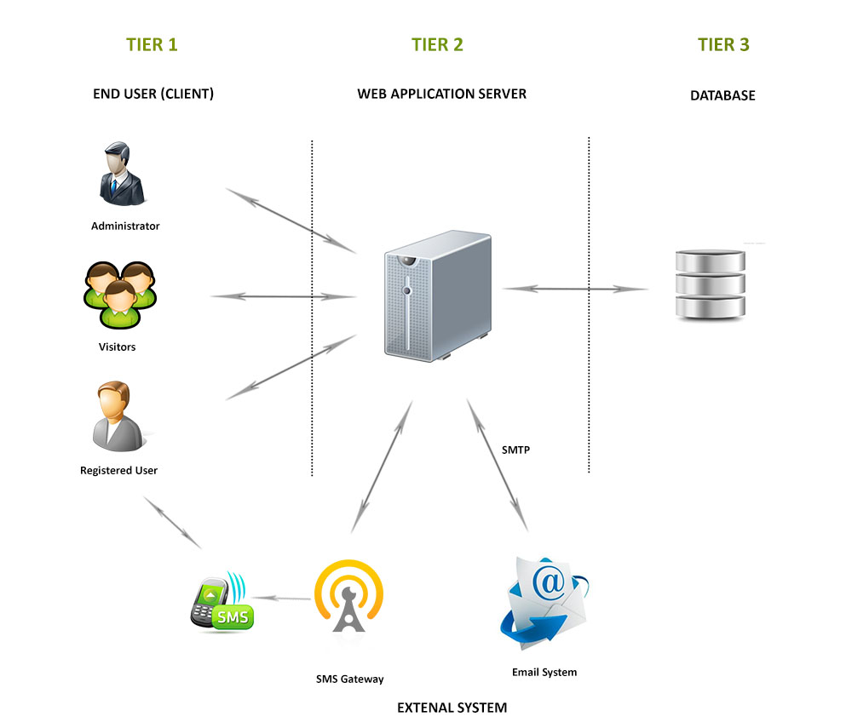

|  |  |
| --- | --- |
| User/Module/System | Description |
| End User | Users access the web application via Internet connection. |
| Web Application Server | Automatically intercepts any user request, coordinates application, makes logic decision and evaluation. |
| Database | Where information is stored and retrieved from. |
| SMS Gateway | Get data from Database and then interact with user through SMS and then send user’s feedback to system |
| Email System | Get data from Database and then send Email to users automatically |

### Web Application Architecture

The architecture for the RHF web application will be depicted as the following diagram:

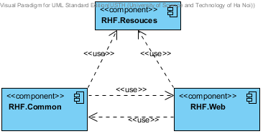

#### Common Component

This component contains common logic that can be used throughout the application. It includes for example mechanism for logging, caching, cryptography, and other utilities.

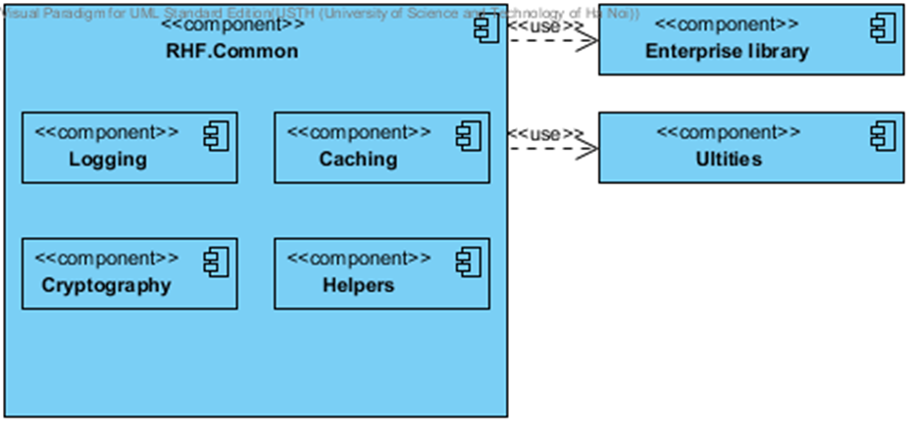

#### Resources Component

This component contains static resources for the system. It includes localized strings and messages.

#### Web Component

This component is responsible for delivering the front end to the users and accepting their inputs. This component also contains all business logic for the system. It includes ORM classes, business classes, data access layer, business interface…

It will be developed using ASP.NET MVC 3 framework. An MVC Application is designed and implemented using the following three attributes:

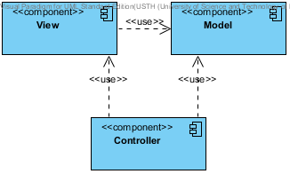

* **Model:** The model contains the core information for an application. This includes the data and validation rules as well as data access and aggregation logic.
* **View:** The view encapsulates the presentation of the application, and in ASP.NET this is typically the HTML markup.
* **Controller:** The controller contains the control-flow logic. It interacts with the Model and Views to control the flow of information and execution of the application.

The **RHF** application will make use another attribute: **View Model**. The view model encapsulates all the data properties that the view needs or provides. It is the view model that the view depends directly on, not the model. The model will be also implemented in this component.

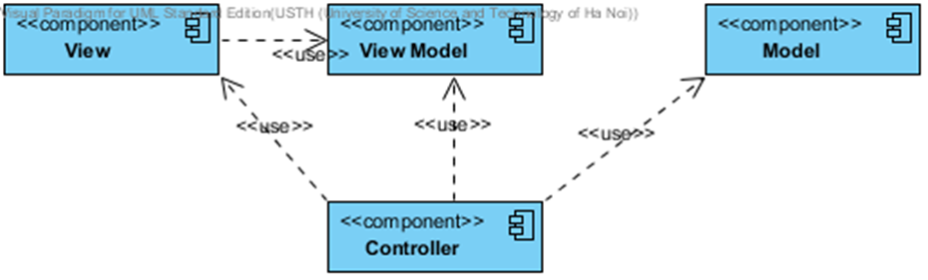

The overall architecture of RHF.Web component will be depicted as the following diagram:

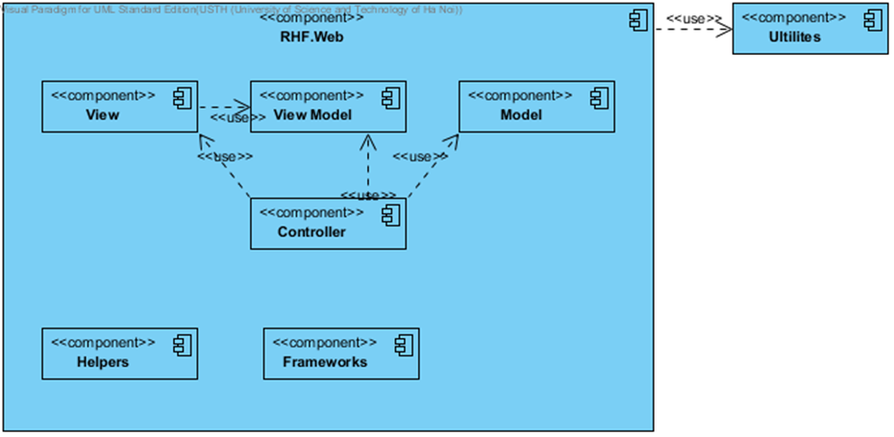

* **Helpers:** These are utilities classes specific for this component
* **Framework:** Contain the core framework to build web application

## Detailed Design

### Class Diagram

#### Post

This part is the detailed design for the following use cases:

* Add Post
* Edit Post
* Delete Post
* View detail of post
* Add post to favorite
* Delete post from favorite

##### Class Diagram

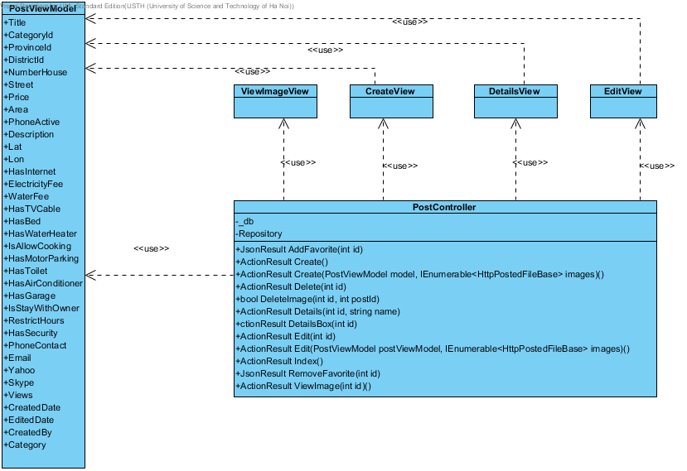

##### Class Explanations

###### PostController class

##### Attributes

|  |  |  |  |
| --- | --- | --- | --- |
| Attribute | Type | Visibility | Description |
| \_db | RentalHouseFindingEntities | Private |  |

##### Operations

###### ActionResult AddFavorite(int id)

Add post to favorite

**Parameters and Return**

|  |  |  |
| --- | --- | --- |
| Parameter | Type | Description |
| id | Int | Post’s Id |
|  | ActionResult | Return action result |

###### ActionResult Create()

Render Create post screen

**Parameters and Return**

|  |  |  |
| --- | --- | --- |
| Parameter | Type | Description |
|  | ActionResult | Return action result |

###### ActionResult Create(PostViewModel model, IEnumerable<HttpPostedFileBase> images)

Create a post

**Parameters and Return**

|  |  |  |
| --- | --- | --- |
| Parameter | Type | Description |
| model | PostViewModel | PostViewModel Object |
| Images | IEnumerable<HttpPostedFileBase> | Image File upload |
|  | ActionResult | Return action result |

###### ActionResult Delete(int id)

Delete a post

**Parameters and Return**

|  |  |  |
| --- | --- | --- |
| Parameter | Type | Description |
| id | Int | Post’s Id |
|  | ActionResult | Return action result |

###### ActionResult DeleteImage(int id, int postId)

Delete image of post

**Parameters and Return**

|  |  |  |
| --- | --- | --- |
| Parameter | Type | Description |
| id | Int | Image’s Id |
| postId | Int | Post’s Id |
|  | ActionResult | Return action result |

###### ActionResult Details(int id, string name)

Display details page

**Parameters and Return**

|  |  |  |
| --- | --- | --- |
| Parameter | Type | Description |
| id | Int | Post’s Id |
| name | string | Rewriting URL |
|  | ActionResult | Return action result |

###### ActionResult DetailsBox(int id)

Display details popup

**Parameters and Return**

|  |  |  |
| --- | --- | --- |
| Parameter | Type | Description |
| Id | Int | Post’s Id |
|  | ActionResult | Return action result |

###### ActionResult Edit(int id)

Render Edit post page

**Parameters and Return**

|  |  |  |
| --- | --- | --- |
| Parameter | Type | Description |
| Id | Int | Post’s Id |
|  | ActionResult | Return action result |

###### ActionResult Edit(int id, IEnumerable<HttpPostedFileBase> images)

Edit post page

**Parameters and Return**

|  |  |  |
| --- | --- | --- |
| Parameter | Type | Description |
| id | Int | Post’s Id |
| images | IEnumerable<HttpPostedFileBase> | Image’s Id |
|  | ActionResult | Return action result |

###### ActionResult RemoveFavorite(int id)

Delete favotite post

**Parameters and Return**

|  |  |  |
| --- | --- | --- |
| Parameter | Type | Description |
| id | Int | Post’s Id |
|  | ActionResult | Return action result |

###### DetailsView class

Contain HTML markup and .NET code to render View screen

###### CreateView class

Contain HTML markup and .NET code to render View screen

###### ViewImageView class

Contain HTML markup and .NET code to render View screen

###### EditView class

Contain HTML markup and .NET code to render View screen

###### PostViewModel class

Model type of CreateView, DetailsView and EditView

#### Search Post

This part is the detailed design for the following use cases:

* Search
* Advance Search

##### Class Diagram

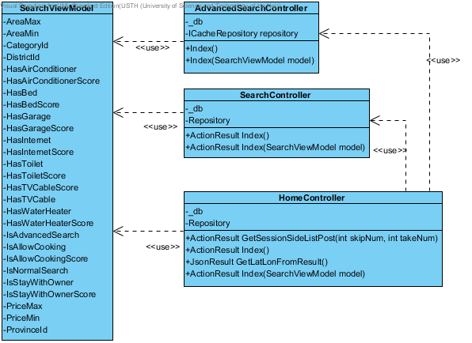

##### Class Explanations

###### SearchController Class

##### Attributes

|  |  |  |
| --- | --- | --- |
| Parameter | Type | Description |
| \_db | RentalHouseFindingEntities |  |
| Repository | ICacheRepository |  |

##### Operations

###### ActionResult Index()

Render Search page

**Parameters and Return**

|  |  |  |
| --- | --- | --- |
| Parameter | Type | Description |
|  | ActionResult | Return action result |

###### ActionResult Index(SearchViewModel model)

Search

**Parameters and Return**

|  |  |  |
| --- | --- | --- |
| Parameter | Type | Description |
| model | SearchViewModel | SearchViewModel Object |
|  | ActionResult | Return action result |

###### HomeController class

##### Attributes

|  |  |  |
| --- | --- | --- |
| Parameter | Type | Description |
| \_db | RentalHouseFindingEntities |  |
| Repository | ICacheRepository |  |

##### Operations

###### JsonResult GetLatLonFromResult()

Get Latitude and Longitude of Result.

**Parameters and Return**

|  |  |  |
| --- | --- | --- |
| Parameter | Type | Description |
|  | JsonResult | Return Json result |

###### ActionResult GetSectionSideListPost(int skipNum, int takeNum)

Get list post result

**Parameters and Return**

|  |  |  |
| --- | --- | --- |
| Parameter | Type | Description |
| skipNum | Int | Number skip post |
| takeNum | Int | Number take Posts result |
|  | ActionResult | Return action result |

###### ActionResult Index()

Display result page.

**Parameters and Return**

|  |  |  |
| --- | --- | --- |
| Parameter | Type | Description |
|  | ActionResult | Return action result |

###### ActionResult Index(SearchViewModel model)

Search

**Parameters and Return**

|  |  |  |
| --- | --- | --- |
| Parameter | Type | Description |
| model | SeachViewModel | SearchViewModel Object |
|  | ActionResult | Return action result |

#### LogOn\_Register\_LogOut

This part is the detailed design for the following use cases:

* Login
* Register
* Logout

##### Class Diagram

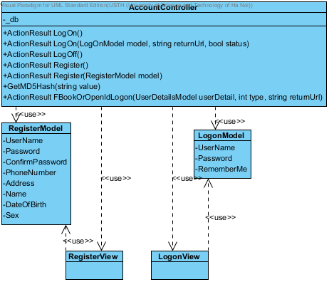

##### Class Explanations

###### AccountController Class

##### Attributes

|  |  |  |
| --- | --- | --- |
| Parameter | Type | Description |
| \_db | RentalHouseFindingEntities |  |

##### Operations

###### ActionResult LogOn()

Render Login page

**Parameters and Return**

|  |  |  |
| --- | --- | --- |
| Parameter | Type | Description |
|  | ActionResult | Return action result |

###### ActionResult LogOn(LogOnModel model, string returnUr)

Login.

**Parameters and Return**

|  |  |  |
| --- | --- | --- |
| Parameter | Type | Description |
| model | LogOnModel | LogOnModel Object |
| returnUrl | string | URL return after logon |
|  | ActionResult | Return action result |

###### ActionResult Register()

Render Register page

**Parameters and Return**

|  |  |  |
| --- | --- | --- |
| Parameter | Type | Description |
|  | ActionResult | Return action result |

###### ActionResult Register(RegisterModel model)

Register new account.

**Parameters and Return**

|  |  |  |
| --- | --- | --- |
| Parameter | Type | Description |
| model | RegisterModel | RegisterModel Object |
|  | ActionResult | Return action result |

###### ActionResult FaceBookOrOpendIdLogOn(UserDetailModel model, int type, string returnUrl)

Login by using Facebook or OpenId

**Parameters and Return**

|  |  |  |
| --- | --- | --- |
| Parameter | Type | Description |
| model | UserDetailModel | UserDetailModel Object |
| type | Int | Logging by Facebook or OpenId |
| returnUrl | string | URL return after login |
|  | ActionResult | Return action result |

###### ActionResult LogOff()

Log out.

**Parameters and Return**

|  |  |  |
| --- | --- | --- |
| Parameter | Type | Description |
|  | ActionResult | Return action result |

###### LogOnView class

Contain HTML markup and .NET code to render LogOn screen

###### RegisterView class

Contain HTML markup and .NET code to render Register screen

###### LogOnModel class

Model type of LogOnView

###### RegisterModel class

Model type of RegisterView

#### Change PassWord

This part is the detailed design for the following use cases:

* ChangePassword

##### Class Diagram

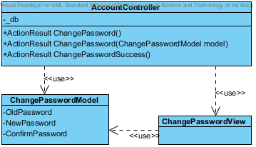

##### Class Explanations

###### AccountController Class

##### Attributes

|  |  |  |
| --- | --- | --- |
| Parameter | Type | Description |
| \_db | RentalHouseFindingEntities |  |

##### Operations

###### ActionResult ChangePassword()

Render change password page

**Parameters and Return**

|  |  |  |
| --- | --- | --- |
| Parameter | Type | Description |
|  | ActionResult | Return action result |

###### ActionResult ChangePassword(ChangePasswordModel model)

Change password

**Parameters and Return**

|  |  |  |
| --- | --- | --- |
| Parameter | Type | Description |
| model | ChangePasswordModel | ChangePasswordModel Object |
|  | ActionResult | Return action result |

###### ChangePasswordView class

Contain HTML markup and .NET code to render Change password screen

###### ChangePasswordViewModel class

Model type of ChangePasswordView

#### User Control Panel

This part is the detailed design for the following use cases:

* Manage post
* Manage payment
* Manage favorite
* View User Info
* Edit User Info

##### Class Diagram

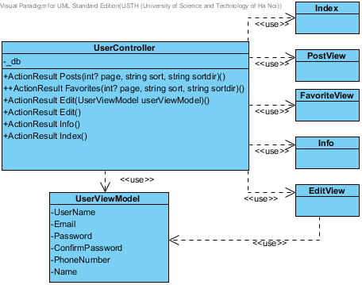

##### Class Explanations

###### UserController Class

##### Attributes

|  |  |  |
| --- | --- | --- |
| Parameter | Type | Description |
| \_db | RentalHouseFindingEntities |  |

##### Operations

###### ActionResult Edit()

Render Edit User Info page

**Parameters and Return**

|  |  |  |
| --- | --- | --- |
| Parameter | Type | Description |
|  | ActionResult | Return action result |

###### ActionResult Edit(UserViewModel userViewModel)

Edit User Info

**Parameters and Return**

|  |  |  |
| --- | --- | --- |
| Parameter | Type | Description |
| userViewModel | UserViewModel | UserViewMdel Object |
|  | ActionResult | Return action result |

###### ActionResult Posts(int? page, string sort, string sortdir)

Render User Manage Post

**Parameters and Return**

|  |  |  |
| --- | --- | --- |
| Parameter | Type | Description |
| page | Int? | Page of WebGridView |
| sort | string | Sort by field |
| sortdir | string | ASC or DESC |
|  | ActionResult | Return action result |

###### ActionResult Favorite(int? page, string sort, string sortdir)

Render User Manage Favorite

**Parameters and Return**

|  |  |  |
| --- | --- | --- |
| Parameter | Type | Description |
| page | Int? | Page of WebGridView |
| sort | string | Sort by field |
| sortdir | string | ASC or DESC |
|  | ActionResult | Return action result |

###### ActionResult Payments(int? page, string sort, string sortdir)

Render User Manage Post

**Parameters and Return**

|  |  |  |
| --- | --- | --- |
| Parameter | Type | Description |
| page | Int? | Page of WebGridView |
| sort | string | Sort by field |
| sortdir | string | ASC or DESC |
|  | ActionResult | Return action result |

###### ActionResult Index()

Render User Control Panel page

**Parameters and Return**

|  |  |  |
| --- | --- | --- |
| Parameter | Type | Description |
|  | ActionResult | Return action result |

###### ActionResult Info()

Render User Manage Post

**Parameters and Return**

|  |  |  |
| --- | --- | --- |
| Parameter | Type | Description |
|  | ActionResult | Return action result |

###### PostView class

Contain HTML markup and .NET code to render Post list screen

###### EditView class

Contain HTML markup and .NET code to render Edit User info screen

###### InfoView class

Contain HTML markup and .NET code to render Info screen

###### FavoriteView class

Contain HTML markup and .NET code to render Favorite List screen

###### InxdexView class

Contain HTML markup and .NET code to render User Control Panel screen

###### UserViewModel class

Model type of EditView and InfoView

#### Manage Categories

This part is the detailed design for the following use cases:

* View Categories list
* Create a new category
* Edit category
* Delete category

##### Class Diagram

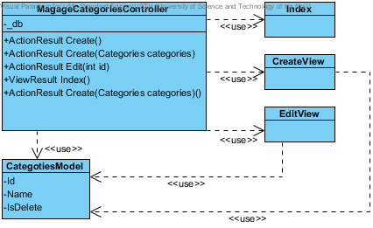

##### Class Explanations

###### ManageCategoriesController Class

##### Attributes

|  |  |  |
| --- | --- | --- |
| Parameter | Type | Description |
| \_db | RentalHouseFindingEntities |  |

##### Operations

###### ActionResult Create()

Render Create category page

**Parameters and Return**

|  |  |  |
| --- | --- | --- |
| Parameter | Type | Description |
|  | ActionResult | Return action result |

###### ActionResult Create(Categories categories)

Insert a new category

**Parameters and Return**

|  |  |  |
| --- | --- | --- |
| Parameter | Type | Description |
| categories | Categories | Categories Object |
|  | ActionResult | Return action result |

###### ActionResult Edit(Categories categories)

Edit category

**Parameters and Return**

|  |  |  |
| --- | --- | --- |
| Parameter | Type | Description |
| categories | Categories | Categories Object |
|  | ActionResult | Return action result |

###### ActionResult Edit()

Render Edit page

**Parameters and Return**

|  |  |  |
| --- | --- | --- |
| Parameter | Type | Description |
|  | ActionResult | Return action result |

###### IndexView class

Contain HTML markup and .NET code to render Manage Categories screen

###### CreateView class

Contain HTML markup and .NET code to render Insert a new Category screen

###### EditView class

Contain HTML markup and .NET code to render Edit Category screen

###### CategoryModel class

Model type of CreateView and EditView

#### Admin Manage Bad Post

This part is the detailed design for the following use cases:

* Manage bad post

##### Class Diagram

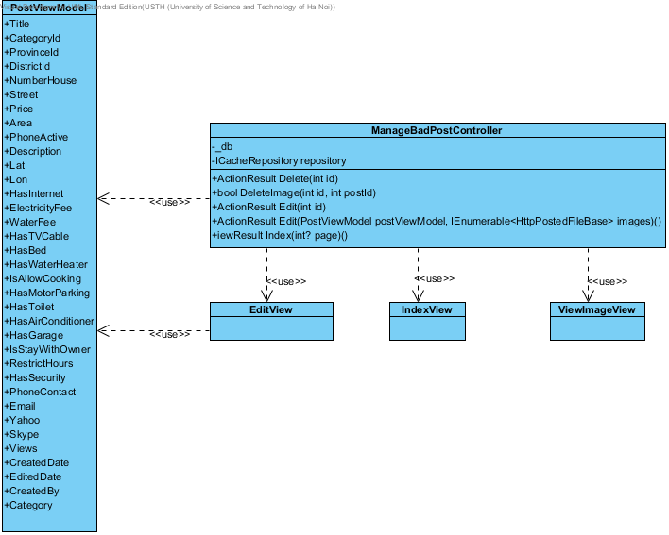

##### Class Explanations

###### ManageBadPostController Class

##### Attributes

|  |  |  |
| --- | --- | --- |
| Parameter | Type | Description |
| \_db | RentalHouseFindingEntities |  |

##### Operations

###### ActionResult Delete(int id)

Delete bad post

**Parameters and Return**

|  |  |  |
| --- | --- | --- |
| Parameter | Type | Description |
| id | Int | Id of bad post |
|  | ActionResult | Return action result |

###### ActionResult Edit(int id)

Get the reported details of place

**Parameters and Return**

|  |  |  |
| --- | --- | --- |
| Parameter | Type | Description |
| id | Int | Id of bad post |
|  | ActionResult | Return action result |

###### ActionResult Index(int? page)

Display list bad post

**Parameters and Return**

|  |  |  |
| --- | --- | --- |
| Parameter | Type | Description |
| page | Int? | Page number of GridView |
|  | ActionResult | Return action result |

###### ActionResult Edit(PostViewModel postViewModel, IEnumerable<HttpPostedFileBase> images)

Edit post and accept post

**Parameters and Return**

|  |  |  |
| --- | --- | --- |
| Parameter | Type | Description |
| postViewModel | PostViewModel | PostViewModel Object |
| images | IEnumerable<HttpPostedFileBase> | Image’s post |
|  | ActionResult | Return action result |

###### EditView class

Contain HTML markup and .NET code to render Edit bad post screen

###### Index

Contain HTML markup and .NET code to render List bad post screen

###### PostViewModel class

Model type of EditView

#### Admin Manage Bad Words

This part is the detailed design for the following use cases:

* Manage bad words
* Add bad word
* Edit bad word
* Delete bad word

##### Class Diagram

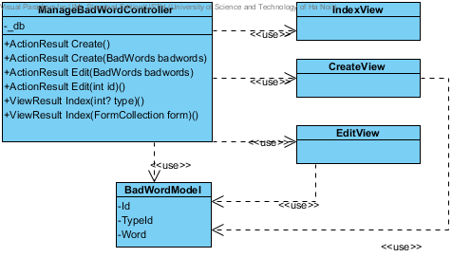

##### Class Explanations

###### ManageBadWordsController Class

##### Attributes

|  |  |  |
| --- | --- | --- |
| Parameter | Type | Description |
| \_db | RentalHouseFindingEntities |  |

##### Operations

###### ActionResult Create()

Render Create page

**Parameters and Return**

|  |  |  |
| --- | --- | --- |
| Parameter | Type | Description |
|  | ActionResult | Return action result |

###### ActionResult Create(BadWords badword)

Create new Bad Word

**Parameters and Return**

|  |  |  |
| --- | --- | --- |
| Parameter | Type | Description |
| badword | BadWords | BadWords Object |
|  | ActionResult | Return action result |

###### ActionResult Edit(int id)

Render Edit page

**Parameters and Return**

|  |  |  |
| --- | --- | --- |
| Parameter | Type | Description |
| id | Int | BadWord’s Id |
|  | ActionResult | Return action result |

###### ActionResult Edit(BadWords badword)

Edit bad word

**Parameters and Return**

|  |  |  |
| --- | --- | --- |
| Parameter | Type | Description |
| badword | BadWords | BadWords Object |
|  | ActionResult | Return action result |

###### ActionResult Index()

Display list bad words

**Parameters and Return**

|  |  |  |
| --- | --- | --- |
| Parameter | Type | Description |
|  | ActionResult | Return action result |

###### CreateView class

Contain HTML markup and .NET code to render Create new Bad word screen

###### EditView class

Contain HTML markup and .NET code to render Edit Bad word screen

###### Index class

Contain HTML markup and .NET code to render List Bad words screen

###### BadWordsModel class

Model type of CreateView and EditView

#### Admin Manage Bad Word Type

This part is the detailed design for the following use cases:

* Manage bad word type
* Add bad word type
* Edit bad word type
* Delete bad word type

##### Class Diagram

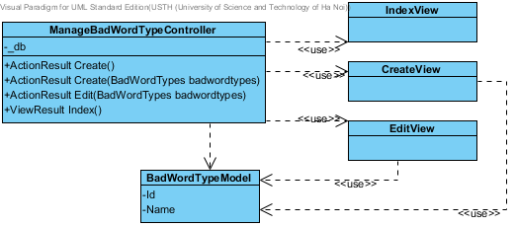

##### Class Explanations

###### ManageBadWordTypesController Class

##### Attributes

|  |  |  |
| --- | --- | --- |
| Parameter | Type | Description |
| \_db | RentalHouseFindingEntities |  |

##### Operations

###### ActionResult Create()

Render Create page

**Parameters and Return**

|  |  |  |
| --- | --- | --- |
| Parameter | Type | Description |
|  | ActionResult | Return action result |

###### ActionResult Create(BadWordTypes badwordType)

Create new Bad Word Type

**Parameters and Return**

|  |  |  |
| --- | --- | --- |
| Parameter | Type | Description |
| badwordType | BadWordTypes | BadWordTypes Object |
|  | ActionResult | Return action result |

###### ActionResult Edit(int id)

Render Edit page

**Parameters and Return**

|  |  |  |
| --- | --- | --- |
| Parameter | Type | Description |
| id | Int | BadWordType’s Id |
|  | ActionResult | Return action result |

###### ActionResult Edit(BadWordTypes badwordType)

Edit bad word type

**Parameters and Return**

|  |  |  |
| --- | --- | --- |
| Parameter | Type | Description |
| badwordType | BadWordTypes | BadWordTypes Object |
|  | ActionResult | Return action result |

###### ActionResult Index()

Display list bad words type

**Parameters and Return**

|  |  |  |
| --- | --- | --- |
| Parameter | Type | Description |
|  | ActionResult | Return action result |

###### CreateView class

Contain HTML markup and .NET code to render Create new Bad word type screen

###### EditView class

Contain HTML markup and .NET code to render Edit Bad word type screen

###### Index class

Contain HTML markup and .NET code to render List Bad words type screen

###### BadWordTypesModel class

Model type of CreateView and EditView

#### Admin Manage District

This part is the detailed design for the following use cases:

* Manage District
* Add District
* Edit District
* Delete District

##### Class Diagram

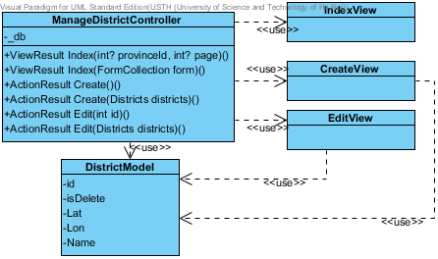

##### Class Explanations

###### ManageDistictController Class

##### Attributes

|  |  |  |
| --- | --- | --- |
| Parameter | Type | Description |
| \_db | RentalHouseFindingEntities |  |

##### Operations

###### ActionResult Create()

Render Create page

**Parameters and Return**

|  |  |  |
| --- | --- | --- |
| Parameter | Type | Description |
|  | ActionResult | Return action result |

###### ActionResult Create(Districts district)

Create new district

**Parameters and Return**

|  |  |  |
| --- | --- | --- |
| Parameter | Type | Description |
| district | Districts | Districts Object |
|  | ActionResult | Return action result |

###### ActionResult Edit(int id)

Render Edit page

**Parameters and Return**

|  |  |  |
| --- | --- | --- |
| Parameter | Type | Description |
| id | Int | District’s Id |
|  | ActionResult | Return action result |

###### ActionResult Edit(Districts district)

Edit District

**Parameters and Return**

|  |  |  |
| --- | --- | --- |
| Parameter | Type | Description |
| district | Districts | Districts Object |
|  | ActionResult | Return action result |

###### ActionResult Index()

Display list districts

**Parameters and Return**

|  |  |  |
| --- | --- | --- |
| Parameter | Type | Description |
|  | ActionResult | Return action result |

###### CreateView class

Contain HTML markup and .NET code to render Create new District screen

###### EditView class

Contain HTML markup and .NET code to render Edit District screen

###### Index class

Contain HTML markup and .NET code to render List Districts screen

###### DistrictsModel class

Model type of CreateView and EditView

#### Admin Manage Post Status

This part is the detailed design for the following use cases:

* Manage Post Status
* Add Status
* Edit Status
* Delete Status

##### Class Diagram

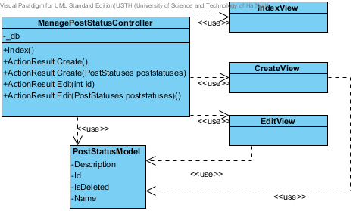

##### Class Explanations

###### ManagePostStatusController Class

##### Attributes

|  |  |  |
| --- | --- | --- |
| Parameter | Type | Description |
| \_db | RentalHouseFindingEntities |  |

##### Operations

###### ActionResult Create()

Render Create page

**Parameters and Return**

|  |  |  |
| --- | --- | --- |
| Parameter | Type | Description |
|  | ActionResult | Return action result |

###### ActionResult Create(PostStatuses status)

Create new status

**Parameters and Return**

|  |  |  |
| --- | --- | --- |
| Parameter | Type | Description |
| status | PostStatuses | PostStatuses Object |
|  | ActionResult | Return action result |

###### ActionResult Edit(int id)

Render Edit page

**Parameters and Return**

|  |  |  |
| --- | --- | --- |
| Parameter | Type | Description |
| id | Int | PostStatus Object |
|  | ActionResult | Return action result |

###### ActionResult Edit(PostStatuses status)

Edit status

**Parameters and Return**

|  |  |  |
| --- | --- | --- |
| Parameter | Type | Description |
| status | PostStatuses | PostStatuses Object |
|  | ActionResult | Return action result |

###### ActionResult Index()

Display list status

**Parameters and Return**

|  |  |  |
| --- | --- | --- |
| Parameter | Type | Description |
|  | ActionResult | Return action result |

###### CreateView class

Contain HTML markup and .NET code to render Create new status screen

###### EditView class

Contain HTML markup and .NET code to render Edit status screen

###### Index class

Contain HTML markup and .NET code to render List status screen

###### PostStatusesModel class

Model type of CreateView and EditView

#### Admin Manage Provinces

This part is the detailed design for the following use cases:

* Manage Provinces
* Add Province
* Edit Province
* Delete Province

##### Class Diagram

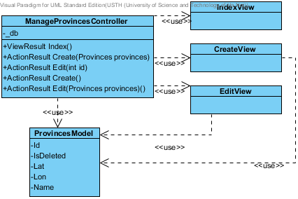

##### Class Explanations

###### ManageProvincesController Class

##### Attributes

|  |  |  |
| --- | --- | --- |
| Parameter | Type | Description |
| \_db | RentalHouseFindingEntities |  |

##### Operations

###### ActionResult Create()

Render Create page

**Parameters and Return**

|  |  |  |
| --- | --- | --- |
| Parameter | Type | Description |
|  | ActionResult | Return action result |

###### ActionResult Create(Provinces province)

Create new province

**Parameters and Return**

|  |  |  |
| --- | --- | --- |
| Parameter | Type | Description |
| province | Provinces | Provinces Object |
|  | ActionResult | Return action result |

###### ActionResult Edit(int id)

Render Edit province page

**Parameters and Return**

|  |  |  |
| --- | --- | --- |
| Parameter | Type | Description |
| id | Int | Province’s id |
|  | ActionResult | Return action result |

###### ActionResult Edit(Provinces province)

Edit province

**Parameters and Return**

|  |  |  |
| --- | --- | --- |
| Parameter | Type | Description |
| province | Provinces | Provinces Object |
|  | ActionResult | Return action result |

###### ActionResult Index()

Display list province

**Parameters and Return**

|  |  |  |
| --- | --- | --- |
| Parameter | Type | Description |
|  | ActionResult | Return action result |

###### CreateView class

Contain HTML markup and .NET code to render Create new province screen

###### EditView class

Contain HTML markup and .NET code to render Edit province screen

###### Index class

Contain HTML markup and .NET code to render List province screen

###### ProvincesModel class

Model type of CreateView and EditView

#### Admin Manage Roles

This part is the detailed design for the following use cases:

* Manage Roles
* Add role
* Edit role
* Delete role

##### Class Diagram

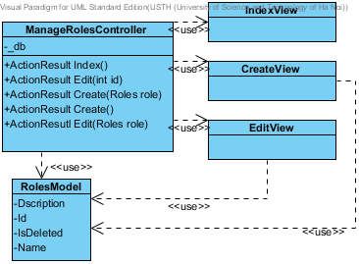

##### Class Explanations

###### ManageRolesController Class

##### Attributes

|  |  |  |
| --- | --- | --- |
| Parameter | Type | Description |
| \_db | RentalHouseFindingEntities |  |

##### Operations

###### ActionResult Create()

Render Create page

**Parameters and Return**

|  |  |  |
| --- | --- | --- |
| Parameter | Type | Description |
|  | ActionResult | Return action result |

###### ActionResult Create(Roles role)

Create new role

**Parameters and Return**

|  |  |  |
| --- | --- | --- |
| Parameter | Type | Description |
| role | Roles | Roles Object |
|  | ActionResult | Return action result |

###### ActionResult Edit(int id)

Render Edit page

**Parameters and Return**

|  |  |  |
| --- | --- | --- |
| Parameter | Type | Description |
| id | Int | Role’s id |
|  | ActionResult | Return action result |

###### ActionResult Edit(Roles role)

Edit role

**Parameters and Return**

|  |  |  |
| --- | --- | --- |
| Parameter | Type | Description |
| role | Roles | Roles Object |
|  | ActionResult | Return action result |

###### ActionResult Index()

Display list role

**Parameters and Return**

|  |  |  |
| --- | --- | --- |
| Parameter | Type | Description |
|  | ActionResult | Return action result |

###### CreateView class

Contain HTML markup and .NET code to render Create new role screen

###### EditView class

Contain HTML markup and .NET code to render Edit role screen

###### Index class

Contain HTML markup and .NET code to render List role screen

###### RolesModel class

Model type of CreateView and EditView

#### Admin Manage Payments

This part is the detailed design for the following use cases:

* Manage Payment

##### Class Diagram

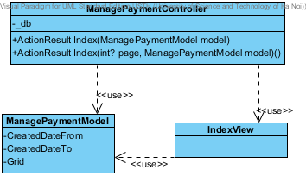

##### Class Explanations

###### ManagePaymentController Class

##### Attributes

|  |  |  |
| --- | --- | --- |
| Parameter | Type | Description |
| \_db | RentalHouseFindingEntities |  |

##### Operations

###### ActionResult Index(int? page, string sort, string sortdir, ManagePaymentModel model)

Display list payment

**Parameters and Return**

|  |  |  |
| --- | --- | --- |
| Parameter | Type | Description |
| page | Int? | Page number of grid view |
| sort | string | Sort by field |
| sortdir | string | ASC or DESC |
| model | ManagePaymentModel | ManagePaymentModel Object |
|  | ActionResult | Return action result |

###### Index class

Contain HTML markup and .NET code to render List payment screen

###### ManagePaymenModel class

Model type of IndexView

#### Admin Manage Report Post

This part is the detailed design for the following use cases:

* Manage Report Post

##### Class Diagram

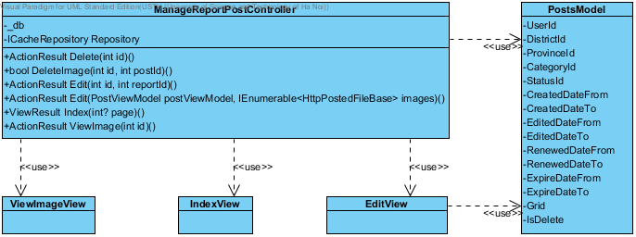

##### Class Explanations

###### ManageReportPostController Class

##### Attributes

|  |  |  |
| --- | --- | --- |
| Parameter | Type | Description |
| \_db | RentalHouseFindingEntities |  |

##### Operations

###### ActionResult Delete(int id)

Delete post

**Parameters and Return**

|  |  |  |
| --- | --- | --- |
| Parameter | Type | Description |
| id | Int | Post’s Id |
|  | ActionResult | Return action result |

###### ActionResult DeleteImage(int id, int postId)

Create new status

**Parameters and Return**

|  |  |  |
| --- | --- | --- |
| Parameter | Type | Description |
| id | Int | Image’s id |
| postId | Int | Post’s id |
|  | ActionResult | Return action result |

###### ActionResult Edit(int id, int repostId)

Render Edit page

**Parameters and Return**

|  |  |  |
| --- | --- | --- |
| Parameter | Type | Description |
| id | Int | Post’s id |
| repostId | Int | Id of reposted post |
|  | ActionResult | Return action result |

###### ActionResult Edit(PostViewModel postViewModel, IEnumerable<HttpPostedFileBase> images)

Edit Post

**Parameters and Return**

|  |  |  |
| --- | --- | --- |
| Parameter | Type | Description |
| postViewModel | PostViewModel | PostViewModel Object |
| images | IEnumerable<HttpPostedFileBase> | ManagePaymentModel Object |
|  | ActionResult | Return action result |

###### ActionResult Index()

Display list reported post

**Parameters and Return**

|  |  |  |
| --- | --- | --- |
| Parameter | Type | Description |
|  | ActionResult | Return action result |

###### ViewImageView class

Contain HTML markup and .NET code to render view image screen

###### EditView class

Contain HTML markup and .NET code to render Edit post screen

###### Index class

Contain HTML markup and .NET code to render List status screen

###### PostsModel class

Model type of EditView

### Sequence Diagram

#### Search

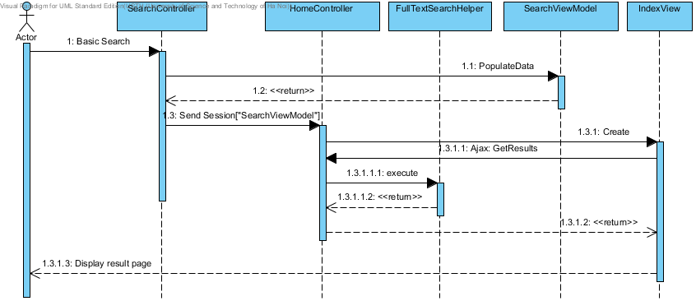

#### Advanced Search

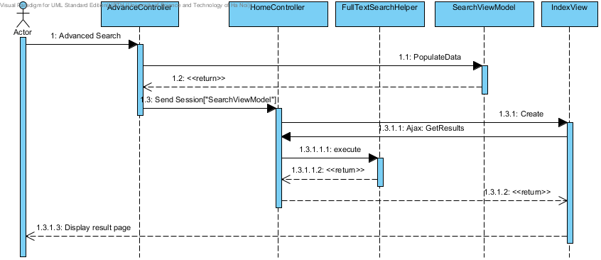

#### Delete Post

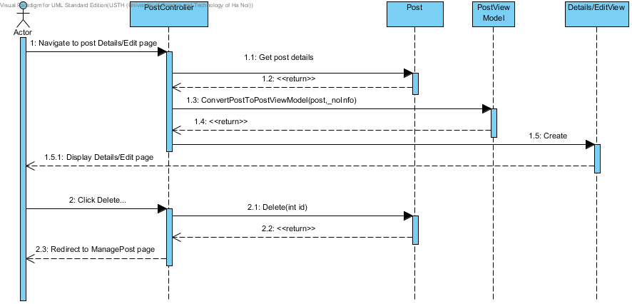

#### View Post

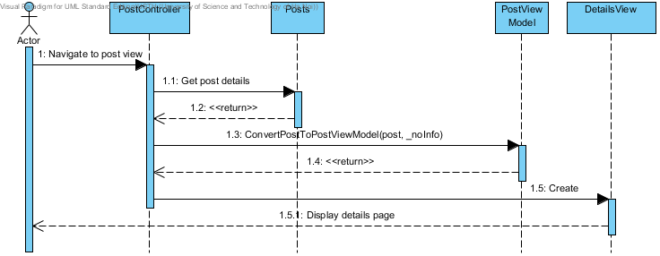

#### Create Post

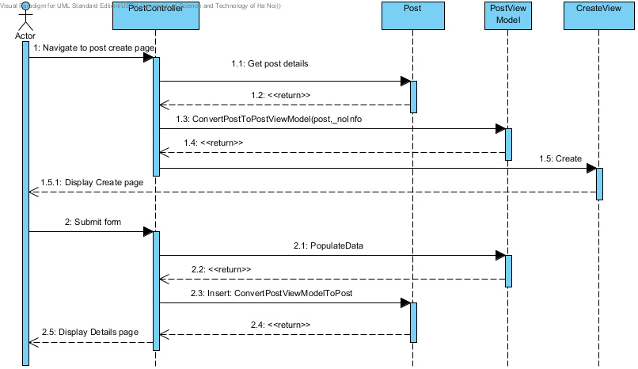

#### Edit Post

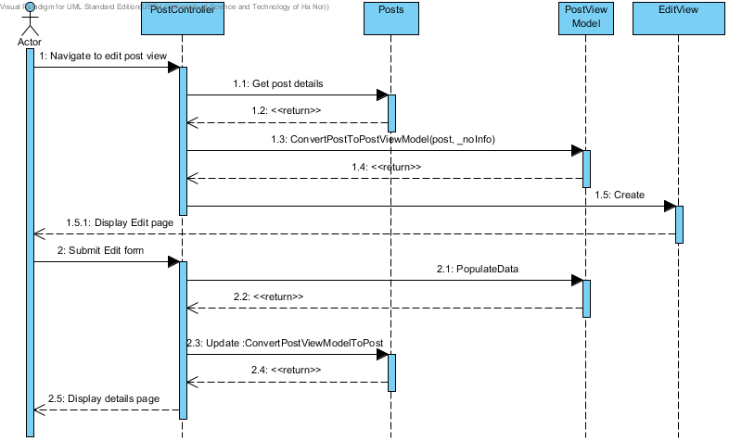

#### Register

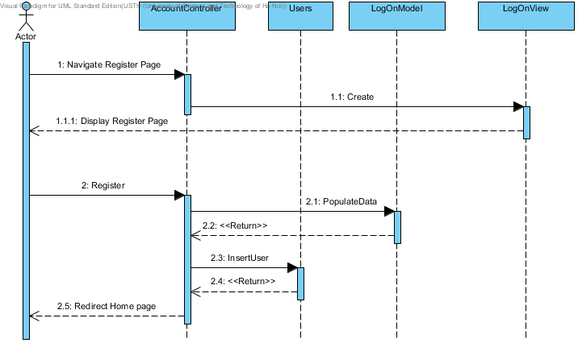

#### Login

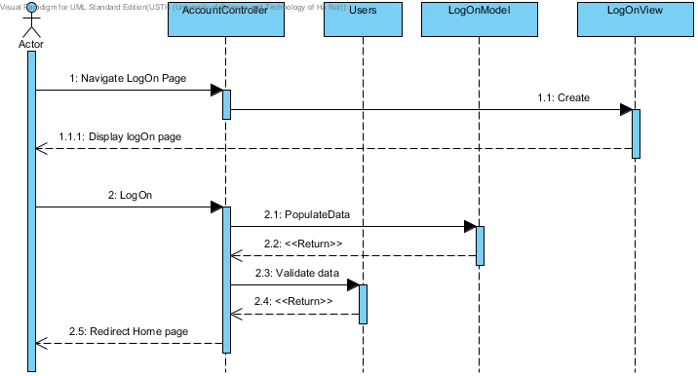

#### View User Profile

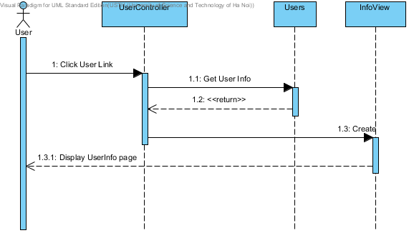

#### Edit User Profile

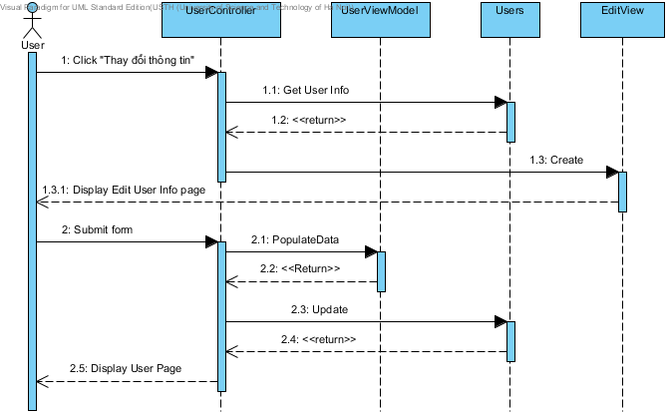

#### Manage Post

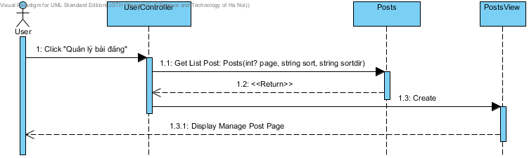

#### Manage Favorites

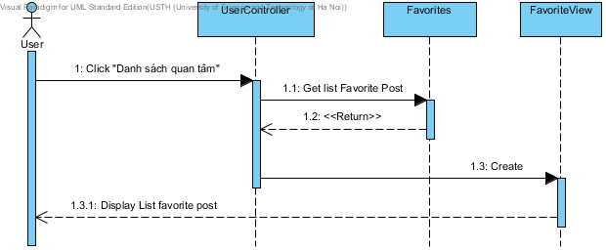

#### Add Post to Favorite

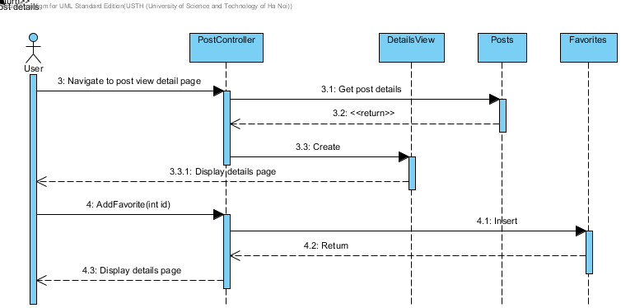

#### Remove Post from Favorite

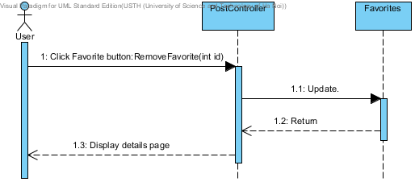

#### Add new Categories

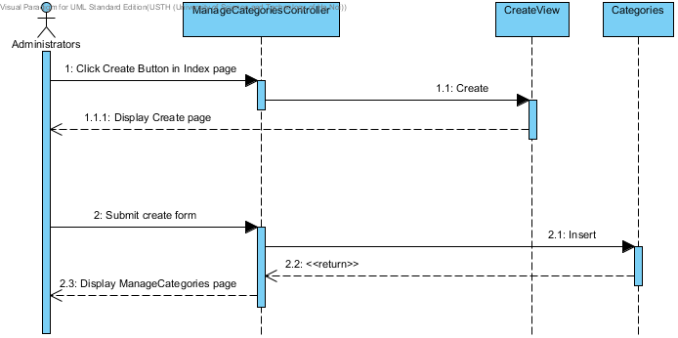

## Database Design

### ERDs

Refer to attached ERD design

### Tables

|  |  |
| --- | --- |
| Table Name | Description |
| AdvanceSearchScore | Store all score for advance search |
| Answer | Stores all answer |
| Badwords | Stores all badwords |
| BadWordTypes | Stores types of badwords |
| Categories | Store all categories |
| ConfigurationRHFs | Stores all configurations setting |
| Contacts | Stores all contacts information of post |
| Districts | Stores all districts |
| EmailTemplates | Stores all email templates |
| Facilities | Stores facilities information of post |
| FacilityTemplates | Store facilities template for advanced search algorithm |
| Favorites | Store all favorites |
| Locations | Stores locations for nearby place |
| Payments | Stores all payments information |
| PostImages | Store images of a post |
| PostLocations | Store relationship of post and location |
| Posts | Store information of post |
| PostStatus | Store status of post |
| Provinces | Store information of province |
| Questions | Store information of questions |
| ReportedPosts | Store information of reported post |
| Roles | Store roles of user |
| UserLogs | Store user log for messaging |
| Users | Store information of user |

### AdvanceSearchScore

|  |  |  |  |  |  |  |
| --- | --- | --- | --- | --- | --- | --- |
| Column Name | Type | Null | Unique | P/F Key | Default | Description |
| Id | int |  |  | PK |  | Id of AdvanceSearchScore |
| Name | nvarchar(MAX) |  |  |  |  | Name of Score |
| Score | int |  |  |  |  | Score of Title |

### Answer

|  |  |  |  |  |  |  |
| --- | --- | --- | --- | --- | --- | --- |
| Column Name | Type | Null | Unique | P/F Key | Default | Description |
| Id | int |  |  | PK |  | Id of Answer |
| Content | nvarchar(MAX) |  |  |  |  | Content of Answer |
| CreatedDate | datetime |  |  |  |  | Created date |
| IsDeleted | bit |  |  |  |  | Is deleted |
| QuestionId | int |  |  | FK |  | Id of questions  FK to Questions.Id |
| IsRead | bit |  |  |  | False | Is receiver read this answer |

### Badwords

|  |  |  |  |  |  |  |
| --- | --- | --- | --- | --- | --- | --- |
| Column Name | Type | Null | Unique | P/F Key | Default | Description |
| Id | int |  |  | PK |  | Id of badwords |
| Word | nvarchar(100) |  |  |  |  | Content of word |
| TypeId | int |  |  | FK |  | Id of badwordtype  FK to BadWordTypes.Id |

### BadWordTypes

|  |  |  |  |  |  |  |
| --- | --- | --- | --- | --- | --- | --- |
| Column Name | Type | Null | Unique | P/F Key | Default | Description |
| Id | int |  |  | PK |  | Id of bad words type |
| Name | nvarchar(50) |  |  |  |  | Name of bad word types |

### Categories

|  |  |  |  |  |  |  |
| --- | --- | --- | --- | --- | --- | --- |
| Column Name | Type | Null | Unique | P/F Key | Default | Description |
| Id | int |  |  | PK |  | Id of category |
| Name | nvarchar(50) |  |  |  |  | Name of category |
| Description | nvarchar(MAX) | x |  |  |  | Description of category |
| IsDeleted | bit |  |  |  | False | Is it deleted |

### ConfigurationRHFs

|  |  |  |  |  |  |  |
| --- | --- | --- | --- | --- | --- | --- |
| Column Name | Type | Null | Unique | P/F Key | Default | Description |
| Id | int |  |  | PK |  | Id of configuration |
| Name | nvarchar(100) |  |  |  |  | Name of configuration |
| Value | nvarchar(100) |  |  |  |  | Value of configuration |

### Contacts

|  |  |  |  |  |  |  |
| --- | --- | --- | --- | --- | --- | --- |
| Column Name | Type | Null | Unique | P/F Key | Default | Description |
| Phone | nvarchar(20) |  |  |  |  | Phone to contact |
| Email | nvarchar(100) | x |  |  |  | Email to contact |
| Yahoo | nvarchar(50) | x |  |  |  | Yahoo to contact |
| Skype | nvarchar(50) | x |  |  |  | Skype to contact |
| PostIdContacts | int |  |  | PK |  | ID of Posts.Id |
| NameContact | nvarchar(50) |  |  |  |  | Name to contact |

### Districts

|  |  |  |  |  |  |  |
| --- | --- | --- | --- | --- | --- | --- |
| Column Name | Type | Null | Unique | P/F Key | Default | Description |
| Id | int |  |  | PK |  | Id of district |
| Name | nvarchar(MAX) |  |  |  |  | Name of district |
| Lat | float |  |  |  |  | Latitude of district |
| Lon | float |  |  |  |  | Longitude of district |
| ProvinceId | int |  |  | FK |  | Id of province  FK to Provinces.Id |
| IsDeleted | bit |  |  |  | False | Is it deleted |

### EmailTemplates

|  |  |  |  |  |  |  |
| --- | --- | --- | --- | --- | --- | --- |
| Column Name | Type | Null | Unique | P/F Key | Default | Description |
| Id | int |  |  | PK |  | Id of EmailTemplate |
| Name | nvarchar(MAX) |  |  |  |  | Name of template |
| Template | nvarchar(MAX) |  |  |  |  | Template of email |

### Facilities

|  |  |  |  |  |  |  |
| --- | --- | --- | --- | --- | --- | --- |
| Column Name | Type | Null | Unique | P/F Key | Default | Description |
| HasInternet | bit |  |  |  |  | Has internet |
| ElectricityFee | float |  |  |  |  | Fee of electricity |
| WaterFee | float |  |  |  |  | Fee of water |
| HasTVCable | bit |  |  |  |  | Has TV cable |
| HasBed | bit |  |  |  |  | Has bed |
| HasWaterHeater | bit |  |  |  |  | Has water heater |
| IsAllowCooking | bit |  |  |  |  | Allow cooking or not |
| HasMotorParkingLot | bit |  |  |  |  | Has motor parking lot |
| HasToilet | bit |  |  |  |  | Has toilet |
| HasAirConditioner | bit |  |  |  |  | Has Airconditioner |
| HasGarage | bit |  |  |  |  | Has Garage |
| IsStayWithOwner | bit |  |  |  |  | Stay with owner or not |
| RestrictHours | nvarchar(50) | x |  |  |  | Restrict hours |
| HasSecurity | bit |  |  |  |  | Has security |
| PostIdFacilities | int |  |  | PK |  | Id of post |
| FacilityTemplateId | int |  |  | FK |  | Id of facility template  FK to FacilityTemplates.Id |

### FacilityTemplates

|  |  |  |  |  |  |  |
| --- | --- | --- | --- | --- | --- | --- |
| Column Name | Type | Null | Unique | P/F Key | Default | Description |
| Id | int |  |  | PK |  | Id of facility templates |
| HasAirConditioner | bit |  |  |  |  | For advance search algorithm |
| HasBed | bit |  |  |  |  | For advance search algorithm |
| HasGarage | bit |  |  |  |  | For advance search algorithm |
| HasInternet | bit |  |  |  |  | For advance search algorithm |
| HasMotorParking | bit |  |  |  |  | For advance search algorithm |
| HasSecurity | bit |  |  |  |  | For advance search algorithm |
| HasToilet | bit |  |  |  |  | For advance search algorithm |
| HasTVCable | bit |  |  |  |  | For advance search algorithm |
| HasWaterHeater | bit |  |  |  |  | For advance search algorithm |
| IsAllowCooking | bit |  |  |  |  | For advance search algorithm |
| IsStayWithOwner | bit |  |  |  |  | For advance search algorithm |

### Favorites

|  |  |  |  |  |  |  |
| --- | --- | --- | --- | --- | --- | --- |
| Column Name | Type | Null | Unique | P/F Key | Default | Description |
| Id | int |  |  | PK |  | Id of favorites |
| UserId | int |  |  | FK |  | User who own favorite  FK to Users.Id |
| PostId | int |  |  | FK |  | Post of favorites  FK to Posts.Id |
| AddedDate | datetime |  |  |  |  | Day created |
| IsDeleted | bit |  |  |  | False | Is it deleted |

### Locations

|  |  |  |  |  |  |  |
| --- | --- | --- | --- | --- | --- | --- |
| Column Name | Type | Null | Unique | P/F Key | Default | Description |
| Id | int |  |  | PK |  | Id of locations |
| Name | nvarchar(MAX) |  |  |  |  | Name of locations |
| DistrictId | int |  |  | FK |  | District id of location  FK to Districts.Id |
| IsCreatedByUser | bit |  |  |  |  | Is created by user |

### Payments

|  |  |  |  |  |  |  |
| --- | --- | --- | --- | --- | --- | --- |
| Column Name | Type | Null | Unique | P/F Key | Default | Description |
| Id | int |  |  | PK |  | Id of payments |
| PhoneNumber | nvarchar(20) |  |  |  |  | Phone number pay |
| CreatedDate | datetime |  |  |  |  | Created date |
| PostsId | int |  |  | FK |  | Post id to pay  FK to Posts.Id |

### Postimages

|  |  |  |  |  |  |  |
| --- | --- | --- | --- | --- | --- | --- |
| Column Name | Type | Null | Unique | P/F Key | Default | Description |
| Id | int |  |  | PK |  | Id of post image |
| PostId | int |  |  | FK |  | Post id of images  FK to Posts.Id |
| Path | nvarchar(MAX) |  |  |  |  | Path of images |
| IsDeleted | bit |  |  |  | False | Is it deleted |

### PostLocations

|  |  |  |  |  |  |  |
| --- | --- | --- | --- | --- | --- | --- |
| Column Name | Type | Null | Unique | P/F Key | Default | Description |
| Id | int |  |  | PK |  | Id of postlocation |
| PostId | int |  |  | FK |  | Id of Post  FK to Posts.Id |
| LocationId | int |  |  | FK |  | Id of Location  FK to Locations.Id |

### Posts

|  |  |  |  |  |  |  |
| --- | --- | --- | --- | --- | --- | --- |
| Column Name | Type | Null | Unique | P/F Key | Default | Description |
| Id | int |  |  | PK |  | Id of Post |
| Title | nvarchar(MAX) |  |  |  |  | Title of post |
| CategoryId | int |  |  | FK |  | Category id of post  FK to Categories.Id |
| StatusId | int |  |  | FK |  | Status id of post  FK to PostStatus.Id |
| IsDeleted | bit |  |  |  | False | Is it deleted |
| CreatedDate | datetime |  |  |  |  | Created date |
| EditedDate | datetime | x |  |  |  | Edited date |
| RenewDate | datetime | x |  |  |  | Renew data ( latest date when user renew the post ) |
| DistrictId | int |  |  | FK |  | District Id of post  FK to Districts.Id |
| NumberAddress | nvarchar(MAX) |  |  |  |  | Detail address |
| Price | float |  |  |  |  | Price |
| Area | float |  |  |  |  | Area |
| PhoneActive | nvarchar(20) |  |  |  |  | Phone number use to active |
| Description | nvarchar(MAX) | x |  |  |  | Description of post |
| Lat | float |  |  |  |  | Latitude of post |
| Lon | float |  |  |  |  | Longitude of post |
| UserId | int | x |  | FK |  | User id who create post  FK to Users.Id |
| Street | nvarchar(50) |  |  |  |  | Street name of post |
| NearbyPlace | nvarchar(MAX) | x |  |  |  | List of nearby place |
| ExpiredDate | datetime |  |  |  |  | Expired date |
| Code | nvarchar(MAX) |  |  |  |  | Code use for pay or edit post |

### PostStatus

|  |  |  |  |  |  |  |
| --- | --- | --- | --- | --- | --- | --- |
| Column Name | Type | Null | Unique | P/F Key | Default | Description |
| Id | int |  |  | PK |  | Id of post status |
| Name | nvarchar(MAX) | x |  |  |  | Name of post status |
| Description | nvarchar(MAX) | x |  |  |  | Description of post status |
| IsDeleted | bit |  |  |  | False | Is deleted |

### Provinces

|  |  |  |  |  |  |  |
| --- | --- | --- | --- | --- | --- | --- |
| Column Name | Type | Null | Unique | P/F Key | Default | Description |
| Id | int |  |  | PK |  | Id of province |
| Name | nvarchar(MAX) |  |  |  |  | Name of province |
| Lat | float |  |  |  |  | Latitude of province |
| Lon | float |  |  |  |  | Longitude of province |
| IsDeleted | bit |  |  |  | False | Is deleted |

### Questions

|  |  |  |  |  |  |  |
| --- | --- | --- | --- | --- | --- | --- |
| Column Name | Type | Null | Unique | P/F Key | Default | Description |
| Id | int |  |  | PK |  | Id of question |
| Content | nvarchar(MAX) |  |  |  |  | Content of question |
| SenderId | int | x |  | FK |  | Id of sender  FK to User.Id |
| CreatedDate | datetime |  |  |  |  | Created date |
| IsRead | bit |  |  |  |  | Is receiver read |
| IsDeleted | bit |  |  |  |  | Is deleted |
| PostId | int |  |  | FK |  | Post id of questions  FK to Posts.Id |
| Title | nvarchar(MAX) |  |  |  |  | Title of question |
| SenderEmail | nvarchar(50) |  |  |  |  | Email of sender ( in case not a user) |

### ReportedPosts

|  |  |  |  |  |  |  |
| --- | --- | --- | --- | --- | --- | --- |
| Column Name | Type | Null | Unique | P/F Key | Default | Description |
| Id | int |  |  | PK |  | Id of reported posts |
| PostId | int |  |  | FK |  | Post id of report  FK to Posts.Id |
| ReportedBy | int |  |  | FK |  | Reported by which user  FK to Users.Id |
| ReportedDate | datetime |  |  |  |  | Date when report submitted |
| Reason | nvarchar(MAX) |  |  |  |  | Reason to report |
| IsIgnored | bit |  |  |  | False | Admin approved or not |

### Roles

|  |  |  |  |  |  |  |
| --- | --- | --- | --- | --- | --- | --- |
| Column Name | Type | Null | Unique | P/F Key | Default | Description |
| Id | int |  |  | PK |  | Id of role |
| Name | nvarchar(20) |  |  |  |  | Name of role |
| Description | nvarchar(MAX) | x |  |  |  | Description of role |
| IsDeleted | bit |  |  |  |  | Is it deleted |

### UserLogs

|  |  |  |  |  |  |  |
| --- | --- | --- | --- | --- | --- | --- |
| Column Name | Type | Null | Unique | P/F Key | Default | Description |
| Id | int |  |  | PK |  | Id of userlogs |
| Message | nvarchar(MAX) |  |  |  |  | Content of message user log |
| UserId | int |  |  | FK |  | User id  FK to Users.Id |
| IsRead | bit |  |  |  |  | Is read by user |
| CreatedDate | datetime |  |  |  |  | Created date |

### Users

|  |  |  |  |  |  |  |
| --- | --- | --- | --- | --- | --- | --- |
| Column Name | Type | Null | Unique | P/F Key | Default | Description |
| Id | int |  |  | PK |  | Id of User |
| Username | nvarchar(50) |  |  |  |  | Username |
| Password | nvarchar(MAX) | x |  |  |  | Password |
| Email | nvarchar(50) | x |  |  |  | Email of user |
| PhoneNumber | nvarchar(15) | x |  |  |  | Phone number |
| Name | nvarchar(MAX) | x |  |  |  | Real name |
| CreatedDate | datetime |  |  |  |  | Created date |
| LastUpdate | datetime |  |  |  |  | Last update |
| IsDeleted | bit |  |  |  | False | Is deleted |
| OpenIdURL | nvarchar(MAX) | x |  |  |  | Open id URL |
| RoleId | int |  |  | FK |  | Role of user  FK to Roles.Id |

# Software Testing Description

## Introduction

### System Overview

This document describes the approach and methodologies used by the testing group to plan, organize and manage the testing of this system. It describes implementation details of test cases or technical details of how the product features should work.

The system will be tested is also the system our team are currently developing. This system is developed based on MVC3 framework. It is a website using for finding house of internet users. The system has similarities with other social network.

### Test Approach

The testing for this project will consist of Unit, System/Integration (combined) and Acceptance test levels. It is hoped that there will be at least one full time independent test person for system/integration testing. Most testing will be done by the test manager with the development team’s participation.

Unit Testing will be done by the developers and will be approved by the implementing team leader. All unit test information (sample, output, data printouts, and defect information…) will be managed by developers and it must be showed when team required.

System/Integration Testing will be performed by the test manager and implementing team leader with assistance from the individual developers as required.

Acceptance Testing will be performed by the test manager and development team leader. The acceptance test will be done for a period of 2 weeks after completion of the System/Integration test process. Programs will enter into Acceptance test after all critical and major defects have been corrected. A program may have one major defect as long as it does not obstruct testing of the program (There is a work around for the error). Prior to final completion of acceptance testing all open critical and major defects must be corrected.

## Test Plan

### Features to be tested

#### Login

Test a certain number of cases when User or Admin log into system.

#### View detail of post

Test a certain number of cases when User wants to view post detail.

#### Search post

Test a certain number of cases when User use normal search and advanced search post.

#### Compare posts

Test a certain number of cases when User wants to compare two posts together.

#### Create new post

Test a certain number of cases when User or Admin wants to create new/share post.

#### Edit posts

Test a certain number of cases when User wants to edit own post.

#### Renew posts

Test a certain number of cases when User wants to refresh own post.

#### Delete posts

Test a certain number of cases when User wants to delete own post.

#### Add post to favorite list

Test a certain number of cases when User adds post to favorite list.

#### Report post

Test a certain number of cases when User report post.

#### Manage User’s Profile

Test a certain number of cases when User wants to manage profile.

#### Manage favorite

Test a certain number of cases when User wants to manage favorite.

#### View list created posts

Test a certain number of cases when User wants to view list created post.

#### Logout

Test a certain number of cases when User or Admin log out of system.

#### <Admin> Filter

Test a certain number of cases when admin filter new post, nearby places, questions.

#### <Admin> Manage user

Test a certain number of cases when Admin wants to view, search, edit user.

#### <Admin> Manage locations

Test a certain number of cases when Admin wants to view, create, and delete locations.

#### <Admin> Manage posts

Test a certain number of cases when Admin wants to manage posts.

#### <Admin> Manage report posts

Test a certain number of cases when Admin wants to manage report posts.

#### <Admin> Manage payments

Test a certain number of cases when admin view, sort payments.

#### <Admin> Manage categories

Test a certain number of cases when Admin wants to manage categories of users.

#### Check GUI

#### Check GUI of the system. Please reference to “RHF\_GUI\_Test.xlsx”.

### Features not to be tested

The following is a list of the areas that will not be tested in this system:

#### Network connected and security

With each user, it will be different. We only ensure that this system will affect to network.

#### Performance

There wasn’t enough time so we can’t optimize source code and improve performance. We can only ensure the system work well but not at its best performance.









## Test Cases



|  |  |  |  |  |  |  |
| --- | --- | --- | --- | --- | --- | --- |
| **Test case ID** | **Test case Title** | **Test procedure** | **Expected result** | **Result** | **Test date** | **Assign** |
|  | **User / Admin login** |  |  |  |  |  |
|  | - User role: all users - Pre-condition: User must be have account of Facebook, Gmail, Yahoo | | |  |  |  |
| [TC\_1] | Login the system with Facebook account at the first time successfully | 1. Click to "Đăng nhập" button 2. Input valid email and password and click to "Đăng nhập" button 3. Click on button "Log In with FaceBook". | 1. Redirect to login page and display pop-up login, require user input email and password. 2. Display window box require access login RHF website by account Facebook. 3. Redirect to Home page. In the top right of page, show nick name of Facebook has used login. | Pass | 25-Mar-2013 | BichTT01501 |
| [TC\_2] | Login the system with Gmail account at the first time successfully | 1. Click to "Đăng nhập" button 2. Input valid email and password and click to "Đăng nhập" button 3. Click on button "Log In with Gmail". | 1. Redirect to login page and display pop-up login, require user input email and password. 2. Display window box require access login RHF website by account Facebook. 3. Redirect to Home page. In the top right of page, show nick name of Gmail has used login. | Pass | 25-Mar-2013 | BichTT01501 |
| [TC\_3] | Login the system with Yahoo mail account at the first time successfully | 1. Click to "Đăng nhập" button 2. Input valid email and password and click to "Đăng nhập" button 3. Click on button "Log In with Yahoo mail". | 1. Redirect to login page and display pop-up login, require user input email and password. 2. Display window box require access login RHF website by account Facebook. 3. Redirect to Home page. In the top right of page, show nick name of Gmail has used login. | Pass | 25-Mar-2013 | BichTT01501 |
| [TC\_4] | Login the system successful at the first time when user had logined Facebook before. | 1. Click to "Đăng nhập" button 2. Click on button "FaceBook". | 1. Redirect to login page and display window box require access login RHF website by account Facebook. 2. Redirect to Home page. In the top right of page, show email of Facebook has used login. | Pass | 25-Mar-2013 | BichTT01501 |
| [TC\_5] | Login the system successful at the first time when user had logined Gmail before. | 1. Click to "Đăng nhập" button 2. Click on button "Gmail". | 1. Redirect to login page and display window box require access login RHF website by account Facebook. 2. Redirect to Home page. In the top right of page, show email of Gmail has used login. |  | 25-Mar-2013 | BichTT01501 |
| [TC\_6] | Login the system successful at the first time when user had logined Yahoo mail before. | 1. Click to "Đăng nhập" button 2. Click on button "Yahoo". | 1. Redirect to login page and display window box require access login RHF website by account Facebook. 2. Redirect to Home page. In the top right of page, show email of Yahoo mail has used login. | Pass | 25-Mar-2013 | BichTT01501 |
| [TC\_7] | Login the system with Facebook account at the first time unsuccessfully | 1. Click to "Đăng nhập" button 2. Input valid email and password and click to "Đăng nhập" button 3. Click on button “Cancel". | 1. Redirect to login page and display pop-up login, require user input email and password. 2. Display window box require access login RHF website by account Facebook. 3. Close window box and redisplay login page. | Pass | 25-Mar-2013 | BichTT01501 |
| [TC\_8] | Login the system with Gmail account at the first time unsuccessfully | 1. Click to "Đăng nhập" button 2. Input valid email and password and click to "Đăng nhập" button 3. Click on button “Cancel". | 1. Redirect to login page and display pop-up login, require user input email and password. 2. Display window box require access login RHF website by account Gmail  3. Close window box and redisplay login page. |  | 25-Mar-2013 | BichTT01501 |
| [TC\_9] | Login the system with Yahoo account at the first time unsuccessfully | 1. Click to "Đăng nhập" button 2. Input valid email and password and click to "Đăng nhập" button 3. Click on button “Cancel". | 1. Redirect to login page and display pop-up login, require user input email and password. 2. Display window box require access login RHF website by account Yahoo. 3. Close window box and redisplay login page. |  | 25-Mar-2013 | BichTT01501 |
| [TC\_10] | Re-login the system after user changed profile and log-out | 1. Click to "Đăng nhập" button.  2. Click to nick name of the top of right page. | 1. Re-loading Home page. In the top right of page.  2. Display Manage profile page and show changed data. | Pass | 25-Mar-2013 | BichTT01501 |
| [TC\_11] | Login with Facebook account at the first time unsuccessfully | 1. Click to "Đăng nhập" button 2. Input invalid email or password and click to "Log in" button | 1. Redirect to login page and display Pop-up login, require user input email and password. 2. Re-Display Pop-up login with one require: "Please re-enter your password". | Pass | 25-Mar-2013 | BichTT01501 |
| [TC\_12] | Login with Gmail account at the first time unsuccessfully | 1. Click to "Đăng nhập" button 2. Input invalid email or password and click to "Log in" button | 1. Redirect to login page and display Pop-up login, require user input email and password. 2. Re-Display Pop-up login with one require: "Please re-enter your password". | Pass | 25-Mar-2013 | BichTT01501 |
| [TC\_13] | Login with Yahoo mail account at the first time unsuccessfully | 1. Click to "Đăng nhập" button 2. Input invalid email or password and click to "Log in" button | 1. Redirect to login page and display Pop-up login, require user input email and password. 2. Re-Display Pop-up login with one require: "Please re-enter your password". | Pass | 25-Mar-2013 | BichTT01501 |
| [TC\_14] | Login the system unsuccessful at the first time when user had logined Facebook before. | 1. Click to "Đăng nhập" button 2. Click on button "Cancel". | 1. Redirect to login page and display window box require access login RHF website by account Facebook. 2. Close window box and redisplay login page. | Pass | 30-Mar-2013 | BichTT01501 |
| [TC\_15] | Login the system unsuccessful at the first time when user had logined Gmail before. | 1. Click to "Đăng nhập" button 2. Click on button "Cancel". | 1. Redirect to login page and display window box require access login RHF website by account Gmail. 2. Close window box and redisplay login page. | Pass | 30-Mar-2013 | BichTT01501 |
| [TC\_16] | Login the system unsuccessful at the first time when user had logined Yahoo before. | 1. Click to "Đăng nhập" button 2. Click on button "Cancel". | 1. Redirect to login page and display window box require access login RHF website by account Yahoo. 2. Close window box and redisplay login page. | Pass | 30-Mar-2013 | BichTT01501 |
| [TC\_17] | Admin login admin page successful | Pre- con: Admin access system from admin page 1. Input valid data and click "Đăng nhập" button. | 1. Redirect to admin page | Pass | 30-Mar-2013 | BichTT01501 |
| [TC\_18] | Admin login admin page unsuccessful | Pre- con: Admin access system from admin login page 1. Input invalid data and click "Đăng nhập" button. | 1. Reload admin login page and require user input valid account and password | Pass | 30-Mar-2013 | BichTT01501 |

|  |  |  |  |  |  |  |
| --- | --- | --- | --- | --- | --- | --- |
|  | **User / Admin logout** |  |  |  |  |  |
|  | - User role: all users - Pre-condition: User must be Login into the system successfully | | |  |  |  |
| [TC\_1] | User logout successfully | 1. User clicks on "Thoát" button on top right of website. | 1. Redirect to Home page, require user to log in. | Pass | 30-Mar-2013 | BichTT01501 |
| [TC\_2] | Admin logout account successfully from admin page | 1. Admin clicks on "Thoát" button on top right of admin page. | 1. Redirect to Home page, require user to log in. | Pass | 30-Mar-2013 | BichTT01501 |

|  |  |  |  |  |  |  |
| --- | --- | --- | --- | --- | --- | --- |
|  | **User manage profiles** |  |  |  |  |  |
|  | - User role: Member - Pre-condition: User must be Login into the system | | |  |  |  |
| [TC\_1] | User view his/her profile at the first time | 1. Click on user name display in top right side of website. | 1. System display "Thông tin tài khoản" tab beside "Quản lý bài đăng" with default information. | Pass | 31-Mar-2013 | BichTT01501 |
| [TC\_2] | User edit email information successfully | 1. Click on user name display in top right side of website. 2. System display "Thông tin tài khoản" with edited information. | 1. System display information of"Thông tin tài khoản" tab beside "Quản lý bài đăng".  2. Data saved successfully, System reload "Thông tin tài khoản" page with new edited information. | Pass | 4-April-2013 | BichTT01501 |
| [TC\_3] | User edit email information successfully | 1. Click on user name display in top right side of website. 2. System display "Thông tin tài khoản" with edited information. | 1. System display information of"Thông tin tài khoản" tab beside "Quản lý bài đăng".  2. Data saved successfully, System reload "Thông tin tài khoản" page with new edited information. | Pass | 4-April-2013 | BichTT01501 |
| [TC\_4] | User edit name information successfully | 1. Click on user name display in top right side of website. 2. System display "Thông tin tài khoản" with edited information. | 1. System display information of"Thông tin tài khoản" tab beside "Quản lý bài đăng".  2. Data saved successfully, System reload "Thông tin tài khoản" page with new edited information. | Pass | 4-April-2013 | BichTT01501 |
| [TC\_5] | User edit email information unsuccessfully | 1. Click on user name display in top right side of website. 2. Input blank email will display into "Email" field incase “Số điện thoại” field is blank and then click on button ""Lưu thay đổi". | 1. System display information of "Thông tin tài khoản" tab. 2. Error message box display "Bạn phải nhập Email hoặc Số điện thoại" and no any data saved. | Pass | 4-April-2013 | BichTT01501 |
| [TC\_6] | User edit email information unsuccessfully | 1. Click on user name display in top right side of website. 2. Input wrong email’s format will display into "Email" field and then click on button ""Lưu thay đổi". | 1. System display information of "Thông tin tài khoản" tab. 2. Error message box display "Email không hợp lệ." and no any data saved. | Pass | 4-April-2013 | BichTT01501 |
| [TC\_7] | User edit phone number information display unsuccessfully | 1. Click on user name display in top right side of website. 2. Input blank email will display into "Số điện thoại" field incase “Email” field is blank and then click on button ""Lưu thay đổi". | 1. System display information of "Thông tin tài khoản" tab. 2. Error message box display "Bạn phải nhập Email hoặc Số điện thoại" and no any data saved. | Pass | 4-April-2013 | BichTT01501 |
| [TC\_8] | User edit phone number information display unsuccessfully | 1. Click on user name display in top right side of website. 2. Input wrong email’s format will display into "Số điện thoại" field and then click on button ""Lưu thay đổi". | 1. System display information of "Thông tin tài khoản" tab. 2. Error message box display "Sai định dạng, xin vui lòng nhập lại" and no any data saved. | Pass | 4-April-2013 | BichTT01501 |
| [TC\_9] | User edit name information display unsuccessfully | 1. Click on user name display in top right side of website. 2. Input more than 50 characters will display into "Họ và tên" field and then click on button ""Lưu thay đổi". | 1. System display information of "Thông tin tài khoản" tab. 2. Error message box display "Họ và tên tối đa là 50 ký tự." and no any data saved. | Pass | 4-April-2013 | BichTT01501 |
| [TC\_10] | User login by OpenID (Facebook, Gmail, or Yahoo) account and edit email information display successfully | 1. Click on user name display in top right side of website.  2. System display "Thông tin tài khoản" with edited information. | 1. System display information of"Thông tin cá nhân" tab beside "Quản lý bài đăng".  2. Data saved successfully, System reload "Thông tin tài khoản" page with new edited information. | Pass | 4-April-2013 | BichTT01501 |
| [TC\_11] | User login by OpenID (Facebook, Gmail, or Yahoo) account and edit name information display successfully | 1. Click on user name display in top right side of website.  2. System display "Thông tin tài khoản" with edited information. | 1. System display information of"Thông tin cá nhân" tab beside "Quản lý bài đăng".  2. Data saved successfully, System reload "Thông tin tài khoản" page with new edited information. | Pass | 4-April-2013 | BichTT01501 |
| [TC\_12] | User login by OpenID (Facebook, Gmail, or Yahoo) account and edit phone number information display successfully | 1. Click on user name display in top right side of website.  2. System display "Thông tin tài khoản" with edited information. | 1. System display information of"Thông tin cá nhân" tab beside "Quản lý bài đăng".  2. Data saved successfully, System reload "Thông tin tài khoản" page with new edited information. | Pass | 4-April-2013 | BichTT01501 |
| [TC\_13] | User login by OpenID (Facebook, Gmail, or Yahoo) account and edit email information display unsuccessfully | 1. Click on user name display in top right side of website. 2. Input blank email will display into "Email" field incase “Số điện thoại” field is blank and then click on button ""Lưu thay đổi". | 1. System display information of "Thông tin tài khoản" tab. 2. Error message box display "Bạn phải nhập Email hoặc Số điện thoại" and no any data saved. | Pass | 4-April-2013 | BichTT01501 |
| [TC\_14] | User login by OpenID (Facebook, Gmail, or Yahoo) account and edit email information display unsuccessfully | 1. Click on user name display in top right side of website. 2. Input wrong email’s format will display into "Email" field and then click on button ""Lưu thay đổi". | 1. System display information of "Thông tin tài khoản" tab. 2. Error message box display "Email không hợp lệ." and no any data saved. | Pass | 4-April-2013 | BichTT01501 |
| [TC\_15] | User login by OpenID (Facebook, Gmail, or Yahoo) account and edit phone number information display unsuccessfully | 1. Click on user name display in top right side of website. 2. Input blank email will display into "Số điện thoại" field incase “Email” field is blank and then click on button ""Lưu thay đổi". | 1. System display information of "Thông tin tài khoản" tab. 2. Error message box display "Bạn phải nhập Email hoặc Số điện thoại" and no any data saved. | Pass | 4-April-2013 | BichTT01501 |
| [TC\_16] | User login by OpenID (Facebook, Gmail, or Yahoo) account and edit phone number information display unsuccessfully | 1. Click on user name display in top right side of website. 2. Input wrong email’s format will display into "Số điện thoại" field and then click on button ""Lưu thay đổi". | 1. System display information of "Thông tin tài khoản" tab. 2. Error message box display "Sai định dạng, xin vui lòng nhập lại" and no any data saved. | Pass | 4-April-2013 | BichTT01501 |
| [TC\_17] | User login by OpenID (Facebook, Gmail, or Yahoo) account and edit name information display unsuccessfully | 1. Click on user name display in top right side of website. 2. Input more than 50 characters will display into "Họ và tên" field and then click on button ""Lưu thay đổi". | 1. System display information of "Thông tin tài khoản" tab. 2. Error message box display "Họ và tên tối đa là 50 ký tự." and no any data saved. | Pass | 4-April-2013 | BichTT01501 |
| [TC\_18] | User change password successfully | 1. Click on user name display in top right side of website.  2. Click on “Đổi mật khẩu” button.  3. User input valid data then click on button “Lưu thay đổi” | 1. System display information of "Thông tin tài khoản" tab. 2. System display information of "Đổi mật khẩu" page.  3. Data saved successfully, System send a message “Bạn đã thay đổi mật khẩu thành công” and reload "Thông tin tài khoản" page with new edited information. | Pass | 4-April-2013 | BichTT01501 |
| [TC\_19] | User change password unsuccessfully | 1. Click on user name display in top right side of website.  2. Click on “Đổi mật khẩu” button.  3. User input wrong old password in to “Mật khẩu cũ” field then click on button “Lưu thay đổi” | 1. System display information of "Thông tin tài khoản" tab. 2. System display information of "Đổi mật khẩu" page.  3. System sends a message “Mật khẩu cũ bạn nhập không đúng. Vui lòng nhập lại.” and reload "Đổi mật khẩu" page with new edited information. | Pass | 4-April-2013 | BichTT01501 |
| [TC\_20] | User change password unsuccessfully | 1. Click on user name display in top right side of website.  2. Click on “Đổi mật khẩu” button.  3. User input valid data but value of “Mật khẩu mới” and “Xác nhận mật khẩu” fields are not the same.  4. Click on button “Lưu thay đổi” | 1. System display information of "Thông tin tài khoản" tab. 2. System display information of "Đổi mật khẩu" page.  3. System gets inputed data.  4. System sends a message “Mật khẩu mới và mật khẩu xác nhận không trùng nhau.” and reload "Đổi mật khẩu" page with new edited information. | Pass | 4-April-2013 | BichTT01501 |
| [TC\_21] | User change password unsuccessfully | 1. Click on user name display in top right side of website.  2. Click on “Đổi mật khẩu” button.  3. User input right old password and input new password with less than 8 character in “Mật khẩu mới” field.  4. Click on button “Lưu thay đổi” | 1. System display information of "Thông tin tài khoản" tab.  2. System display information of "Đổi mật khẩu" page.  3. System gets inputed data.  4. System sends a message “Mật khẩu mới phải có ít nhất 8 kí tự. Vui lòng nhập lại.” and reload "Đổi mật khẩu" page with new edited information. | Pass | 4-April-2013 | BichTT01501 |

|  |  |  |  |  |  |  |  |
| --- | --- | --- | --- | --- | --- | --- | --- |
|  | **User manage favorite** |  |  |  | |  |  |
|  | - User role: User - Pre-condition: - User must be Logined to website successfully | | |  | |  |  |
| [TC\_1] | User view "Danh sách quan tâm" information successfully | 1. Clicks on user name display in top right side of website. 2. Clicks on tab "Danh sách quan tâm" in top of website. | 1. Page is displayed with 5 tabs "Thông tin tài khoản", "  Quản lý bài đăng", “Tin nhắn”, “Lịch sử giao dịch” and "Danh sách quan tâm". 2. Page is displayed information of "Danh sách quan tâm". | Pass | 4-April-2013 | | BichTT01501 |
| [TC\_2] | User view "Danh sách quan tâm" information successfully | 1. Clicks on hyperlink display nearby username in the top of side of website | 1. Page is displayed house’s address of post which added to “Danh sách quan tâm” | Pass | 4-April-2013 | | BichTT01501 |
| [TC\_2] | User view detail one post in "Danh sách quan tâm" box successfully | 1. Clicks on user name display in top right side of website. 2. Clicks on tab "Danh sách quan tâm”.  3. Click on tilte of one post in "Danh sách quan tâm" page | 1. Page is displayed with 5 tabs "Thông tin tài khoản", "  Quản lý bài đăng", “Tin nhắn”, “Lịch sử giao dịch” and "Danh sách quan tâm". 2. Page is displayed information of "Danh sách quan tâm". 3. Page is displayed information detail of post | Pass | 4-April-2013 | | BichTT01501 |
| [TC\_3] | User view detail one post in "Danh sách quan tâm" page successfully | 1. Clicks on hyperlink display nearby username in the top of side of website  2. Click on house’s address which added to “Danh sách quan tâm” list | 1. Page is displayed house’s address of post which added to “Danh sách quan tâm”  2. Page is displayed information detail of post |  |  | |  |
| [TC\_4] | User delete post in "Danh sách quan tâm" page successfully | 1. Clicks on user name display in top right side of website. 2. Clicks on tab "Danh sách quan tâm”.  3. Click on the checkbox one or more two post and then click on the button "Xóa". | 1. Page is displayed with 5 tabs "Thông tin tài khoản", "  Quản lý bài đăng", “Tin nhắn”, “Lịch sử giao dịch” and "Danh sách quan tâm". 2. Page is displayed information of "Danh sách quan tâm". 3. Choosed post is deleted. | Pass | 4-April-2013 | | BichTT01501 |
| [TC\_5] | User delete post in "Danh sách quan tâm" box successfully | 1. Clicks on hyperlink display near by username in the top of side of website  2. Click on house’s address which added to “Danh sách quan tâm” list  3. Click on “X” button | 1. Page is displayed house’s address of post which added to “Danh sách quan tâm”  2. Page is displayed information detail of post.  3. Choosed post is deleted | Pass | 4-April-2013 | | BichTT01501 |

|  |  |  |  |  |  |  |
| --- | --- | --- | --- | --- | --- | --- |
|  | **User view list created posts** | |  |  |  |  |
|  | - User role: User - Pre-condition: - User must be Logined to website successfully  - User must be access to profile page | | |  |  |  |
| [TC\_1] | User view "Quản lý bài đăng" information | 1. Clicks on user name display in top right side of website 2.Clicks on tab "Quản lý bài đăng" tab. | 1. Page is displayed with 5 tabs "Thông tin tài khoản", "  Quản lý bài đăng", “Tin nhắn”, “Lịch sử giao dịch” and "Danh sách quan tâm". 2. Displayed "Quản lý bài đăng" page with list post created. | Pass | 31-Mar-2013 | BichTT01501 |
| [TC\_2] | User view "Quản lý bài đăng" information by URL | Pre-cond: Copy URL of post 1. Paste post's URL into address bar of browser then press Enter | 1. Displayed "Quản lý bài đăng" page with list post created. | Pass | 31-Mar-2013 | BichTT01501 |
| [TC\_3] | User view detail one post in "Quản lý bài đăng" page | 1. Clicks on user name display in top right side of website 2.Clicks on tab "Quản lý bài đăng". 3. Click on tilte of one post in "Quản lý bài đăng" page | 1. Page is displayed with 5 tabs "Thông tin tài khoản", "  Quản lý bài đăng", “Tin nhắn”, “Lịch sử giao dịch” and "Danh sách quan tâm". 2. Displayed "Quản lý bài đăng" page with list post created. 3. Displayed detail information of post | Pass | 31-Mar-2013 | BichTT01501 |
| [TC\_4] | User view all post order by “Mã bài đăng” in "Quản lý bài đăng" page | 1. Clicks on user name display in top right side of website 2.Clicks on tab "Quản lý bài đăng" tab.  3. Click on “Mã bài đăng” | 1. Page is displayed with 5 tabs "Thông tin tài khoản", "  Quản lý bài đăng", “Tin nhắn”, “Lịch sử giao dịch” and "Danh sách quan tâm". 2. Displayed "Quản lý bài đăng" page with list post created. 3. Displayed all post sort by “Mã bài đăng” | Pass | 31-Mar-2013 | BichTT01501 |
| [TC\_5] | User view all post order by “Tiêu đề” in "Quản lý bài đăng" page | 1. Clicks on user name display in top right side of website 2.Clicks on tab "Quản lý bài đăng" tab.  3. Click on “Tiêu đề” | 1. Page is displayed with 5 tabs "Thông tin tài khoản", "  Quản lý bài đăng", “Tin nhắn”, “Lịch sử giao dịch” and "Danh sách quan tâm". 2. Displayed "Quản lý bài đăng" page with list post created. 3. Displayed all post sort by “Tiêu đề” | Pass | 31-Mar-2013 | BichTT01501 |
| [TC\_6] | User view all post order by “Ngày tạo” in "Quản lý bài đăng" page | 1. Clicks on user name display in top right side of website 2.Clicks on tab "Quản lý bài đăng" tab.  3. Click on “Ngày tạo” | 1. Page is displayed with 5 tabs "Thông tin tài khoản", "  Quản lý bài đăng", “Tin nhắn”, “Lịch sử giao dịch” and "Danh sách quan tâm". 2. Displayed "Quản lý bài đăng" page with list post created. 3. Displayed all post sort by “Ngày tạo” | Pass | 31-Mar-2013 | BichTT01501 |
| [TC\_7] | User view all post order by “Lần sửa cuối” in "Quản lý bài đăng" page | 1. Clicks on user name display in top right side of website 2.Clicks on tab "Quản lý bài đăng" tab.  3. Click on “Lần sửa cuối” | 1. Page is displayed with 5 tabs "Thông tin tài khoản", "  Quản lý bài đăng", “Tin nhắn”, “Lịch sử giao dịch” and "Danh sách quan tâm". 2. Displayed "Quản lý bài đăng" page with list post created. 3. Displayed all post sort by “Lần sửa cuối” | Pass | 31-Mar-2013 | BichTT01501 |
| [TC\_8] | User view all post order by “Lần gia hạn cuối” in "Quản lý bài đăng" page | 1. Clicks on user name display in top right side of website 2.Clicks on tab "Quản lý bài đăng" tab.  3. Click on “Lần sửa cuối” | 1. Page is displayed with 5 tabs "Thông tin tài khoản", "  Quản lý bài đăng", “Tin nhắn”, “Lịch sử giao dịch” and "Danh sách quan tâm". 2. Displayed "Quản lý bài đăng" page with list post created. 3. Displayed all post sort by “Lần gia hạn cuối” | Pass | 31-Mar-2013 | BichTT01501 |
| [TC\_9] | User view all post order by “Ngày hết hạn” in "Quản lý bài đăng" page | 1. Clicks on user name display in top right side of website 2.Clicks on tab "Quản lý bài đăng" tab.  3. Click on “Ngày hết hạn” | 1. Page is displayed with 5 tabs "Thông tin tài khoản", "  Quản lý bài đăng", “Tin nhắn”, “Lịch sử giao dịch” and "Danh sách quan tâm". 2. Displayed "Quản lý bài đăng" page with list post created. 3. Displayed all post sort by “Ngày hết hạn” | Pass | 31-Mar-2013 | BichTT01501 |
| [TC\_10] | User view all post order by “Số lần đã gia hạn” in "Quản lý bài đăng" page | 1. Clicks on user name display in top right side of website 2.Clicks on tab "Quản lý bài đăng" tab.  3. Click on “Lần sửa cuối” | 1. Page is displayed with 5 tabs "Thông tin tài khoản", "  Quản lý bài đăng", “Tin nhắn”, “Lịch sử giao dịch” and "Danh sách quan tâm". 2. Displayed "Quản lý bài đăng" page with list post created. 3. Displayed all post sort by “Số lần đã gia hạn” | Pass | 31-Mar-2013 | BichTT01501 |

|  |  |  |  |  |  |  |
| --- | --- | --- | --- | --- | --- | --- |
|  | **User view detail of post** |  |  |  |  |  |
|  | - User role: Vistor / User/ Admin - Pre-condition: - Visitor must be access to website successfully  - User must be login successfully  - Admin must be login with admin role | | |  |  |  |
| [TC\_1] | Vistor view detail post successfully by click on the title of post from search result. | 1. Vistor accesses the website. 2. Vistor clicks on the title of desired post. | 1. Home page is displayed. 2. Selected post was displayed in new page, with full content. (details content, map, pictures, add to favorite, report) | Pass | 31-Mar-2013 | BichTT01501 |
| [TC\_2] | Vistor view detail post successfully by click on the image of post from home page. | 1. Vistor accesses the website. 2. Vistor clicks on the title of desired post. | 1. Home page is displayed. 2. Selected post was displayed in new page, with full content. (details content, map, pictures, add to favorite, report) | Pass | 31-Mar-2013 | BichTT01501 |
| [TC\_3] | Vistor view post successfully by URL | Pre-cond: Copy URL of post 1. Paste post's URL into address bar of browser then press Enter | 1. Corresponding post was displayed with full content (details content, map, pictures, add to favorite, report) | Pass | 31-Mar-2013 | BichTT01501 |
| [TC\_4] | User view detail post successfully by click on the title of post from search result. | 1. Vistor accesses the website. 2. Vistor clicks on the title of desired post. | 1. Home page is displayed. 2. Selected post was displayed in new page, with full content. (details content, map, pictures, add to favorite, report) | Pass | 31-Mar-2013 | BichTT01501 |
| [TC\_5] | User view detail post successfully by click on the image of post from home page. | 1. Vistor accesses the website. 2. Vistor clicks on the title of desired post. | 1. Home page is displayed. 2. Selected post was displayed in new page, with full content. (details content, map, pictures, add to favorite, report) | Pass | 31-Mar-2013 | BichTT01501 |
| [TC\_6] | User view post successfully by URL | Pre-cond: Copy URL of post 1. Paste post's URL into address bar of browser then press Enter | 1. Corresponding post was displayed with full content (details content, map, pictures, add to favorite, report) | Pass | 31-Mar-2013 | BichTT01501 |
| [TC\_7] | User add post to favourite list successfully | Pre-cond: User must login to the system successfully  1. User login website successfully  2. User click on the title of desired post  3. Click on favorite button | 1. Home page is displayed. 2. Selected post was displayed in new page, with full content. (details content, map, pictures, add to favorite, report)  3. System send a message “Đã thêm bài vào danh mục” and choosed post added to favorite list. | Pass | 31-Mar-2013 | BichTT01501 |
| [TC\_8] | Vistor view post unsuccessfully incase post was expired (automatically by system) | Pre-cond: Copy URL of post 1. Paste post's URL into address bar of browser then press Enter | 1. Redirect to error page with error message "Bài viết đã bị xoá hoặc không tồn tại" | Pass | 31-Mar-2013 | BichTT01501 |
| [TC\_9] | Vistor view post unsuccessfully incase post was pending (automatically by system for verifying content) | Pre-cond: Copy URL of post  1. Refresh page | 1. Redirect to error page with error message "Bài viết đã bị xoá hoặc không tồn tại" | Pass | 31-Mar-2013 | BichTT01501 |
| [TC\_10] | Vistor view post unsuccessfully incase post was delete (by admin) | Pre-cond: View detail post before post was deleted 1. Refresh page | Pre-cond: Copy URL of post | Pass | 31-Mar-2013 | BichTT01501 |
| [TC\_11] | Vistor view post unsuccessfully incase post was Delete by admin | Pre-cond: Copy URL of post 1. Paste post's URL into address bar of browser then press Enter | 1. Redirect to error page with error message "Bài viết đã bị xoá hoặc không tồn tại" | Pass | 31-Mar-2013 | BichTT01501 |
| [TC\_12] | Vistor view post unsuccessfully incase post was Delete by admin | Pre-cond: View detail post before post was deleted 1. Refresh page | 1. Redirect to error page with error message "Bài viết đã bị xoá hoặc không tồn tại" | Pass | 31-Mar-2013 | BichTT01501 |
| [TC\_13] | Vistor view post unsuccessfully incase post was Delete by Owner of post | Pre-cond: Copy URL of post 1. Paste post's URL into address bar of browser then press Enter | 1. Redirect to error page with error message "Bài viết đã bị xoá hoặc không tồn tại" | Pass | 31-Mar-2013 | BichTT01501 |
| [TC\_14] | Vistor view post unsuccessfully incase post was Delete by Owner of post | Pre-cond: View detail post before post was deleted 1. Refresh page | 1. Redirect to error page with error message "Bài viết đã bị xoá hoặc không tồn tại" | Pass | 31-Mar-2013 | BichTT01501 |
| [TC\_15] | User view detail post successfully by click on the title of post. | 1. User login to the website. 2. User clicks on the title of desired post. | 1. Home page is displayed. 2. Selected post was displayed in new page, with full content. (details content, map, pictures,hyperlink add to favorite, report ) | Pass | 31-Mar-2013 | BichTT01501 |
| [TC\_16] | User view detail post successfully by click on the image of post. | 1. User login to the website. 2. User clicks on the title of desired post. | 1. Home page is displayed. 2. Selected post was displayed in new page, with full content. (details content, map, pictures,hyperlink add to favorite, report ) | Pass | 31-Mar-2013 | BichTT01501 |
| [TC\_17] | User send question successfully. “Hỏi đáp” function. | 1. User login to the website  2. User clicks on the title of desired post.  3. User input content in “Tiêu để” and “Nội dung” textbox.  4. User click on “Gửi câu hỏi” button | 1. Home page is displayed  2. Selected post was displayed in pop up with full content. (details content, map, pictures,hyperlink add to favorite, report )  3. Website get user’s input and displayed in “Hỏi đáp” part.  4. Website send a message “Câu hỏi đã được gửi đi” | Pass | 31-Mar-2013 | BichTT01501 |
| [TC\_18] | User send question unsuccessfully. “Hỏi đáp” function. | 1. User login to the website  2. User clicks on the title of desired post.  3. User input “Tiêu đề”, “Nội dung” and leaves “Email” textbox blank of “Hỏi đáp” part  4. Click on “Gửi câu hỏi” button | 1. Home page is displayed  2. Selected post was displayed in pop up with full content. (details content, map, pictures,hyperlink add to favorite, report )  3. Website get user’s input and displayed in “Hỏi đáp” part.  4. Website send a message “Xin vui lòng nhập email để liên lạc” | Pass | 31-Mar-2013 | BichTT01501 |
| [TC\_19] | User send question unsuccessfully. “Hỏi đáp” function. | 1. User login to the website  2. User clicks on the title of desired post.  3. User input “Email”, “Tiêu đề” and leaves “Nội dung” textbox blank of “Hỏi đáp” part  4. Click on “Gửi câu hỏi” button | 1. Home page is displayed  2. Selected post was displayed in pop up with full content. (details content, map, pictures,hyperlink add to favorite, report )  3. Website get user’s input and displayed in “Hỏi đáp” part.  4. Website send a message “Xin vui lòng nhập nội dung” | Pass | 31-Mar-2013 | BichTT01501 |
| [TC\_20] | User send question unsuccessfully. “Hỏi đáp” function. | 1. User login to the website  2. User clicks on the title of desired post.  3. User input “Email”, “Nội dung” and leaves “Tiêu đề” textbox blank of “Hỏi đáp” part  4. Click on “Gửi câu hỏi” button | 1. Home page is displayed  2. Selected post was displayed in pop up with full content. (details content, map, pictures,hyperlink add to favorite, report )  3. Website get user’s input and displayed in “Hỏi đáp” part.  4. Website send a message “Xin vui lòng nhập tiêu đề” | Pass | 31-Mar-2013 | BichTT01501 |
| [TC\_21] | User send question unsuccessfully. “Hỏi đáp” function. | 1. User login to the website  2. User clicks on the title of desired post.  3. User leaves “Email”, “Tiêu đề” and “Nội dung” textbox blank in “Hỏi đáp” part  4. Click on “Gửi câu hỏi” button | 1. Home page is displayed  2. Selected post was displayed in pop up with full content. (details content, map, pictures,hyperlink add to favorite, report )  3. Website get user’s input and displayed in “Hỏi đáp” part.  4. Website send a message “Xin vui lòng nhập email để liên lạc”, “Xin vui lòng nhập tiêu đề” and “Xin vui lòng nhập nội dung” | Pass | 31-Mar-2013 | BichTT01501 |
| [TC\_22] | Visitor send question successfully. “Hỏi đáp” function. | 1. User login to the website  2. User clicks on the title of desired post.  3. User input content in “Tiêu để” and “Nội dung” textbox.  4. User click on “Gửi câu hỏi” button | 1. Home page is displayed  2. Selected post was displayed in pop up with full content. (details content, map, pictures,hyperlink add to favorite, report )  3. Website get user’s input and displayed in “Hỏi đáp” part.  4. Website send a message “Câu hỏi đã được gửi đi” | Pass | 31-Mar-2013 | BichTT01501 |
| [TC\_23] | Visitor send question unsuccessfully. “Hỏi đáp” function. | 1. User login to the website  2. User clicks on the title of desired post.  3. User input “Tiêu đề”, “Nội dung” and leaves “Email” textbox blank of “Hỏi đáp” part  4. Click on “Gửi câu hỏi” button | 1. Home page is displayed  2. Selected post was displayed in pop up with full content. (details content, map, pictures,hyperlink add to favorite, report )  3. Website get user’s input and displayed in “Hỏi đáp” function  4. Website send a message “Xin vui lòng nhập email để liên lạc” | Pass | 31-Mar-2013 | BichTT01501 |
| [TC\_24] | Visitor send question unsuccessfully. “Hỏi đáp” function. | 1. User login to the website  2. User clicks on the title of desired post.  3. User input “Email”, “Tiêu đề” and leaves “Nội dung” textbox blank of “Hỏi đáp” part  4. Click on “Gửi câu hỏi” button | 1. Home page is displayed  2. Selected post was displayed in pop up with full content. (details content, map, pictures,button add to favorite, report)  3. Website get user’s input and displayed in “Hỏi đáp” function  4. Website send a message “Xin vui lòng nhập nội dung” | Pass | 31-Mar-2013 | BichTT01501 |
| [TC\_25] | Visitor send question unsuccessfully. “Hỏi đáp” function. | 1. User login to the website  2. User clicks on the title of desired post.  3. User input “Email”, “Nội dung” and leaves “Tiêu đề” textbox blank of “Hỏi đáp” part  4. Click on “Gửi câu hỏi” button | 1. Home page is displayed  2. Selected post was displayed in pop up with full content. (details content, map, pictures,button add to favorite, report )  3. Website get user’s input and displayed in “Hỏi đáp” function  4. Website send a message “Xin vui lòng nhập tiêu đề” | Pass | 31-Mar-2013 | BichTT01501 |
| [TC\_26] | Visitor send question unsuccessfully. “Hỏi đáp” function. | 1. User login to the website  2. User clicks on the title of desired post.  3. User leaves “Email”, “Tiêu đề” and “Nội dung” textbox blank in “Hỏi đáp” part  4. Click on “Gửi câu hỏi” button | 1. Home page is displayed  2. Selected post was displayed in pop up with full content. (details content, map, pictures,hyperlink add to favorite, report )  3. Website get user’s input and displayed in “Hỏi đáp” function  4. Website send a message “Xin vui lòng nhập email để liên lạc”, “Xin vui lòng nhập tiêu đề” and “Xin vui lòng nhập nội dung” | Pass | 31-Mar-2013 | BichTT01501 |
| [TC\_27] | User view post successfully by URL | Pre-cond: Copy URL of post 1. User login to the website. 2. Paste post's URL into address bar of browser then press Enter | 1. Home page is displayed. 2. Corresponding post was displayed with full content (details content, map, pictures,button add to favorite, report ) | Pass | 31-Mar-2013 | BichTT01501 |
| [TC\_28] | User view post unsuccessfully incase post was expired (automatically by system) | Pre-cond: Copy URL of post 1. User login to the website. 2. Paste post's URL into address bar of browser then press Enter | 1. Home page is displayed. 2. Redirect to error page with error message "Bài viết đã bị xoá hoặc không tồn tại" | Pass | 31-Mar-2013 | BichTT01501 |
| [TC\_29] | User view post unsuccessfully incase post was delete (by Admin) | Pre-cond: View detail post before post was deleted 1. Refresh page | 1. Redirect to error page with error message "Bài viết đã bị xoá hoặc không tồn tại" | Pass | 31-Mar-2013 | BichTT01501 |
| [TC\_30] | User view post unsuccessfully incase post was pending (automatically by system) | Pre-cond: Copy URL of post 1. User login to the website. 2. Paste post's URL into address bar of browser then press Enter | 1. Home page is displayed. 2. Redirect to error page with error message "Bài viết đã bị xoá hoặc không tồn tại" | Pass | 31-Mar-2013 | BichTT01501 |
| [TC\_31] | User view post unsuccessfully incase post was Delete by Admin. | Pre-cond: Copy URL of post 1. User login to the website. 2. Paste post's URL into address bar of browser then press Enter | 1. Home page is displayed. 2. Redirect to error page with error message "Bài viết đã bị xoá hoặc không tồn tại" | Pass | 31-Mar-2013 | BichTT01501 |
| [TC\_32] | User view post unsuccessfully incase post was Delete by Admin. | Pre-cond: View detail post before post was deleted 1. Refresh page | 1. Redirect to error page with error message "Bài viết đã bị xoá hoặc không tồn tại" | Pass | 31-Mar-2013 | BichTT01501 |
| [TC\_33] | User view post unsuccessfully incase post was Delete by Owner of post. | Pre-cond: Copy URL of post 1. User login to the website. 2. Paste post's URL into address bar of browser then press Enter | 1. Home page is displayed. 2. Redirect to error page with error message "Bài viết đã bị xoá hoặc không tồn tại" | Pass | 31-Mar-2013 | BichTT01501 |
| [TC\_34] | User view post unsuccessfully incase post was Delete by Owner of post. | Pre-cond: View detail post before post was deleted 1. Refresh page | 1. Redirect to error page with error message "Bài viết đã bị xoá hoặc không tồn tại" | Pass | 31-Mar-2013 | BichTT01501 |
| [TC\_35] | Owner post view detail post successfully by click on the title of post. | 1. User login to the website. 2. User clicks on title of desired post. | 1. Home page is displayed. 2. Selected post was displayed in new page, with full content. (details content, map, pictures, hyperlink add to favorite, hyperlink for edit, delete) | Pass | 31-Mar-2013 | BichTT01501 |
| [TC\_36] | Owner post view detail your post successfully by click on the image of post. | 1. User login to the website. 2. User clicks on image of desired post. | 1. Home page is displayed. 2. Selected post was displayed in new page, with full content. (details content, map, pictures, hyperlink add to favorite, hyperlink for edit, delete) | Pass | 31-Mar-2013 | BichTT01501 |
| [TC\_37] | Owner post view post successfully by URL | Pre-cond: Copy URL of post 1. User login to the website. 2. Paste post's URL into address bar of browser then press Enter | 1. Home page is displayed. 2. Corresponding post was displayed in new page, with full content. (details content, map, pictures, hyperlink add to favorite and rate post, hyperlink for edit, delete) | Pass | 31-Mar-2013 | BichTT01501 |
| [TC\_38] | Owner post view post successfully incase post was expired (automatically by system) | Pre-cond: Copy URL of post 1. User login to the website. 2. Paste Owner post's URL into address bar of browser then press Enter | 1. Home page is displayed. 2. Corresponding post was displayed in new page, with full content. (details content, map, pictures, button for edit, delete) | Pass | 31-Mar-2013 | BichTT01501 |
| [TC\_39] | Owner post view post successfully incase post was pending (automatically by system) | Pre-cond: View detail post before post was hidden 1. Refresh page | 1. Home page is displayed. 2. Selected post was reloaded with full content. (details content, map, pictures, button for edit, delete) | Pass | 31-Mar-2013 | BichTT01501 |
| [TC\_40] | Owner post view post unsuccessfully incase post was Delete by Admin. | Pre-cond: Copy URL of post 1. User login to the website. 2. Paste Owner post's URL into address bar of browser then press Enter | 1. Home page is displayed. 2. Redirect to error page with error message "Bài viết đã bị xoá hoặc không tồn tại" | Pass | 31-Mar-2013 | BichTT01501 |
| [TC\_41] | Owner post view post unsuccessfully incase post was Delete by Admin. | Pre-cond: View detail post before post was deleted 1. Refresh page | 1. Redirect to error page with error message "Bài viết đã bị xoá hoặc không tồn tại" | Pass | 31-Mar-2013 | BichTT01501 |
| [TC\_42] | Admin view detail post successfully by click on the title of post. | 1. User login to the website. 2. User clicks on title of desired post. | 1. Home page is displayed. 2. Selected post was displayed in new page, with full content. (details content, map, pictures, button add to favotite, button for edit, hide,delete) | Pass | 31-Mar-2013 | BichTT01501 |
| [TC\_43] | Admin view detail your post successfully by click on the title of post. | 1. User login to the website. 2. User clicks on image of desired post. | 1. Home page is displayed. 2. Selected post was displayed in new page, with full content. (details content, map, pictures, button add to favotite, button for edit, delete) | Pass | 31-Mar-2013 | BichTT01501 |
| [TC\_44] | Admin view post successfully by URL | Pre-cond: Copy URL of post 1. User login to the website. 2. Paste post's URL into address bar of browser then press Enter | 1. Home page is displayed. 2. Corresponding post was displayed in new page, with full content. (details content, map, pictures, button add to favotite post, button for edit,delete) | Pass | 31-Mar-2013 | BichTT01501 |
| [TC\_45] | Admin view post successfully incase post was expired (automatically by system) | Pre-cond: Copy URL of post 1. User login to the website. 2. Paste Owner post's URL into address bar of browser then press Enter | 1. Home page is displayed. 2. Corresponding post was displayed in new page, with full content. (details content, map, pictures, button add to favotite, button for edit, delete) | Pass | 31-Mar-2013 | BichTT01501 |
| [TC\_46] | Admin view post successfully incase post was pending (automatically by system) | Pre-cond: View detail post before post was hidden 1. Refresh page | 1. Home page is displayed. 2. Selected post was reloaded with full content. (details content, map, pictures, button add to favotite post, button for edit, delete) | Pass | 31-Mar-2013 | BichTT01501 |
| [TC\_47] | Admin view post unsuccessfully incase post was Delete by Admin. | Pre-cond: Copy URL of post 1. User login to the website. 2. Paste Owner post's URL into address bar of browser then press Enter | 1. Home page is displayed. 2. Redirect to error page with error message "Bài viết đã bị xoá hoặc không tồn tại" | Pass | 31-Mar-2013 | BichTT01501 |
| [TC\_48] | Admin view post unsuccessfully incase post was Delete by Admin. | Pre-cond: View detail post before post was deleted 1. Refresh page | 1. Redirect to error page with error message "Bài viết đã bị xoá hoặc không tồn tại" | Pass | 31-Mar-2013 | BichTT01501 |
| [TC\_49] | Admin view post unsuccessfully incase post was Delete by owner of post. | Pre-cond: Copy URL of post 1. User login to the website. 2. Paste Owner post's URL into address bar of browser then press Enter | 1. Home page is displayed. 2. Redirect to error page with error message "Bài viết đã bị xoá hoặc không tồn tại" | Pass | 31-Mar-2013 | BichTT01501 |
| [TC\_50] | Admin view post unsuccessfully incase post was Delete by owner of post. | Pre-cond: View detail post before post was deleted 1. Refresh page | 1. Redirect to error page with error message "Bài viết đã bị xoá hoặc không tồn tại" | Pass | 31-Mar-2013 | BichTT01501 |
| [TC\_51] | User share post successfully | 1. Click on title of desired post  2. Click on share button.  3. Click on desired social service to share post | 1. System display detail of post with full content.  2. System displays all social services.  3. Social services get post’s link for sharing. | Pass | 31-Mar-2013 | BichTT01501 |
| [TC\_52] | Visitor share post successful | 1. Click on title of desired post  2. Click on share button.  3. Click on desired social service to share post | 1. System display detail of post with full content.  2. System displays all social services.  3. Social services get post’s link for sharing. | Pass | 31-Mar-2013 | BichTT01501 |

|  |  |  |  |  |  |  |
| --- | --- | --- | --- | --- | --- | --- |
|  | **User edit Own posts** |  |  |  |  |  |
|  | - User role: User/ Admin - Pre-condition: - User must be Logined to website successfully  - Admin must be login with admin role | | |  |  |  |
| [TC\_1] | Users edit post successfully | 1. Click on "Sửa" button  2. Update valid content and click button "Lưu thay đổi" | 1. Edit post’s detail page is displayed. 2. Data saved successfully and system re-directs to post detail page with full content. (details content, map, pictures, button for edit, delete) | Pass | 7-April-2013 | BichTT01501 |
| [TC\_2] | Users edit post unsuccessfully | 1. Click on "Sửa" button  2. Update valid content and click button "Hủy" | 1. Edit post’s detail page is displayed. 2. No any data saved and system re-directs to post detail page with full content. (details content, map, pictures, button for edit, delete) | Pass | 7-April-2013 | BichTT01501 |
| [TC\_3] | Users edit post successful incase post was expired | 1. Click on "Sửa" button 2. Update valid content and click button "Lưu thay đổi". | 1. Edit post’s detail page is displayed. 2. Data saved successfully and system re-directs to post detail page with full content. (details content, map, pictures, button for edit, delete) | Pass | 7-April-2013 | BichTT01501 |
| [TC\_4] | Users edit post unsuccessful incase post was expired | 1. Click on "Sửa" button 2. Update valid content and click button "Hủy". | 1. Edit post’s detail page is displayed. 2. No any data saved and system re-directs to post detail page with full content. (details content, map, pictures, hyperlink add to favotite, edit, delete) | Pass | 7-April-2013 | BichTT01501 |
| [TC\_5] | Users edit content post unsuccessfully | 1. Click on "Sửa" button  2. Update content with blank "Tiêu đề" fields and click button "Lưu thay đổi" | 1. Edit post’s detail page is displayed. 2. Display error message "Tiêu đề không được để trống" and no any data change. | Pass | 7-April-2013 | BichTT01501 |
| [TC\_6] | Users edit content post unsuccessfully | 1. Click on "Sửa" button  2. Update content with more than 100 character "Tiêu đề" fields , valiad others fields and click button "Lưu thay đổi" | 1. Edit post’s detail page is displayed. 2. System show error message "Độ dài tối đa tiêu đề là 300 kí tự" and no any data change | Pass | 7-April-2013 | BichTT01501 |
| [TC\_7] | Users edit content post unsuccessfully | 1. Click on "Sửa" button  2. Select "Thành phố" drop down list to "Thành Phố" value , valid others fields and click button "Lưu thay đổi" | 1. Edit post’s detail page is displayed. 2. Display error message "Lựa chọn thành phố" and no any data change | Pass | 7-April-2013 | BichTT01501 |
| [TC\_8] | Users edit content post unsuccessfully | 1. Click on "Sửa" button 2. Select "Quận/Huyện" drop down list to "-Quận/Huyện-" value , valiad others fields and click button "Lưu thay đổi" | 1. Edit post’s detail page is displayed. 2. Display error message "Lựa chọn quận/huyện" and no any data change | Pass | 7-April-2013 | BichTT01501 |
| [TC\_9] | Users edit content post unsuccessfully | 1. Click on "Sửa" button 2. Update content with blank "Ngõ/ngách/số nhà" fields and click button "Lưu thay đổi" | 1. Edit post’s detail page is displayed. 2. System display error message “Ngõ/ngách/số nhà không được trống" and no any data change. | Pass | 7-April-2013 | BichTT01501 |
| [TC\_10] | Users edit content post unsuccessfully | 1. Click on "Sửa" button  2. Update content with blank "Diện tích" fields and click button "Lưu thay đổi" | 1. Edit post’s detail page is displayed. 2. System display error message "Diện tích không được để trống" and no any data change. | Pass | 7-April-2013 | BichTT01501 |
| [TC\_11] | Users edit content post unsuccessfully | 1. Click on "Sửa" button  2. Update content with blank "Giá" fields and click button "Lưu thay đổi" | 1. Edit post’s detail page is displayed. 2. System display error message "Giá không được trống" and no any data change. | Pass | 7-April-2013 | BichTT01501 |
| [TC\_12] | Users edit content post unsuccessfully | 1. Click on "Sửa" button 2. Update content with blank "Tiền nước" fields and click button "Lưu thay đổi" | 1. Edit post’s detail page is displayed. 2. System display error message "Nhập vào Tiền nước đơn vị nghìn đồng" and no any data change. | Pass | 7-April-2013 | BichTT01501 |
| [TC\_13] | Users edit content post unsuccessfully | 1. Click on "Sửa" button 2. Update content with blank "Tiền điện" fields and click button "Lưu thay đổi" | 1. Edit post’s detail page is displayed. 2. System display error message "Nhập vào Tiền điện đơn vị nghìn đồng" and no any data change. | Pass | 7-April-2013 | BichTT01501 |
| [TC\_14] | Users edit content post unsuccessfully | 1. Click on "Sửa" button 2. Radio button "Chỗ để xe" checked value "Thu tiền", leaves field "Phí hàng tháng" blank and inputs value into required fields and click button "Lưu thay đổi" | 1. Edit post’s detail page is displayed. 2. System display error message "Nhập vào Giá để Xe đơn vị nghìn đồng" and no any data change. | Pass | 7-April-2013 | BichTT01501 |
| [TC\_15] | Users edit content post unsuccessfully | 1. Click on "Sửa" button  2. Input some words into "Số điện thoại" fields and click button "Lưu thay đổi" | 1. Edit post’s detail page is displayed. 2. System display error message "Số điện thoại phải là số" and no any data change. | Pass | 7-April-2013 | BichTT01501 |
| [TC\_16] | Users edit content post unsuccessfully | 1. Click on "Sửa" button  2. Update content with blank "Số điện thoại" fields and click button "Lưu thay đổi" | 1. Edit post’s detail page is displayed. 2. System display error message "Số điện thoại không được trống" and no any data change. | Pass | 7-April-2013 | BichTT01501 |
| [TC\_17] | Users edit content post unsuccessfully | 1. Click on "Sửa" button  2 Input some words into "Giá" fields and click button "Lưu thay đổi" | 1. Edit post’s detail page is displayed. 2. System display error message "Gía Hãy nhập số" and no any data change. | Pass | 7-April-2013 | BichTT01501 |
| [TC\_18] | Users edit content post unsuccessfully | 1. Click on "Sửa" button 2. Input some words into "Diện tích" fields and click button "Lưu lại" | 1. Edit post’s detail page is displayed. 2. System display error message "Diện tích Hãy nhập số" and no any data change. | Pass | 7-April-2013 | BichTT01501 |
| [TC\_19] | Users edit content post unsuccessfully | 1. Click on "Sửa" button  2. Input some words into "Tiền nước" fields and click button "Lưu thay đổi" | 1. Edit post’s detail page is displayed. 2. System display error message "Nhập vào Tiền nước đơn vị nghìn đồng" and no any data change. | Pass | 7-April-2013 | BichTT01501 |
| [TC\_20] | Users edit content post unsuccessfully | 1. Click on "Sửa" button 2. Input some words into "Tiền điện" fields and click button "Lưu thay đổi" | 1. Edit post’s detail page is displayed. 2. System display error message "Nhập vào Tiền điện đơn vị nghìn đồng" and no any data change. | Pass | 7-April-2013 | BichTT01501 |

|  |  |  |  |  |  |  |
| --- | --- | --- | --- | --- | --- | --- |
|  | **User renew own posts** |  |  |  |  |  |
|  | - User role: Visitor/User/Admin - Pre-condition: - User must be Logged into website successfully  - User view Owned detail post page  - Admin view detail post page. | | |  |  |  |
| [TC\_1] | User renews post successfully | 1. User clicks on username on top of website.  2. Click on “Quản lý bài đăng” then get code of desired post.  3. Send SMS by format “MS code” to “X” (stimulator) | 1. Display user profile page with 5 tabs.  2. Show user's post list  3. System extends the post's expire date by a fixed number | Pass | 7-April-2013 | BichTT01501 |
| [TC\_2] | Visitor renews post successfully | 1. Send SMS by format “MS code” to “X” (stimulator) | 1. System extends the post's expire date by a fixed number | Pass | 7-April-2013 | BichTT01501 |

|  |  |  |  |  |  |  |
| --- | --- | --- | --- | --- | --- | --- |
|  | **User delete Own posts** |  |  |  |  |  |
|  | - User role: Visitor/User/Admin - Pre-condition: - User must be Logined to website successfully  - User view detail post page  - Admin view detail post page. | | |  |  |  |
| [TC\_1] | Users delete post successful | 1. Click on "Xóa" hyperlink. 2. Click on "OK" button from pop-up. | 1. Display pop-up "Bạn có chắc muốn xóa bài này?" 2. Redirect to home page and deleted post had deleted. | Pass | 8-April-2013 | BichTT01501 |
| [TC\_2] | Admin delete post successful | 1. Click on "Xóa" hyperlink. 2. Click on "OK" button from pop-up. | 1. Display pop-up "Bạn có chắc muốn xóa bài này?" 2. Redirect to home page and deleted post had deleted. | Pass | 8-April-2013 | BichTT01501 |
| [TC\_3] | Users delete post unsuccessful | 1. Click on "Xóa" hyperlink. 2. Click on "Cancel" button from pop-up. | 1. Display pop-up "Bạn có chắc muốn xóa bài này?" 2. Close pop-up and redisplay post detail page. | Pass | 8-April-2013 | BichTT01501 |
| [TC\_4] | Admin delete post unsuccessful | 1. Click on "Xóa" button 2. Click on "Cancel" button from pop-up. | 1. Display pop-up "Bạn có chắc muốn xóa bài này?" 2. Close pop-up and redisplay post detail page. | Pass | 8-April-2013 | BichTT01501 |
| [TC\_5] | Admin delete post unsuccessful | Pre-con: Admin view manage post page  1. Click on titile of desired topic.  2. Click on “Xóa” button 2. Click on "Cancel" button from pop-up. | 1. System display post detail page with full content. (details content, map, pictures, button for edit, delete)  2. Display pop-up "Bạn có chắc muốn xóa bài này?" 3. Close pop-up and redisplay post detail page. | Pass | 8-April-2013 | BichTT01501 |
| [TC\_6] | Visitor delete post successful | 1. Click on sent link in notification mail after creating a post.  2. Click on "Xóa" button from pop-up.  3. Click “OK” button | 1. System redirect to post detail page with full content. (details content, map, pictures, button for edit, delete) | Pass | 8-April-2013 | BichTT01501 |
| [TC\_7] | Visitor delete post unsuccessful | 1. Click on sent link in notification mail after creating a post.  2. Click on "Xóa" button from pop-up.  3. Click “Cancel” button | 1. Reload manage post page and no any post is delete | Pass | 8-April-2013 | BichTT01501 |

|  |  |  |  |  |  |  |
| --- | --- | --- | --- | --- | --- | --- |
|  | **User report post** |  |  |  |  |  |
|  | - User role: User/ Admin - Pre-condition: - User must be Logined to website successfully  - User view detail post page | | |  |  |  |
| [TC\_1] | User report post successful | 1. Clicks on button "Báo vi phạm" 2. Input reason report and clicks on button "Hủy" in pop-up | 1. System shown pop-up "Báo cáo vi phạm" with text for user input reason. 2. Report post successful. | Pass | 8-April-2013 | BichTT01501 |
| [TC\_2] | User report post successful | 1. Clicks on button "Báo vi phạm" 2. Input blank reason report and clicks on button "Hủy" in pop-up. | 1. System shown pop-up "Báo cáo vi phạm" with text for user input reason. 2. Report post successful. | Pass | 8-April-2013 | BichTT01501 |
| [TC\_3] | User report post unsuccessful | 1. Clicks on button "Báo vi phạm" 2. Clicks on button "Hủy" in pop-up. | 1. System shown pop-up "Báo cáo vi phạm" with text for user input reason. 2. Close pop-up, redisplay detail post page. | Pass | 8-April-2013 | BichTT01501 |
| [TC\_4] | User report post unsuccessful | 1. Clicks on button "Báo vi phạm" 2. Input blank reason report and clicks on button "Gửi" in pop-up. | 1. System shown pop-up "Báo cáo vi phạm" with text for user input reason. 2. Redisplay pop-up and system send a message “Vui lòng nhập lý do” | Pass | 8-April-2013 | BichTT01501 |

|  |  |  |  |  |  |  |
| --- | --- | --- | --- | --- | --- | --- |
|  | **User compare posts** |  |  |  |  |  |
|  | - User role: User  - Pre-condition: - User must be access to website successfully | | |  |  |  |
| [TC\_1] | User add post to compare list successful | 1. Clicks on desired post and add post to favorite button for compare. | 1. Reload page and update “Danh sách quan tâm” list for compare. | Pass | 9-April-2013 | BichTT01501 |
| [TC\_2] | User compare post unsuccessful | 1. Click on “Danh sách quan tâm” hyperlink near by username on top of the website.  2. Click on "So sánh" button from “Danh sách quan tâm” pop-up | 1. System display “Danh sách quan tâm” information.  2. Display a pop-up with message “Bạn cần chọn bài ít nhất 2 bài để so sánh" | Pass | 9-April-2013 | BichTT01501 |
| [TC\_3] | User add more than 3 post to compare unsuccessful | 1. Click on check box for more than 3 posts in "Danh sách quan tâm" hyperlink. 2. Click on “So sánh” button | 1. System display “Danh sách quan tâm” pop-up with value of checked box. 2. System display a pop-up with a message “Hiện tại chúng tôi chỉ hỗ trợ so sánh tối đa 3 bài đăng” | Pass | 9-April-2013 | BichTT01501 |
| [TC\_5] | User compare post successful | Pre-cond: add some post to favorite list. 1. Click on "So sánh" button. | 1. Redirect to "So sánh" page and display information of selected post | Pass | 9-April-2013 | BichTT01501 |

|  |  |  |  |  |  |  |
| --- | --- | --- | --- | --- | --- | --- |
|  | **User add post to favorite list** | |  |  |  |  |
|  | - User role: User/Admin - Pre-condition: - User/Admin must be login to website successfully | | |  |  |  |
| [TC\_1] | User add post to favorite list successfully | Pre-con: User view detail post page. 1. Click on favorite button on detail post. | 1. System display a message “Đã thêm bài vào danh sách quan tâm” and re-loaded post detail page with other favorite button. | Pass | 9-April-2013 | BichTT01501 |
| [TC\_2] | User remove a post from favorite list successfully | Pre-con: User view detail post page. 1. Click on favorite button on detail post | 1. System display a message “Đã thêm bài vào danh sách quan tâm” and re-loaded post detail page with other favorite button. | Pass | 9-April-2013 | BichTT01501 |
| [TC\_3] | User remove a post from favorite list successfully | 1. Click on “Danh sách quan tâm” hyperlink on Home page.  2. Click “X” button to remove desired post  3. Click “OK” button. | 1. System display all post in “Danh sách quan tâm” list into pop-up.  2. System displays a message on pop-up “Bạn có chắc chắn muốn xóa bài này khỏi danh sách?”  3. Redisplay page without desired post. | Pass | 9-April-2013 | BichTT01501 |
| [TC\_4] | User remove a post from favorite list successfully | 1. User clicks on username on the top of website.  2. Click on “Danh sách quan tâm” tab on “Trang cá nhân” page.  3. Click on “Xóa” hyperlink.  4. Click “OK” button | 1. System display “Trang cá nhân” with 5 tabs.  2. System display all post in “Danh sách quan tâm” list  3. System displays a message “Xóa khỏi danh mục?”  4. System displays a message “Đã xóa bài khỏi danh mục” | Pass | 9-April-2013 | BichTT01501 |
| [TC\_5] | Visitor add post to favorite list unsuccessfully | Pre-con: visitor view detail post page. 1. Click on favorite button of detail post page. 2. Click on "Đăng nhập" button | 1. Display pop-up notify require login the system. 2. Refer to sheet Login | Pass | 9-April-2013 | BichTT01501 |
| [TC\_6] | Visitor add post to favorite list unsuccessfully | Pre-con: visitor view detail post page. 1. Click on "Thêm vào ưa thích" hyperlink of detail post page. 2. Click on "Đóng" button | 1. Display pop-up notify require login the system. 2. Re-Display detail post page. | Pass | 9-April-2013 | BichTT01501 |

|  |  |  |  |  |  |  |
| --- | --- | --- | --- | --- | --- | --- |
|  | **User create new posts** | |  |  |  |  |
|  | - User role: Vistor/User/Admin - Pre-condition: - User must be login to website successfully  - Admin must be login with admin role | | |  |  |  |
| [TC\_1] | Create a new post successful incase user inputs valid data into all fields | 1. Clicks on “Đăng tin mới” button on top site 2. Input all valid data into all fields in form new post and Clicks on "Đăng tin" button | 1. Form create new post is opened 2. Data was saved, new post created successful. And system redirect to home page | Pass | 9-April-2013 | BichTT01501 |
| [TC\_2] | Create a new post unsuccessful incase user clicks "Hủy" | 1. Clicks on "Đăng tin ngay” button on top site 2. Input all valid data and then clicks "Hủy" | 1. Form create new post is opened 2. No data saved and re-display create new post | Pass | 9-April-2013 | BichTT01501 |
| [TC\_3] | Create new post unsuccessful incase user leaves field "Tiêu đề" blank | 1. Clicks on "Đăng tin ngay" button on top site 2. Leaves "Tiêu đề" field blank and inputs value into other desired field(s) and then clicks on "Đăng tin" button | 1. Form create new post is opened 2. Display error message "Xin vui lòng nhập tiêu đề" and re-display create new post | Pass | 9-April-2013 | BichTT01501 |
| [TC\_4] | Create new post unsuccessful incase user input data into field "Tiêu đề" more than 100 characters | 1. Clicks on "Đăng tin mới" button on top site 2. Inputs more than 100 characters into "Tiêu đề" field, inputs value into others desired fields and clicks on "Đăng tin" button. | 1. Form create new post is opened 2. System show error message "Độ dài tối đa tiêu đề là 100 kí tự" and re-display create new post | Pass | 9-April-2013 | BichTT01501 |
| [TC\_5] | Create a new post unsuccessful incase user input invalid data to "Giá tiền điện (vnđ/số)" field. | 1. Clicks on “Đăng tin” button on top site 2. Input invalid data into " Giá tiền điện (vnđ/số)" fields, valid data into other fields and clicks on "Đăng tin" button | 1. Form create new post is opened 2. Display error message "Sai định dạng hãy nhập số" and re-display create new post | Pass | 9-April-2013 | BichTT01501 |
| [TC\_6] | Create new post unsuccessful incase user don't choose drop down list "Quận/Huyện" | 1. Clicks on “Đăng tin mới” button on top site 2. Ignore drop down list "Quận/Huyện" and inputs value into other desired field(s) and clicks on "Đăng tin ngay" button | 1. Form create new post is opened 2. Display error message "Lựa chọn quận/huyện" and re-display create new post | Pass | 9-April-2013 | BichTT01501 |
| [TC\_7] | Create new post unsuccessful incase user leaves field "Địa chỉ cụ thể" blank | 1. Clicks on “Đăng tin mới” button on top site 2. Leaves "Địa chỉ cụ thể" field blank and inputs value into other desired field(s) and clicks on "Đăng tin ngay" button | 1. Form create new post is opened 2. Display error message "Xin vui lòng điền địa chỉ cụ thể" and re-display create new post | Pass | 9-April-2013 | BichTT01501 |
| [TC\_8] | Create a new post unsuccessful incase user leaves field "Diện tích(m2)" blank | 1. Clicks on “Đăng tin mới” button on top site 2. Leaves "Diện tích (m2)" field blank and inputs value into required fields and clicks on "Đăng tin ngay" button | 1. Form create new post is opened 2. Display error message "Xin vui lòng nhập diện tích." and re-display create new post | Pass | 9-April-2013 | BichTT01501 |
| [TC\_9] | Create a new post unsuccessful incase user input invalid data to "Diện tích (m2)" field. | 1. Clicks on “Đăng tin mới” button on top site 2. Input invalid data into "Diện tích(m2)" fields, valid data into other fields and clicks on "Đăng tin ngay" button | 1. Form create new post is opened 2. Display error message "Diện tích Hãy nhập số" and re-display create new post | Pass | 9-April-2013 | BichTT01501 |
| [TC\_10] | Create new post unsuccessful incase user leaves field "Giá tiền (triệu VND/tháng) " blank | 1. Clicks on “Đăng tin mới” button on top site 2. Do not input data for "Giá tiền (triệu VND/tháng)" field and then clicks on "Đăng tin" button | 1. Form create new post is opened 2. Display error message "Giá không được trống" and re-display create new post | Pass | 9-April-2013 | BichTT01501 |
| [TC\_11] | Create a new post unsuccessful incase user input invalid data to "Giá tiền (triệu VND/tháng)" field. | 1. Clicks on “Đăng tin mới” button on top site 2. Input invalid data into " Giá tiền (triệu VND/tháng)" fields, valid data into other fields and clicks on "Đăng tin ngay!" button | 1. Form create new post is opened 2. Display error message "Sai định dạng. Hãy nhập số" and re-display create new post | Pass | 9-April-2013 | BichTT01501 |
| [TC\_12] | Create new post unsuccessful incase user leaves field " Giá tiền nước (VNĐ/khối)" blank | 1. Clicks on “Đăng tin mới” button on top site 2. Do not input data for " Giá tiền nước (VNĐ/khối)" field and then clicks on "Đăng tin ngay" button | 1. Form create new post is opened 2. Display error message "Sai định dạng hãy nhập số" and re-display create new post | Pass | 9-April-2013 | BichTT01501 |
| [TC\_13] | Create a new post unsuccessful incase user input invalid data to "Giá tiền nước (vnđ/khối)" field. | 1. Clicks on “Đăng tin mới” button on top site 2. Input invalid data into " Giá tiền nước (vnđ/khối)" fields, valid data into other fields and clicks on "Đăng tin ngay" button | 1. Form create new post is opened 2. Display error message "Sai định dạng hãy nhập số" and re-display create new post | Pass | 9-April-2013 | BichTT01501 |
| [TC\_14] | Create new post unsuccessful incase user leaves field " Giá tiền điện (vnđ/số)" blank | 1. Clicks on “Đăng tin mới” button on top site 2. Do not input data for " Giá tiền điện (nghìn vnđ/số)" field and then clicks on "Đăng tin ngay" button | 1. Form create new post is opened 2. Display error message "Sai định dạng hãy nhập số" and re-display create new post | Pass | 9-April-2013 | BichTT01501 |
| [TC\_15] | Create a new post unsuccessful incase user input invalid data to "Giá tiền điện (vnđ/số)" field. | 1. Clicks on “Đăng tin” button on top site 2. Input invalid data into " Giá tiền điện (vnđ/số)" fields, valid data into other fields and clicks on "Đăng tin" button | 1. Form create new post is opened 2. Display error message "Sai định dạng hãy nhập số" and re-display create new post | Pass | 9-April-2013 | BichTT01501 |
| [TC\_16] | Create new post unsuccessful incase user leaves field "Điện thoại liên hệ" blank | 1. Clicks on “Đăng tin” button on top site 2. Leaves field " Điện thoại liên hệ" blank and inputs value into required fields and clicks on "Đăng tin" button | 1. Form create new post is opened 2. Display error message "Xin vui lòng nhập số điện thoại liên lạc " and re-display create new post | Pass | 9-April-2013 | BichTT01501 |
| [TC\_17] | Create a new post unsuccessful incase user input invalid data to "Điện thoại liên hệ" field. | 1. Clicks on “Đăng tin” button on top site 2. Input some words into "Điện thoại liên hệ" fields, valid data into other fields and clicks on "Đăng tin" button | 1. Form create new post is opened 2. Display error message "Sai định dạng, xin vui lòng nhập lại" and re-display create new post | Pass | 9-April-2013 | BichTT01501 |
| [TC\_18] | Create a new post unsuccessful incase user clicks "Tải ảnh" | 1. Clicks on “Đăng tin” button on top site 2. Clicks on button "Tải ảnh"  3. Choose other system support type image and clicks on "Đăng tin" button | 1. Form create new post is opened 2. Display window box to user choose image. 3. Display warning message " File ảnh chỉ chấp nhận: jpg, jpeg, png" and no image is uploaded. | Pass | 9-April-2013 | BichTT01501 |
| [TC\_19] | Create a new post unsuccessful incase user clicks "Browser" | 1. Clicks on “Đăng tin” button on top site 2. Clicks on button "Browser"  3. Choose image have size > 2MB. | 1. Form create new post is opened 2. Display window box to user choose image. 3. Display warning message "Ảnh phải nhỏ hơn 2Mb" and no image is saved. | Pass | 9-April-2013 | BichTT01501 |
| [TC\_20] | Create a new post unsuccessful incase user clicks "Browser" | 1. Clicks on “Đăng tin” button on top site 2. Clicks on button "Browser"  3. Choose more than 10 image and clicks on "Đăng tin ngay" button | 1. Form create new post is opened 2. Display window box to user choose image. 3. Display warning message "Bạn chỉ được up tối đa 10 ảnh và ảnh phải nhỏ hơn 2Mb" and no image is saved. | Pass | 9-April-2013 | BichTT01501 |
| [TC\_21] | Create a new post unsuccessful incase user forget choose location of leasing house in map | 1. Clicks on “Đăng tin mới” button on top site 2. Input all valid data into all fields in form new post but no choose house's location in map and Clicks on "Đăng tin ngay" button | 1. Form create new post is opened 2. Display warning message "Lựa chọn vị trí trên bản đồ" and no data saved. | Pass | 9-April-2013 | BichTT01501 |

|  |  |  |  |  |  |  |
| --- | --- | --- | --- | --- | --- | --- |
|  | **User Search post** |  |  |  |  |  |
|  | - User role: Visitor/User/ Admin | | |  |  |  |
| [TC\_1] | User search by quick search | 1. Do not change value of drop down list and click on search button from home page | 1. Redirect to searching page and show all post in type “Phòng trọ” at Hanoi of website | Pass | 9-April-2013 | BichTT01501 |
| [TC\_2] | User search by quick search | 1. Change value of drop down list "Thành Phố" and click on search button. | 1. Redirect to searching page and show all post with City is this "Thành Phố" drop down list | Pass | 9-April-2013 | BichTT01501 |
| [TC\_3] | User search by quick search | 1. Change value of drop down list "Quận/Huyện" and click on search button. | 1. Redirect to searching page and show all post with District is this "Quận/Huyện" drop down list | Pass | 9-April-2013 | BichTT01501 |
| [TC\_4] | User search by quick search | 1. Change value of drop down list type of house and click on search button. | 1. Redirect to searching page and show all post with Type of post is this type of house drop down list | Pass | 9-April-2013 | BichTT01501 |
| [TC\_5] | User search by click on location of post link | 1. Click on location of post link in the left of home page | 1. Redirect to searching page and show all post with corresponding location of post | Pass | 9-April-2013 | BichTT01501 |
| [TC\_6] | User search by full text search | 1. Input "giá rẻ" and press Enter button | 1. Redirect to searching page and show all posts with any fields have "giá rẻ" word. | Pass | 9-April-2013 | BichTT01501 |
| [TC\_7] | User search by full text search | 1. Input "rẻ" in text box at home page and press Enter button | 1. Redirect to searching page and show all posts with any fields have "rẻ" word. | Pass | 9-April-2013 | BichTT01501 |
| [TC\_8] | User search by full text search | 1. Input "giá r" and press Enter button | 1. Redirect to searching page and show all posts with any fields have "Giấy" word. | Pass | 9-April-2013 | BichTT01501 |
| [TC\_9] | User search by full text search | 1. Input "Cầu" and press Enter button | 1. Redirect to searching page and show all posts with any fields have "giá" word. | Pass | 9-April-2013 | BichTT01501 |
| [TC\_10] | User search by advanced search successfully | 1. Click “Tìm kiếm nâng cao” hyperlink  2. Do not change value of drop down list and click Enter or button “Tìm kiếm nâng cao” | 1. System display “Tìm kiếm nâng cao” page  2. Redirect to “Kết quả tìm kiếm” page and show all post with default type of house and city of website. | Pass | 9-April-2013 | BichTT01501 |
| [TC\_11] | User search by advanced search successfully | 1. Click “Tìm kiếm nâng cao” hyperlink  2. Input valid data for “Giá tiền” into “Từ” and “Tới” textbox and click Enter or button “Tìm kiếm nâng cao” | 1. System display “Tìm kiếm nâng cao” page  2. Redirect to “Kết quả tìm kiếm” page and show all post with inputed data. | Pass | 9-April-2013 | BichTT01501 |
| [TC\_12] | User search by advanced search successfully | 1. Click “Tìm kiếm nâng cao” hyperlink  2. Input valid data for “Giá tiền” into “Từ” and click Enter or button “Tìm kiếm nâng cao” | 1. System display “Tìm kiếm nâng cao” page  2. Redirect to “Kết quả tìm kiếm” page and show all post corresponding with inputed data. | Pass | 9-April-2013 | BichTT01501 |
| [TC\_13] | User search by advanced search successfully | 1. Click “Tìm kiếm nâng cao” hyperlink  2. Input valid data for “Giá tiền” into “Tới” and click Enter or button “Tìm kiếm nâng cao” | 1. System display “Tìm kiếm nâng cao” page  2. Redirect to “Kết quả tìm kiếm” page and show all post corresponding with inputed data. | Pass | 9-April-2013 | BichTT01501 |
| [TC\_14] | User search by advanced search successfully | 1. Click “Tìm kiếm nâng cao” hyperlink  2. Input valid data for “Diện tích” into “Từ” and “Tới” then click Enter or button “Tìm kiếm nâng cao” | 1. System display “Tìm kiếm nâng cao” page  2. Redirect to “Kết quả tìm kiếm” page and show all post with corresponding with inputed data. | Pass | 9-April-2013 | BichTT01501 |
| [TC\_15] | User search by advanced search successfully | 1. Click “Tìm kiếm nâng cao” hyperlink  2. Input valid data for “Diện tích” into “Từ” then click Enter or button “Tìm kiếm nâng | 1. System display “Tìm kiếm nâng cao” page  2. Redirect to “Kết quả tìm kiếm” page and show all post with corresponding with inputed data. | Pass | 9-April-2013 | BichTT01501 |
| [TC\_16] | User search by advanced search successfully | 1. Click “Tìm kiếm nâng cao” hyperlink  2. Input valid data for “Diện tích” into “Tới” then click Enter or button “Tìm kiếm nâng” | 1. System display “Tìm kiếm nâng cao” page  2. Redirect to “Kết quả tìm kiếm” page and show all post with corresponding with inputed data. | Pass | 9-April-2013 | BichTT01501 |
| [TC\_17] | User search by advanced search successfully | 1. Click “Tìm kiếm nâng cao” hyperlink  2. Input valid data for “Giá tiền” and “Diện tích” into “Từ” and “Từ” textbox then click Enter or button “Tìm kiếm nâng” | 1. System display “Tìm kiếm nâng cao” page  2. Redirect to “Kết quả tìm kiếm” page and show all post with corresponding with inputed data. | Pass | 9-April-2013 | BichTT01501 |
| [TC\_18] | User search by advanced search successfully | 1. Click “Tìm kiếm nâng cao” hyperlink  2. Input valid data for “Giá tiền” and “Diện tích” into “Tới” and “Tới” textbox then click Enter or button “Tìm kiếm nâng” | 1. System display “Tìm kiếm nâng cao” page  2. Redirect to “Kết quả tìm kiếm” page and show all post with corresponding with inputed data. | Pass | 9-April-2013 | BichTT01501 |
| [TC\_19] | User search by advanced search successfully | 1. Click “Tìm kiếm nâng cao” hyperlink  2. Input valid data for “Giá tiền” and “Diện tích” into “Từ” and “Tới” textbox then click Enter or button “Tìm kiếm nâng” | 1. System display “Tìm kiếm nâng cao” page  2. Redirect to “Kết quả tìm kiếm” page and show all post with corresponding with inputed data. | Pass | 9-April-2013 | BichTT01501 |
| [TC\_20] | User search by advanced search successfully | 1. Click “Tìm kiếm nâng cao” hyperlink  2. Input valid data for “Giá tiền” and “Diện tích” into “Tới and “Từ” textbox then click Enter or button “Tìm kiếm nâng” | 1. System display “Tìm kiếm nâng cao” page  2. Redirect to “Kết quả tìm kiếm” page and show all post with corresponding with inputed data. | Pass | 9-April-2013 | BichTT01501 |
| [TC\_21] | User search by advanced search successfully | 1. Click “Tìm kiếm nâng cao” hyperlink  2. Change value of “Internet” field’s drop down list then click Enter or “Tìm kiếm nâng cao” | 1. System display “Tìm kiếm nâng cao” page  2. Redirect to “Kết quả tìm kiếm” page and show all post with corresponding with changed data. | Pass | 9-April-2013 | BichTT01501 |
| [TC\_22] | User search by advanced search successfully | 1. Click “Tìm kiếm nâng cao” hyperlink  2. Change value of “Giường, tủ” field’s drop down list then click Enter or “Tìm kiếm nâng cao”. | 1. System display “Tìm kiếm nâng cao” page  2. Redirect to “Kết quả tìm kiếm” page and show all post with corresponding with changed data. | Pass | 9-April-2013 | BichTT01501 |
| [TC\_23] | User search by advanced search successfully | 1. Click “Tìm kiếm nâng cao” hyperlink  2. Change value of “Bảo vệ” field’s drop down list then click Enter or “Tìm kiếm nâng cao”. | 1. System display “Tìm kiếm nâng cao” page  2. Redirect to “Kết quả tìm kiếm” page and show all post with corresponding with changed data. | Pass | 9-April-2013 | BichTT01501 |
| [TC\_24] | User search by advanced search successfully | 1. Click “Tìm kiếm nâng cao” hyperlink  2. Change value of “WC riêng” field’s drop down list then click Enter or “Tìm kiếm nâng cao”. | 1. System display “Tìm kiếm nâng cao” page  2. Redirect to “Kết quả tìm kiếm” page and show all post with corresponding with changed data. | Pass | 9-April-2013 | BichTT01501 |
| [TC\_25] | User search by advanced search successfully | 1. Click “Tìm kiếm nâng cao” hyperlink  2. Change value of “Bãi đỗ xe” field’s drop down list then click Enter or “Tìm kiếm nâng cao”. | 1. System display “Tìm kiếm nâng cao” page  2. Redirect to “Kết quả tìm kiếm” page and show all post with corresponding with changed data. | Pass | 9-April-2013 | BichTT01501 |
| [TC\_26] | User search by advanced search successfully | 1. Click “Tìm kiếm nâng cao” hyperlink  2. Change value of “Cho nấu ăn” field’s drop down list then click Enter or “Tìm kiếm nâng cao”. | 1. System display “Tìm kiếm nâng cao” page  2. Redirect to “Kết quả tìm kiếm” page and show all post with corresponding with changed data. | Pass | 9-April-2013 | BichTT01501 |
| [TC\_27] | User search by advanced search successfully | 1. Click “Tìm kiếm nâng cao” hyperlink  2. Change value of “Bình nóng lạnh” field’s drop down list then click Enter or “Tìm kiếm nâng cao”. | 1. System display “Tìm kiếm nâng cao” page  2. Redirect to “Kết quả tìm kiếm” page and show all post with corresponding with changed data. | Pass | 9-April-2013 | BichTT01501 |
| [TC\_28] | User search by advanced search successfully | 1. Click “Tìm kiếm nâng cao” hyperlink  2. Change value of “Điều hòa” field’s drop down list then click Enter or “Tìm kiếm nâng cao”. | 1. System display “Tìm kiếm nâng cao” page  2. Redirect to “Kết quả tìm kiếm” page and show all post with corresponding with changed data. | Pass | 9-April-2013 | BichTT01501 |
| [TC\_29] | User search by advanced search successfully | 1. Click “Tìm kiếm nâng cao” hyperlink  2. Change value of “Tivi, cáp quang” field’s drop down list then click Enter or “Tìm kiếm nâng cao”. | 1. System display “Tìm kiếm nâng cao” page  2. Redirect to “Kết quả tìm kiếm” page and show all post with corresponding with changed data. | Pass | 9-April-2013 | BichTT01501 |
| [TC\_30] | User search by advanced search successfully | 1. Click “Tìm kiếm nâng cao” hyperlink  2. Change value of “Điều hòa” field’s drop down list then click Enter or “Tìm kiếm nâng cao”. | 1. System display “Tìm kiếm nâng cao” page  2. Redirect to “Kết quả tìm kiếm” page and show all post with corresponding with changed data. | Pass | 9-April-2013 | BichTT01501 |
| [TC\_31] | User search by advanced search successfully | 1. Click “Tìm kiếm nâng cao” hyperlink  2. Change value of “Gara otô” field’s drop down list then click Enter or “Tìm kiếm nâng cao”. | 1. System display “Tìm kiếm nâng cao” page  2. Redirect to “Kết quả tìm kiếm” page and show all post with corresponding with changed data. | Pass | 9-April-2013 | BichTT01501 |
| [TC\_32] | User search by advanced search successfully | 1. Click “Tìm kiếm nâng cao” hyperlink  2. Change value of 2 or more than 2 field’s drop down list then click Enter or “Tìm kiếm nâng cao”. | 1. System display “Tìm kiếm nâng cao” page  2. Redirect to “Kết quả tìm kiếm” page and show all post with corresponding with changed data. | Pass | 9-April-2013 | BichTT01501 |
| [TC\_33] | User search by advanced search unsuccessfully | 1. Click “Tìm kiếm nâng cao” hyperlink  2. Input invalid data for “Giá tiền” into “Từ” and “Tới” textbox and click Enter or button “Tìm kiếm nâng cao” | 1. System display “Tìm kiếm nâng cao” page  2. Redirect to “Kết quả tìm kiếm” page and show all post with inputed data. | Pass | 9-April-2013 | BichTT01501 |
| [TC\_34] | User search by advanced search unsuccessfully | 1. Click “Tìm kiếm nâng cao” hyperlink  2. Input invalid data for “Giá tiền” into “Từ” and click Enter or button “Tìm kiếm nâng cao” | 1. System display “Tìm kiếm nâng cao” page  2. Redirect to “Kết quả tìm kiếm” page and show all post corresponding with inputed data. | Pass | 9-April-2013 | BichTT01501 |
| [TC\_35] | User search by advanced search unsuccessfully | 1. Click “Tìm kiếm nâng cao” hyperlink  2. Input invalid data for “Giá tiền” into “Tới” and click Enter or button “Tìm kiếm nâng cao” | 1. System display “Tìm kiếm nâng cao” page  2. Redirect to “Kết quả tìm kiếm” page and show all post corresponding with inputed data. | Pass | 9-April-2013 | BichTT01501 |
| [TC\_36] | User search by advanced search unsuccessfully | 1. Click “Tìm kiếm nâng cao” hyperlink  2. Input invalid data for “Diện tích” into “Từ” and “Tới” then click Enter or button “Tìm kiếm nâng cao” | 1. System display “Tìm kiếm nâng cao” page  2. Redirect to “Kết quả tìm kiếm” page and show all post with corresponding with inputed data. | Pass | 9-April-2013 | BichTT01501 |
| [TC\_37] | User search by advanced search unsuccessfully | 1. Click “Tìm kiếm nâng cao” hyperlink  2. Input invalid data for “Diện tích” into “Từ” then click Enter or button “Tìm kiếm nâng | 1. System display “Tìm kiếm nâng cao” page  2. Redirect to “Kết quả tìm kiếm” page and show all post with corresponding with inputed data. | Pass | 9-April-2013 | BichTT01501 |
| [TC\_38] | User search by advanced search unsuccessfully | 1. Click “Tìm kiếm nâng cao” hyperlink  2. Input invalid data for “Diện tích” into “Tới” then click Enter or button “Tìm kiếm nâng” | 1. System display “Tìm kiếm nâng cao” page  2. Redirect to “Kết quả tìm kiếm” page and show all post with corresponding with inputed data. | Pass | 9-April-2013 | BichTT01501 |
| [TC\_39] | User search by advanced search unsuccessfully | 1. Click “Tìm kiếm nâng cao” hyperlink  2. Input invalid data for “Giá tiền” and “Diện tích” into “Từ” and “Từ” textbox then click Enter or button “Tìm kiếm nâng” | 1. System display “Tìm kiếm nâng cao” page  2. Redirect to “Kết quả tìm kiếm” page and show all post with corresponding with inputed data. | Pass | 9-April-2013 | BichTT01501 |
| [TC\_40] | User search by advanced search unsuccessfully | 1. Click “Tìm kiếm nâng cao” hyperlink  2. Input invalid data for “Giá tiền” and “Diện tích” into “Tới” and “Tới” textbox then click Enter or button “Tìm kiếm nâng” | 1. System display “Tìm kiếm nâng cao” page  2. Redirect to “Kết quả tìm kiếm” page and show all post with corresponding with inputed data. | Pass | 9-April-2013 | BichTT01501 |
| [TC\_41] | User search by advanced search unsuccessfully | 1. Click “Tìm kiếm nâng cao” hyperlink  2. Input invalid data for “Giá tiền” and “Diện tích” into “Từ” and “Tới” textbox then click Enter or button “Tìm kiếm nâng” | 1. System display “Tìm kiếm nâng cao” page  2. Redirect to “Kết quả tìm kiếm” page and show all post with corresponding with inputed data. | Pass | 9-April-2013 | BichTT01501 |
| [TC\_42] | User search by advanced search unsuccessfully | 1. Click “Tìm kiếm nâng cao” hyperlink  2. Input invalid data for “Giá tiền” and “Diện tích” into “Tới and “Từ” textbox then click Enter or button “Tìm kiếm nâng” | 1. System display “Tìm kiếm nâng cao” page  2. Redirect to “Kết quả tìm kiếm” page and show all post with corresponding with inputed data. | Pass | 9-April-2013 | BichTT01501 |

|  |  |  |  |  |  |  |
| --- | --- | --- | --- | --- | --- | --- |
| **Admin filter bad words in create new post** | | | | | | |
| - User role: admin  - Pre-condition: - User must be Login into the system with admin role.  - Admin view admin page successful | | | | | | |
| [TC\_1] | Admin filter content in “Create new post” page successfully | 1. User input some bad words into one field in one field in this page then click “Đăng tin ngay” button | 1. If some bad words are defined in filter, this question must be review before being display. | Pass | 10-April-2013 | BichTT01501 |
| [TC\_2] | Admin filter content in “Create new post” page successfully | 1. User input some bad words into more than one field in one field in this page then click “Đăng tin ngay” button | 1. If some bad words are defined in filter, this post must be review before being displayed. | Pass | 10-April-2013 | BichTT01501 |
| **Admin filter bad words in nearby place** | | | | | | |
| - User role: admin  - Pre-condition: - User must be Login into the system with admin role.  - Admin view admin page successful | | | | | | |
| [TC\_1] | Admin filter content in “Nearby places” function successfully | 1. User input some bad words into field in one field in this page then click “Đăng tin ngay” button | 1. If some bad words are defined in filter, this post must be review before being displayed. | Pass | 10-April-2013 | BichTT01501 |

|  |  |  |  |  |  |  |
| --- | --- | --- | --- | --- | --- | --- |
| **Admin manage locations** | | | | | | |
| - User role: admin  - Pre-condition: - User must be Login into the system with admin role.  - Admin view admin page successful | | | | | | |
| [TC\_1] | Admin view locations successfully | 1. Click on "Địa điểm" and “Tỉnh/thành” sub-menu item in top site. | 1. Redirect to manage location page with all provice in database. | Pass | 10-April-2013 | BichTT01501 |
| [TC\_2] | Admin view locations successfully | 1. Click on "Địa điểm" and “Tỉnh/thành” sub-menu item in top site.  2. Cick on hyperlink - name of City from list "Tỉnh/thành". | 1. Redirect to manage location page with all provice in database.  2. System display information of desired city. | Pass | 10-April-2013 | BichTT01501 |
| [TC\_3] | Admin view locations successfully | 1. Click on "Địa điểm" and “Tỉnh/thành” sub-menu item in top site.  2. Cick on “Quận/Huyện” hyperlink from list "Tỉnh/thành". | 1. Redirect to manage location page with all provice in database.  2. System displays all districts corresponding desired city. | Pass | 10-April-2013 | BichTT01501 |
| [TC\_4] | Admin view locations successfully | 1. Click on "Địa điểm" and “Tỉnh/thành” sub-menu item in top site.  2. Cick on “Quận/Huyện” hyperlink from list "Tỉnh/thành".  3. Click on “Địa điểm xung quanh” hyperlink | 1. Redirect to manage location page with all provice in database.  2. System displays all districts corresponding desired city.  3. System displays all “Địa điểm xung quanh” list of selected district. | Pass | 10-April-2013 | BichTT01501 |
| [TC\_5] | Admin view locations successfully | 1. Click on "Địa điểm" and “Quận/huyện” sub-menu item in top site. | 1. Redirect to manage location page with all districts in database. | Pass | 10-April-2013 | BichTT01501 |
| [TC\_6] | Admin view locations susccesfully | 1. Click on "Địa điểm" and “Địa điểm xung quanh” sub-menu item in top site. | 1. System displays all districts corresponding desired city. | Pass | 10-April-2013 | BichTT01501 |
| [TC\_7] | Admin add new locations successful | 1. Click on "Địa điểm" and “Tỉnh/thành” sub-menu item in top site. 2. Input valid data in "Tên”, “Kinh độ”, and “Vĩ độ” then click on "Tạo mới” button. | 1. Display Manage location page with all location in the system. 2. Re-display message with new city/provice and reload Manage location page | Pass | 10-April-2013 | BichTT01501 |
| [TC\_8] | Admin add new locations successful | 1. Click on "Địa điểm" and “Tỉnh/thành” sub-menu item in top site. 2. Input valid data in "Tên”, “Kinh độ”, “Vĩ độ” and choose value on dropdown list of “Tỉnh/thành” then click on "Tạo mới” button. | 1. Display Manage location page with all location in the system. 2. Re-display message with new district and reload Manage location page | Pass | 10-April-2013 | BichTT01501 |
| [TC\_9] | Admin add new locations unsuccessful | 1. Click on "Địa điểm" and “Tỉnh/thành” sub-menu item in top site. 2. Input invalid data in "Tên”, “Kinh độ”, and “Vĩ độ” fields then click on "Tạo mới” button. | 1. Display Manage location page with all user in the system. 2. Re-display Manage location page with error message “The field Lat must be a number.” Or “The Lon field is required.” | Pass | 10-April-2013 | BichTT01501 |
| [TC\_10] | Admin add new locations unsuccessful | 1. Click on "Địa điểm" and “Quận/Huyện” sub-menu item in top site. 2. Input invalid data in "Tên”, “Kinh độ”, “Vĩ độ” and choose value on dropdown list of “Tỉnh/thành” then click on "Tạo mới” button. | 1. Display Manage location page with all user in the system. 2. Re-display Manage location page with error message The field Lat must be a number.” Or “The Lon field is required.” | Pass | 10-April-2013 | BichTT01501 |
| [TC\_11] | Admin add new locations unsuccessful | 1. Click on user name display in top right side of website then click to “Manage locations” drop down list. 2. Input more than 254 characters into "Name" field, select valids drop down list and click "Add" button. | 1. Display Manage location page with all user in the system. 2. The first 254 character inputed had saved and reload Manage location page. | Pass | 10-April-2013 | BichTT01501 |
| [TC\_12] | Admin delete location successful | 1. Click on "All location list" in top site. 2. Click Action link "Remove" at location want delete. | 1. Display Manage location page with all user in the system. 2. Reload Manage location page and deleted post had deleted. | Pass | 10-April-2013 | BichTT01501 |

|  |  |  |  |  |  |  |
| --- | --- | --- | --- | --- | --- | --- |
|  | **Admin manage all post** |  |  |  |  |  |
|  | - User role: admin - Pre-condition: - User must be Login into the system with admin role.  - Admin view admin page successful | | |  |  |  |
| [TC\_1] | Admin view list all posted post. | 1. Click on "Bài Đăng" tab | 1. Display Manage post page with all post in the system. | Pass | 10-April-2013 | BichTT01501 |
| [TC\_2] | Admin delete posted post successful | 1. Selected one post want delete by click on title of desired post.  2. Click on button “Xóa”  3. Click “Ok” | 1. Redirect to view detail page of desired post.  2. System display pop-up with message “Bạn có chắc chắn muốn xóa bài này?”  3. Selected post was deleted and redisplay Manage post page. | Pass | 10-April-2013 | BichTT01501 |
| [TC\_3] | Admin delete posted post unsuccessful | 1. Selected one post want delete by click on title of desired post.  2. Click on button “Xóa”  3. Click “Cancel” | 1. Redirect to view detail page of desired post.  2. System display pop-up with message “Bạn có chắc chắn muốn xóa bài này?”  3. No post is deleted and redisplay Manage post page. | Pass | 10-April-2013 | BichTT01501 |
| [TC\_4] | Admin view post successful | 1. Click on "Bài Đăng" tab  2. Click on “Tiêu đề” hyperlink | 1. Display Manage post page with all post in the system.  2. Redisplay Manage post page with all post sorted by title in the system | Pass | 10-April-2013 | BichTT01501 |
| [TC\_5] | Admin view post successful | 1. Click on "Bài Đăng" tab  2. Click on “Trạng thái” hyperlink | 1. Display Manage post page with all post in the system.  2. Redisplay Manage post page with all post sorted by “Trạng thái” in the system | Pass | 10-April-2013 | BichTT01501 |
| [TC\_6] | Admin view post successful | 1. Click on "Bài Đăng" tab  2. Click on “Ngày tạo” hyperlink | 1. Display Manage post page with all post in the system.  2. Redisplay Manage post page with all post sorted by “Ngày tạo” in the system | Pass | 10-April-2013 | BichTT01501 |
| [TC\_7] | Admin view post successful | 1. Click on "Bài Đăng" tab  2. Click on “Lần sửa cuối” hyperlink | 1. Display Manage post page with all post in the system.  2. Redisplay Manage post page with all post sorted by “Lần sửa cuối” in the system | Pass | 10-April-2013 | BichTT01501 |
| [TC\_8] | Admin view post successful | 1. Click on "Bài Đăng" tab  2. Click on “Ngày gia hạn cuối” hyperlink | 1. Display Manage post page with all post in the system.  2. Redisplay Manage post page with all post sorted by “Ngày gia hạn cuối” in the system | Pass | 10-April-2013 | BichTT01501 |
| [TC\_9] | Admin view post successful | 1. Click on "Bài Đăng" tab  2. Click on “Ngày hết hạn” hyperlink | 1. Display Manage post page with all post in the system.  2. Redisplay Manage post page with all post sorted by “Ngày hết hạn” in the system | Pass | 10-April-2013 | BichTT01501 |
| [TC\_10] | Admin view post successful | 1. Click on "Bài Đăng" tab  2. Click on “Số lần đã gia hạn” hyperlink | 1. Display Manage post page with all post in the system.  2. Redisplay Manage post page with all post sorted by “Số lần đã gia hạn” in the system | Pass | 10-April-2013 | BichTT01501 |
| [TC\_9] | Admin view post successful (use filter function in manage post) | 1. Click on "Bài Đăng" tab  2. Choose value of “UserID” dropdown list hyperlink then click on “Tìm kiếm” button | 1. Display Manage post page with all post in the system.  2. Redisplay Manage post page with all post corresponding with value in dropdown list in the system | Pass | 10-April-2013 | BichTT01501 |
| [TC\_11] | Admin view post successful (use filter function in manage post) | 1. Click on "Bài Đăng" tab  2. Choose value of “Tỉnh/Thành phố” dropdown list hyperlink then click on “Tìm kiếm” button | 1. Display Manage post page with all post in the system.  2. Redisplay Manage post page with all post corresponding with value in dropdown list in the system | Pass | 10-April-2013 | BichTT01501 |
| [TC\_12] | Admin view post successful (use filter function in manage post) | 1. Click on "Bài Đăng" tab  2. Choose value of “Quận/Huyện” dropdown list hyperlink then click on “Tìm kiếm” button | 1. Display Manage post page with all post in the system.  2. Redisplay Manage post page with all post corresponding with value in dropdown list in the system | Pass | 10-April-2013 | BichTT01501 |
| [TC\_13] | Admin view post successful (use filter function in manage post) | 1. Click on "Bài Đăng" tab  2. Choose value of “Phân loại” dropdown list hyperlink then click on “Tìm kiếm” button | 1. Display Manage post page with all post in the system.  2. Redisplay Manage post page with all post corresponding with value in dropdown list in the system | Pass | 10-April-2013 | BichTT01501 |
| [TC\_14] | Admin view post successful (use filter function in manage post) | 1. Click on "Bài Đăng" tab  2. Choose value of “Trạng thái” dropdown list hyperlink then click on “Tìm kiếm” button | 1. Display Manage post page with all post in the system.  2. Redisplay Manage post page with all post corresponding with value in dropdown list in the system | Pass | 10-April-2013 | BichTT01501 |

|  |  |  |  |  |  |  |
| --- | --- | --- | --- | --- | --- | --- |
|  | **Admin manage all report posts** | |  |  |  |  |
|  | - User role: admin - Pre-condition: - User must be Login into the system with admin role.  - Admin view admin page successful | | |  |  |  |
| [TC\_1] | Admin view list report posts | 1. Click on "Bài bị vi phạm" in the top of admin page. | 1. Display Manage report post page with all post in the system. | Pass | 10-April-2013 | BichTT01501 |
| [TC\_2] | Admin remove a post out of list report post successful | 1. Click on "Bài bị vi phạm" in the top of admin page. 2. Click on title of desired post to review.  3. Click on "Lưu thay đổi" button. | 1. Display Manage post page with all post in the system 2. Redirect to edit post page.  3. Reload Manage reported post page and remove selected post | Pass | 10-April-2013 | BichTT01501 |

|  |  |  |  |  |  |  |
| --- | --- | --- | --- | --- | --- | --- |
|  | **Admin manage payments** | |  |  |  |  |
|  | - User role: admin - Pre-condition: - User must be Login into the system with admin role.  - Admin view admin page successful | | |  |  |  |
| [TC\_1] | Admin view list payments successful | 1. Click on "Giao dịch" tab in the top of admin page. | 1. Display Manage payment page with all payments in the system. | Pass | 10-April-2013 | BichTT01501 |
| [TC\_2] | Admin view list payments successful | 1. Click on "Giao dịch" tab in the top of admin page.  2. Click on “Tên bài đăng” hyperlink | 1. Display Manage payment page with all payments in the system.  2. Re-display Manage payment page with sorted post by “Tên bài đăng” in the system | Pass | 10-April-2013 | BichTT01501 |
| [TC\_3] | Admin view list payments successful | 1. Click on "Giao dịch" tab in the top of admin page.  2. Click on “Ngày giao dịch” hyperlink | 1. Display Manage payment page with all payments in the system.  2. Re-display Manage payment page with sorted post by “Giao dịch” in the system | Pass | 10-April-2013 | BichTT01501 |
| [TC\_4] | Admin view list payments successful | 1. Click on "Giao dịch" tab in the top of admin page.  2. Click on “Số điện thoại giao dịch” hyperlink | 1. Display Manage payment page with all payments in the system.  2. Re-display Manage payment page with sorted post by “Số điện thoại” in the system | Pass | 10-April-2013 | BichTT01501 |

|  |  |  |  |  |  |  |
| --- | --- | --- | --- | --- | --- | --- |
|  | **Admin manage categories** | |  |  |  |  |
|  | - User role: admin - Pre-condition: - User must be Login into the system with admin role.  - Admin view admin page successful | | |  |  |  |
| [TC\_1] | Admin view categories | 1. Click on "Phân loại người dùng" in the top of admin page. | 1. Display Manage roles page will all roles in the system. | Pass | 10-April-2013 | BichTT01501 |
| [TC\_2] | Admin view one categories successful | 1. Click on "Phân loại người dùng" in the top of admin page.  2. Click on “Admin” hyperlink to | 1. Display Manage roles page will all roles in the system.  2. System display detail information of admin role. | Pass | 10-April-2013 | BichTT01501 |
| [TC\_3] | Admin view one categories successful | 1. Click on "Phân loại người dùng" in the top of admin page.  2. Click on “Moderator” hyperlink to | 1. Display Manage roles page will all roles in the system.  2. System display detail information of moderator role. | Pass | 10-April-2013 | BichTT01501 |
| [TC\_4] | Admin view one categories successful | 1. Click on "Phân loại người dùng" in the top of admin page.  2. Click on “User” hyperlink to | 1. Display Manage roles page will all roles in the system.  2. System display detail information of user role. | Pass | 10-April-2013 | BichTT01501 |
| [TC\_5] | Admin create new role successful | 1. Input dât into “Tên” and “Mô tả” fields then click on “Tạo mới” button. | 1. Display Manage roles page will all roles in the system.  2. System display detail information of user role. | Pass | 10-April-2013 | BichTT01501 |

## Appendix A: Test Logs

### Test Results

|  |  |  |  |  |
| --- | --- | --- | --- | --- |
| **Module** | **Pass** | **Fail** | **Untested** | **Number of Test case** |
| Login-Logout | 20 | 0 | 0 | 20 |
| User manage Owner profile | 21 | 0 | 0 | 21 |
| User manage favorite | 5 | 0 | 0 | 5 |
| View list created posts | 10 | 0 | 0 | 10 |
| View posts detail | 51 | 0 | 0 | 51 |
| Edit posts | 20 | 0 | 0 | 20 |
| Renew post | 2 | 0 | 0 | 2 |
| Delete post | 7 | 0 | 0 | 7 |
| Report post | 4 | 0 | 0 | 4 |
| Compare posts | 5 | 0 | 0 | 5 |
| Add post to favorite list | 6 | 0 | 0 | 6 |
| Create new post | 21 | 0 | 0 | 21 |
| Search | 42 | 0 | 0 | 42 |
| <Admin> Filter | 3 | 0 | 0 | 3 |
| <Admin> Manage locations | 12 | 0 | 0 | 12 |
| <Admin> Manage all posts | 14 | 0 | 0 | 14 |
| <Admin> Manage report posts | 2 | 0 | 0 | 2 |
| <Admin> Manage payments | 4 | 0 | 0 | 4 |
| <Admin> Manage categories | 5 | 0 | 0 | 5 |
| **Total** | **254** | **0** | **0** | **254** |

### Bug Lists

|  |  |  |  |  |  |  |
| --- | --- | --- | --- | --- | --- | --- |
| **No.** | **Module** | **Bug Descriptions** | **Expected Result** | **Assign** | **Status** | **Notes** |
| 1. | Register | Visitor register system successful although they don’t tick for check box “Tôi đồng ý với những điều khoản sử dụng” | When visitor register the system they must click on check box “Tôi đồng ý với [điều khoản sử dụng](http://5house.us/tai-khoan/dang-ky)” | HungCQ | Close |  |
| 2. | Count search result | When user or visitor click on search button on Home page. The search result page must be displayed all results and counted all result. But count search result still “0 kết quả” | When user or visitor click on search button on Home page. The search result page must be displayed all results and counted all result. | HungCQ | Close |  |
| 3. | Create new post | Price, Area was not validate number | Price, Area fields must be validate number, User only type number into Price, Area fields. | HungCQ | Close |  |
| 4 | Creat new post | “Giờ đóng cửa” was not validate number | “Giờ đóng cửa” field must be validate number, User only type number less than 24 hours. | HungCQ | Close | Solution: Change data type for this field to string. |
| 5. | User edit profile | Text box "Tên tài khoản" was not check maxlenght when user edit display name. | User can change display name with max 50 characters and cannot input more than 50 character | VietVH | Close |  |
| 6. | Cannot delete first picture when create new post | User or visitor create new post and upload more than 2 pictures. But they cannot delete first picture | User or visitor create new post and upload more than 2 pictures. They can delete any picture they want. | VietVH | Close |  |
| 7. | Create new post | User or visitor create new post and upload more than 2 pictures. But they cannot delete first picture | User or visitor create new post and upload more than 2 pictures. They can delete any picture they want. | VietVH | Close |  |
| 8. | Compare | User adds one post to favorite list and click on compare button. System displays compare resulte post. | User just can use compare function if they choose 2 or 3 post or comparing. | HungCQ | Close |  |

# Capstone Project User Manual

## Visitor

### Search

* Navigate to homepage
* Select type of house, province, and district where you want to search
* Enter additional keyword
* Click search, or hit Enter

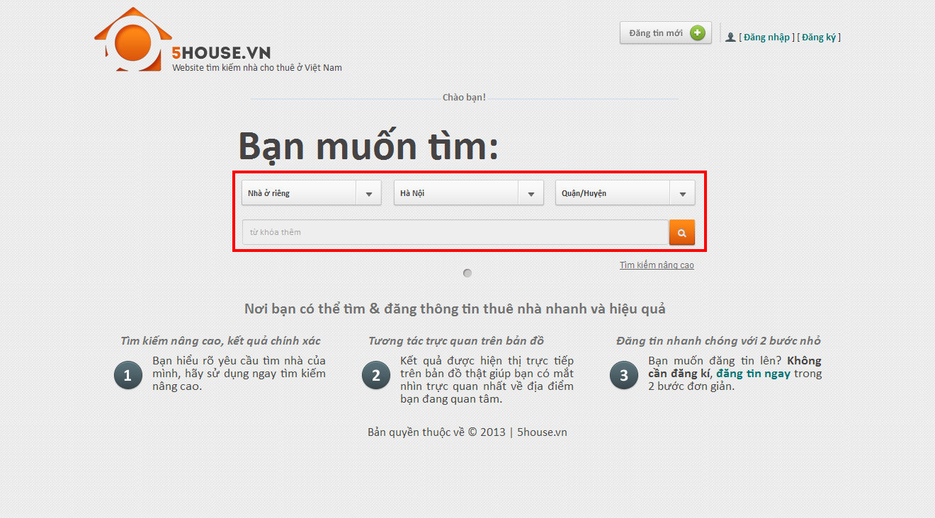

### Advanced Search

* Navigate to homepage
* Click “Tìm kiếm nâng cao”
* Select type of house, province, and district where you want to search
* Provide desired price range and area range (not required)
* Provide information concerning facilities priorities. There are 3 values of priority: Thấp, Vừa, Cao. Unpicked facilities will be ignored.

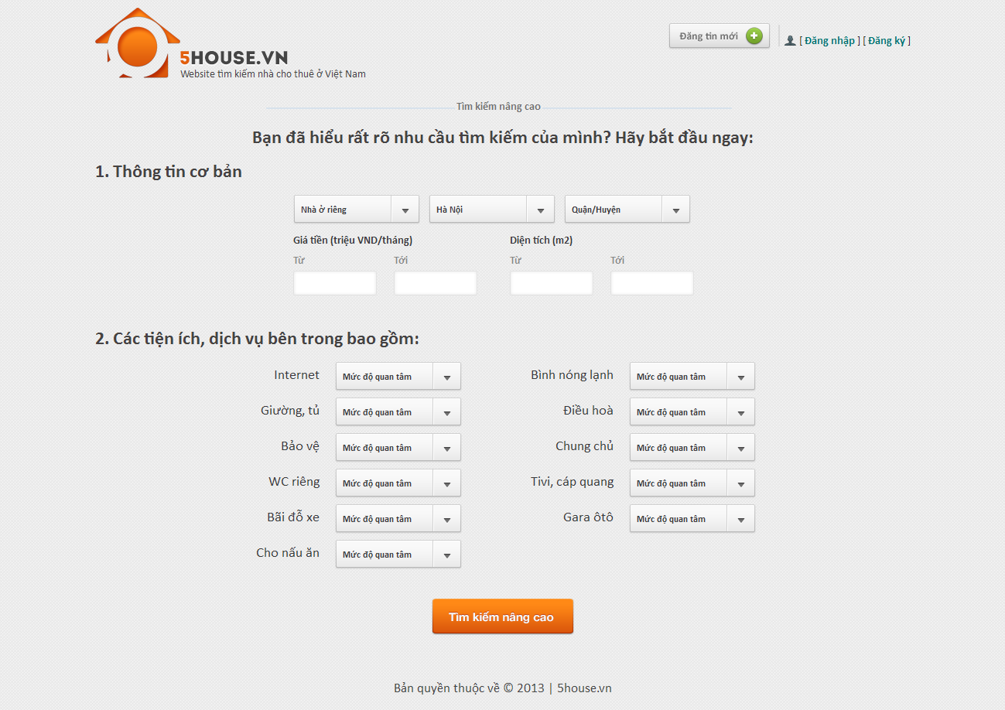

### View Post Detail

* Perform a search then click on a result on the list or a marker on the map, or enter the link directly to browser’s address bar

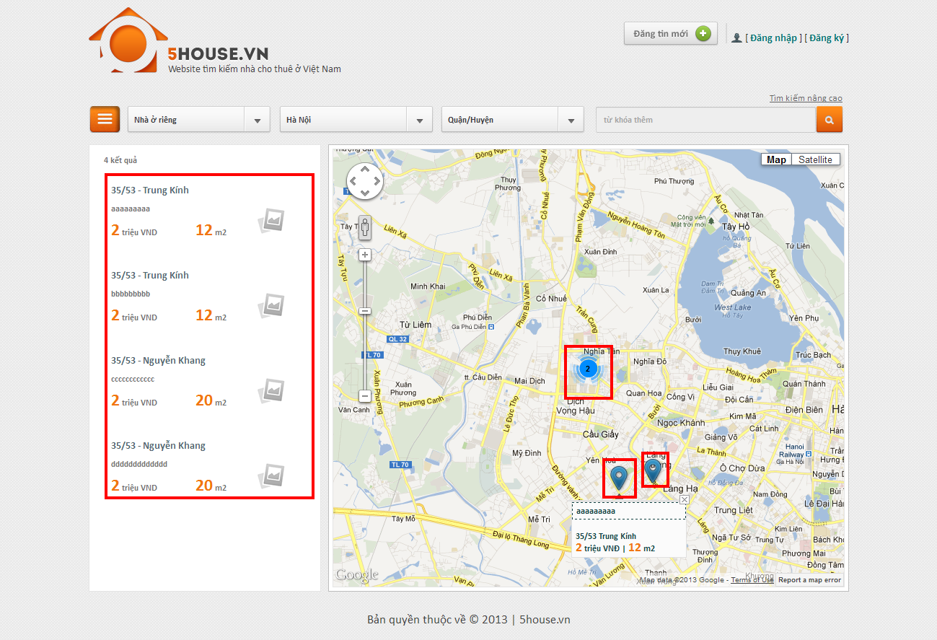

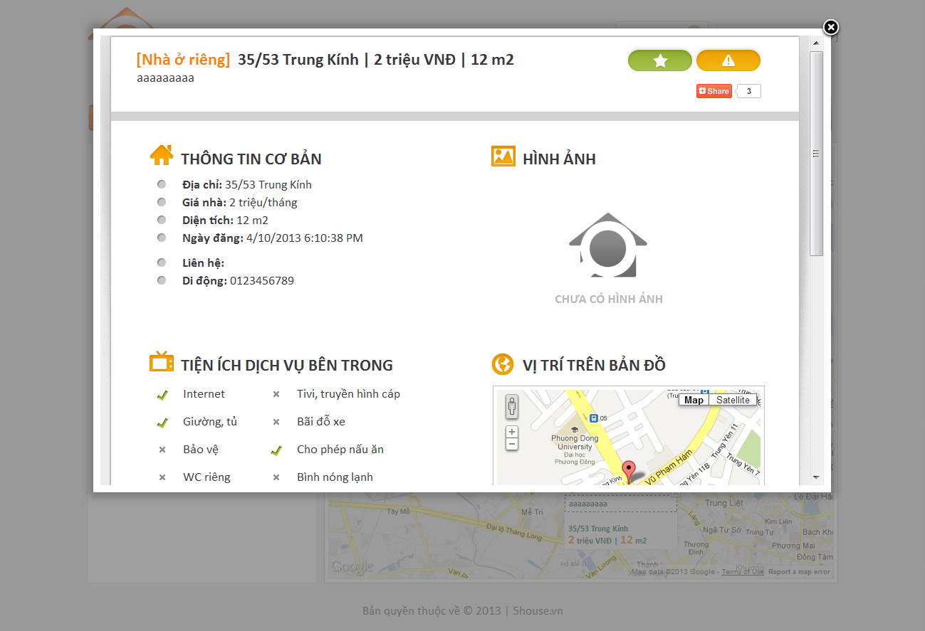

### Add Post

* Click on “Đăng tin mới” button on top of any page
* Enter input as prompted

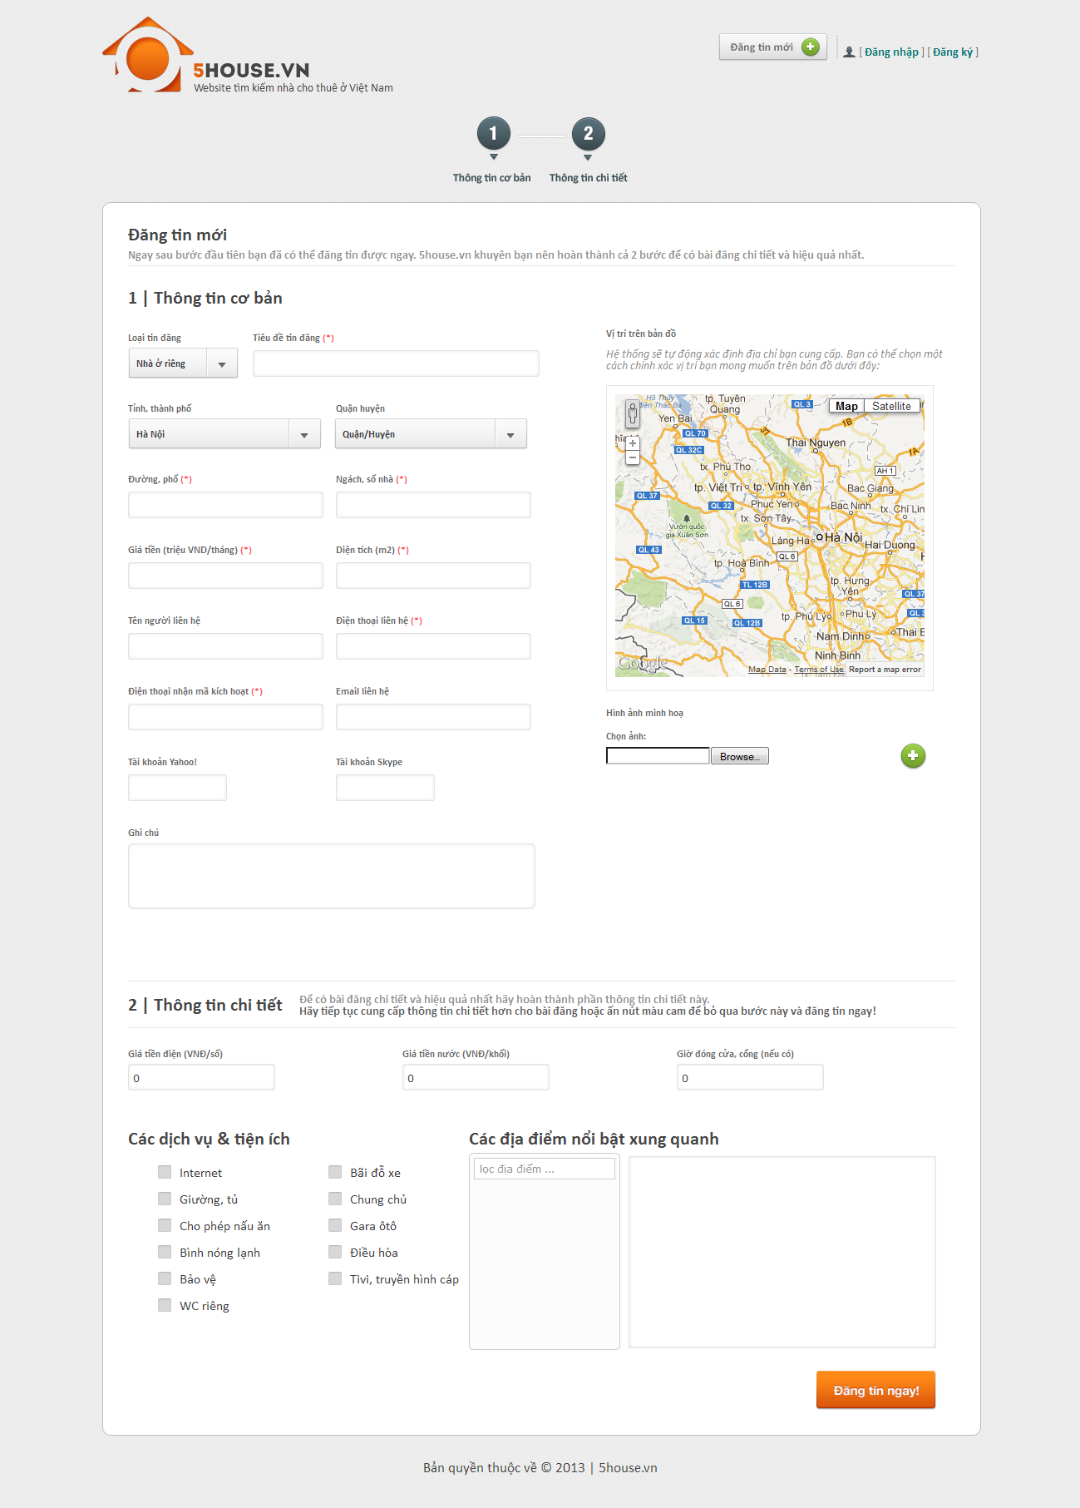

### Edit Post

* Enter the link provided when posting into the browser
* Enter the provided password
* Edit post details
* Click “Lưu thay đổi” button

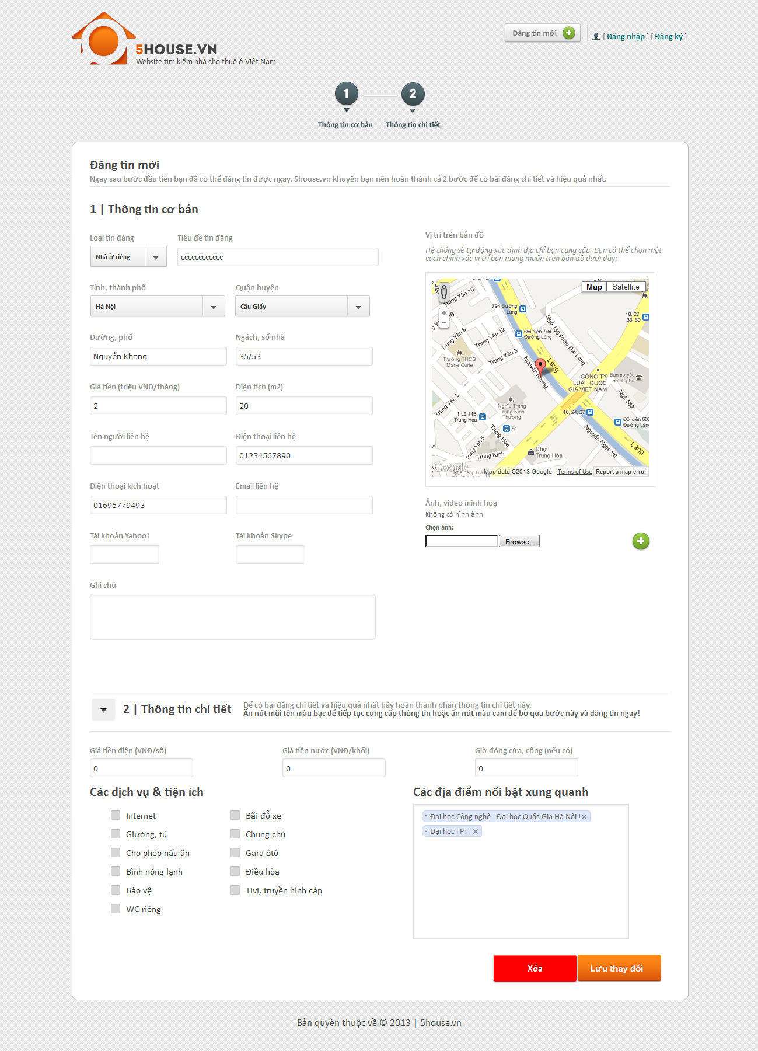

### Delete Post

* Enter the link provided when posting into the browser
* Enter the provided password
* Edit post details
* Click “Xóa” button

****

### Renew Post

Send and SMS with the following content to our SMS service  
MS [password]

*With* ***[password]*** *is the one that was provided when posting.*

### Register

* Click on “Đăng ký” link
* Provide details as prompted
* Click “Đăng ký” button

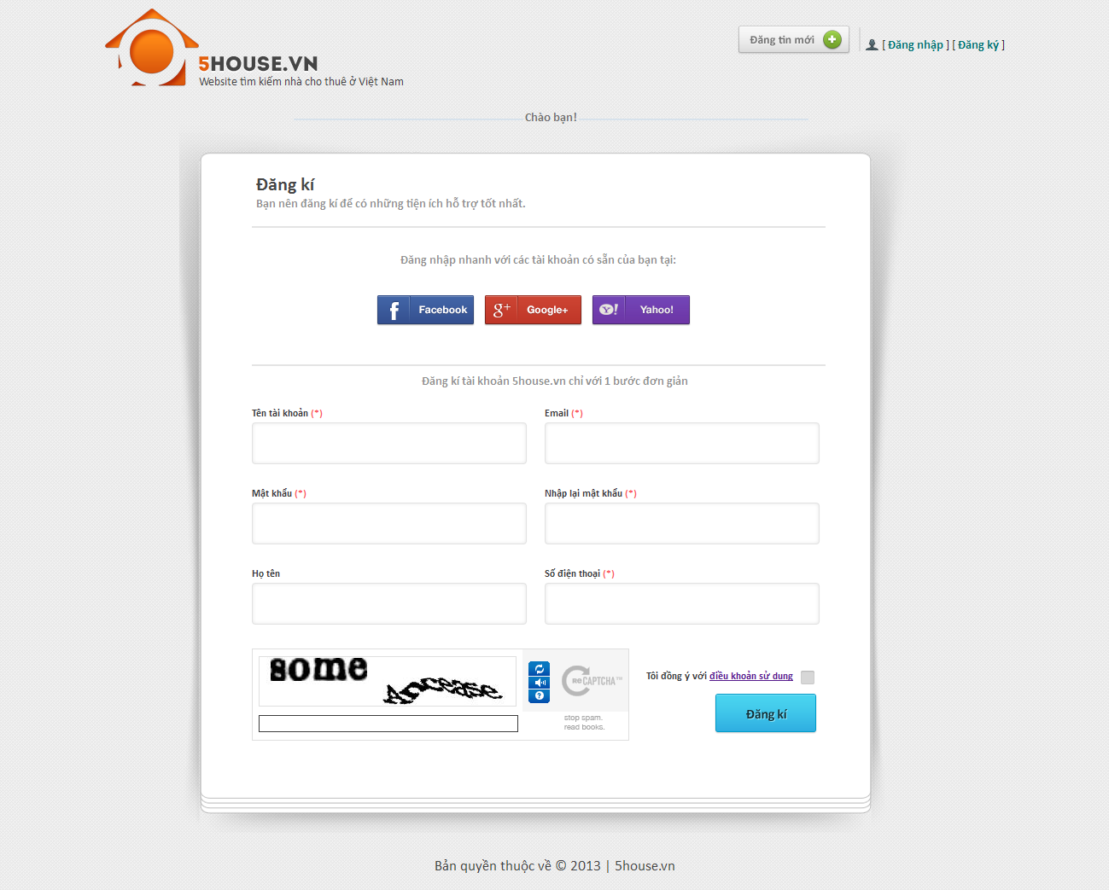

## User

### Login

* Click on “Đăng nhập” button
* Login with registered username and password, or use Facebook/Google/Yahoo ID

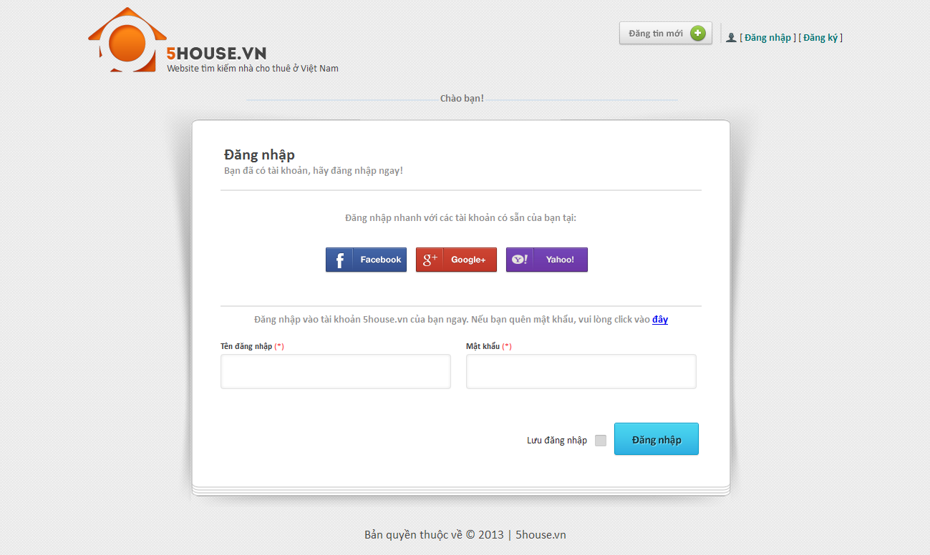

### Logout

* User must have logged into the system
* Click on “Thoát” button

**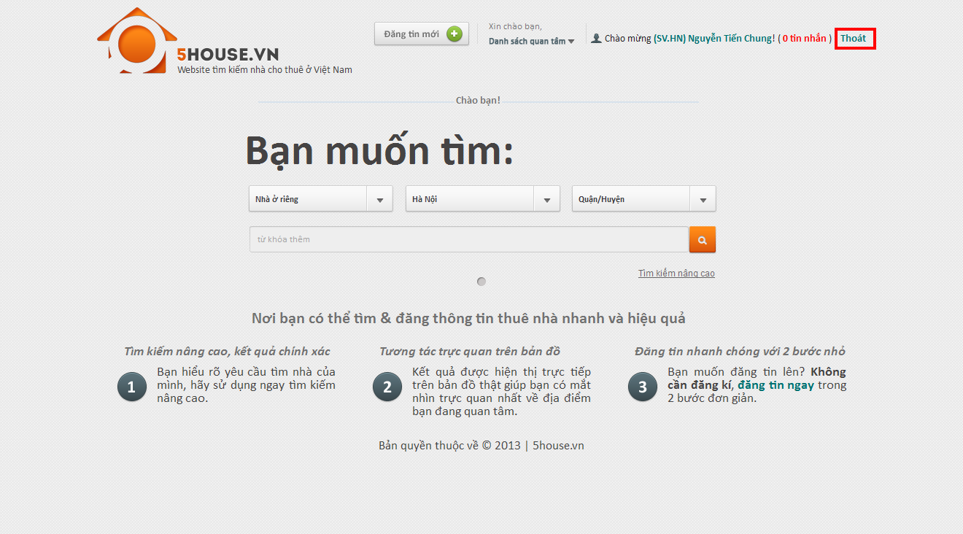**

### Edit user profile

* Login to the system
* Go to User Control Panel by clicking on the displayed username on top of the page
* Click “Thay đổi thong tin” button
* Edit user details
* Click “Lưu thay đổi” button

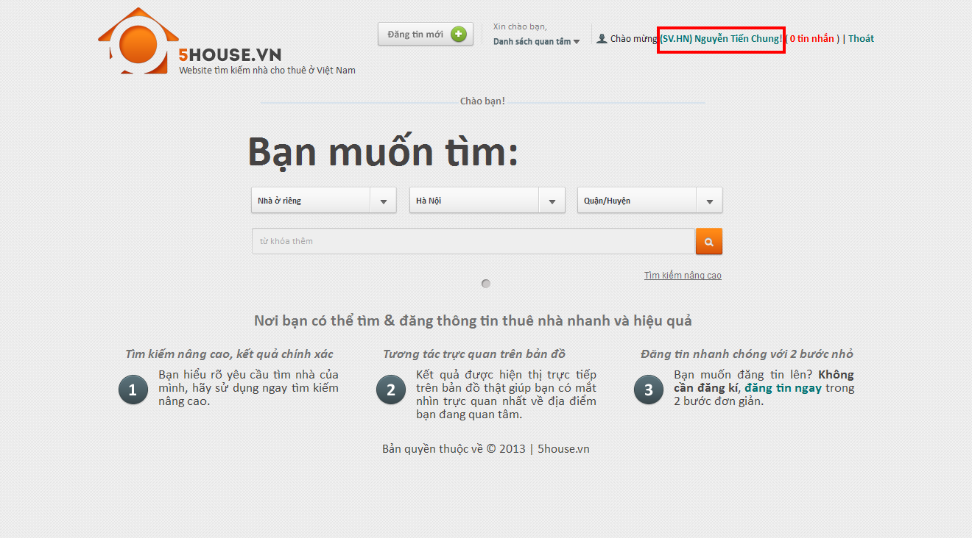

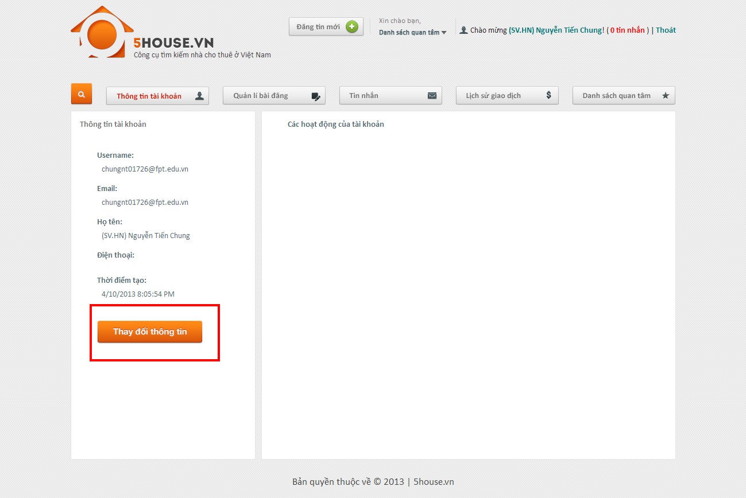

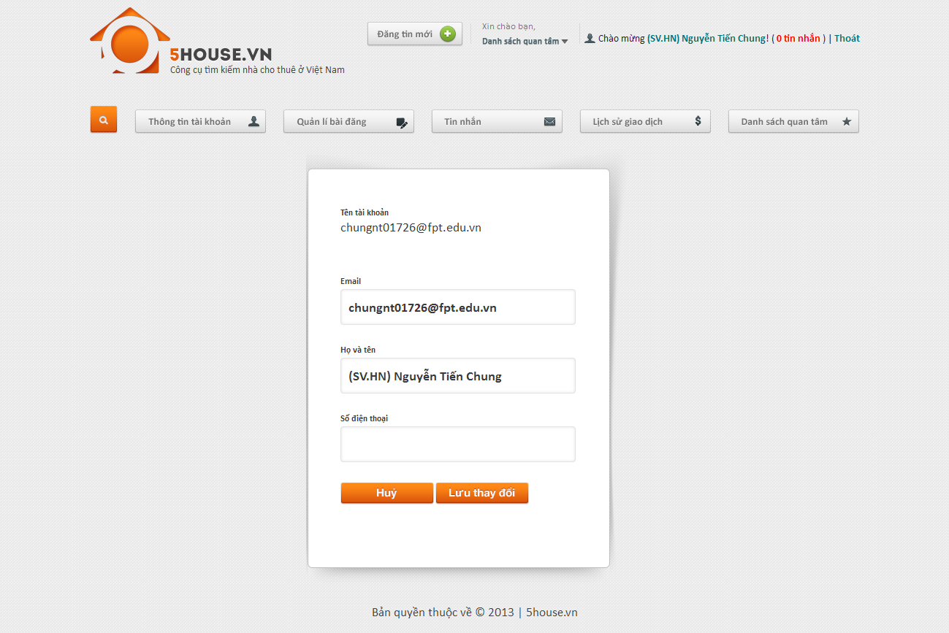

### Change password

* Login to the system
* Go to User Control Panel
* Click on “Đổi mật khẩu” button
* Provide new password
* Click “Lưu thay đổi”

**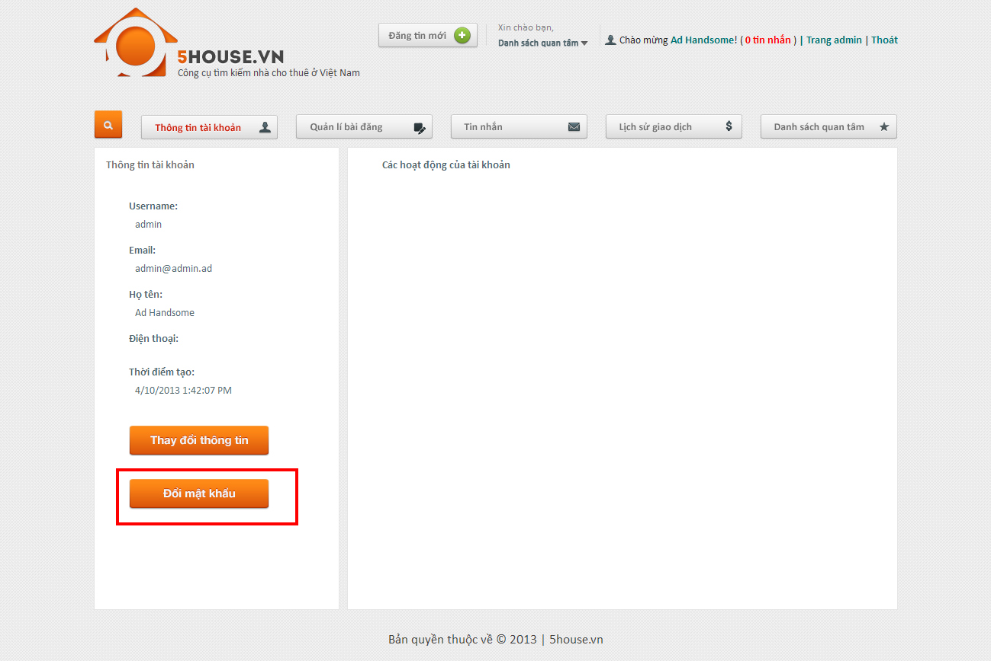**

### Recover password

* Go to login page
* Click on password recovery link
* Click button

**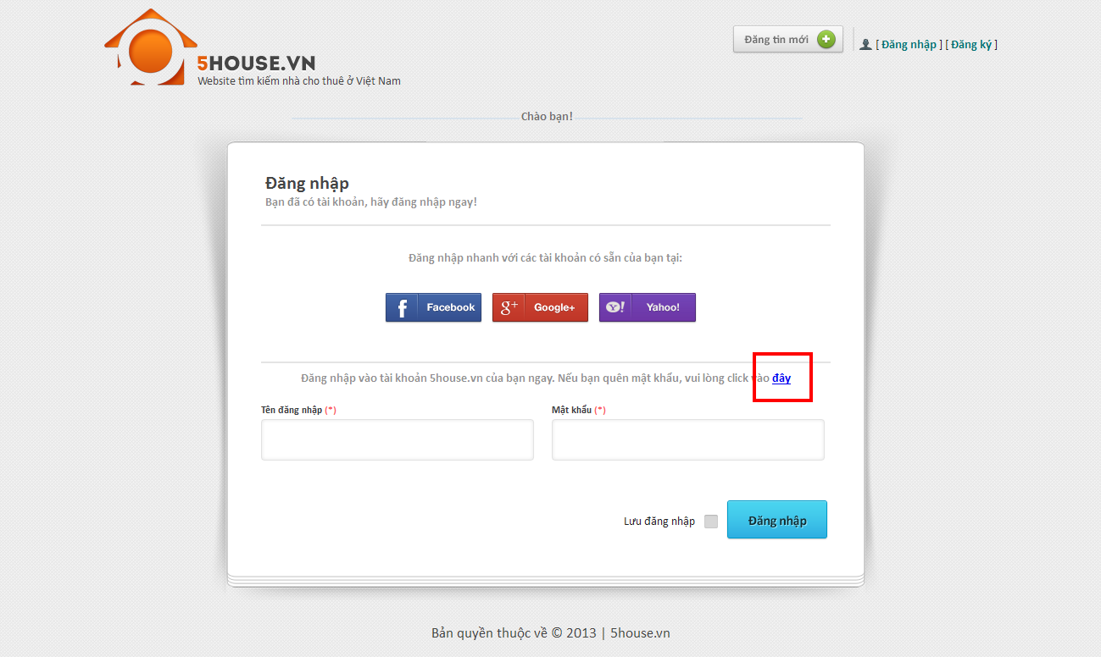**

### View favorite list

* Go to User Control Panel
* Click on “Quản lý bài đăng” button

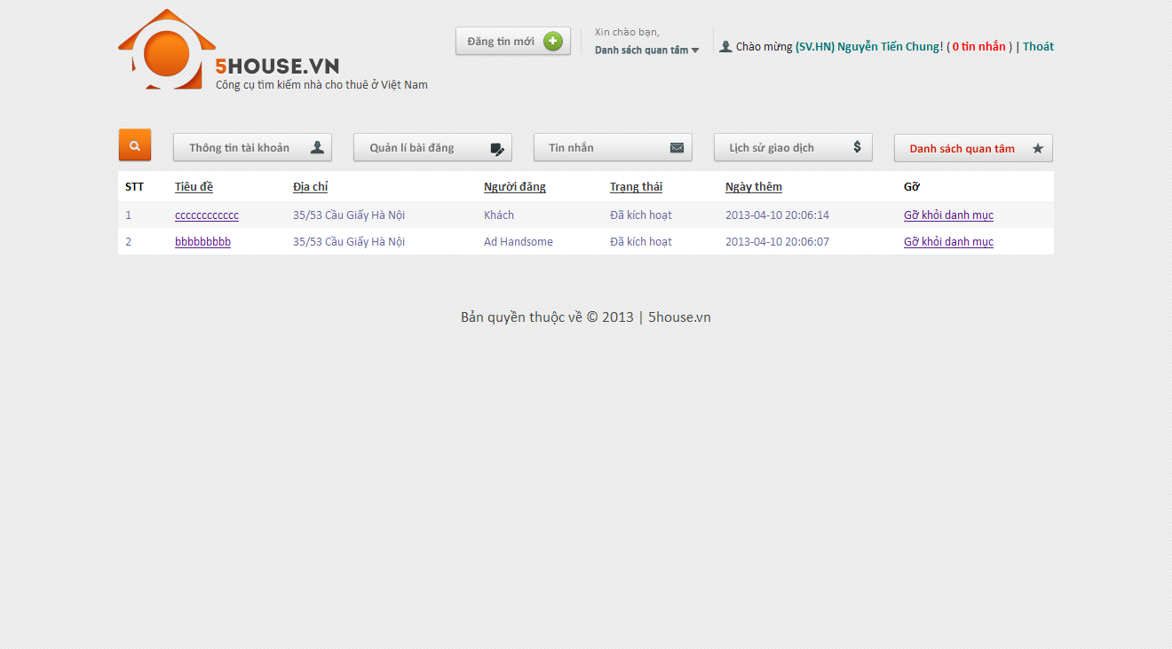

### Add favorite

* View a post which is not in favorite list
* Click on Favorite button

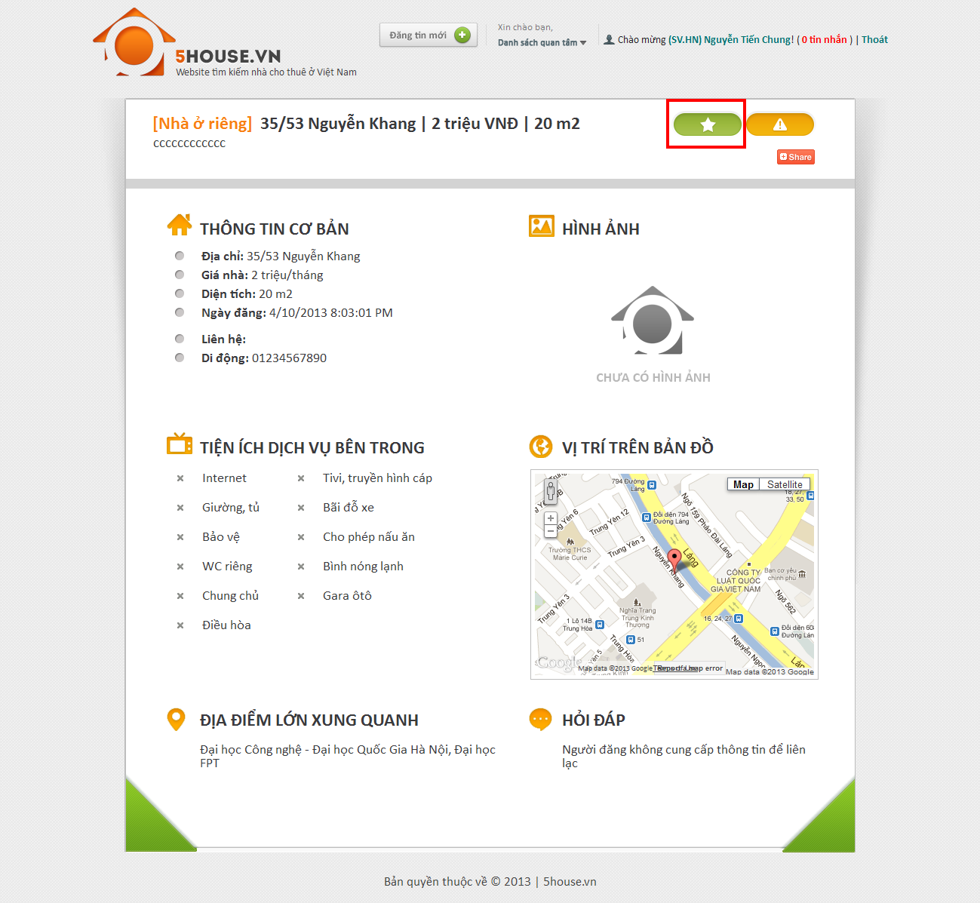

### Remove favorite

* View a post which is currently in favorite list
* Click on Favorite button

**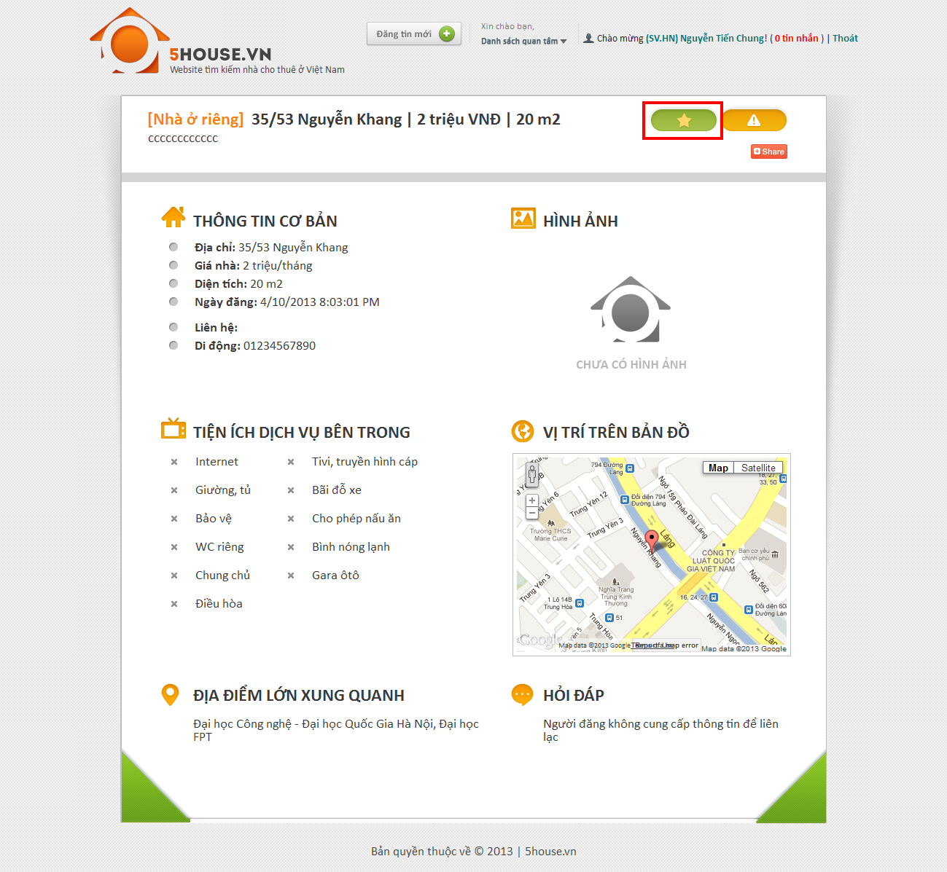**

### Compare

* Add at least 2 post to favorite list
* Click on “Danh sách quan tâm” link
* Check at least 2 post
* Click “So sánh”

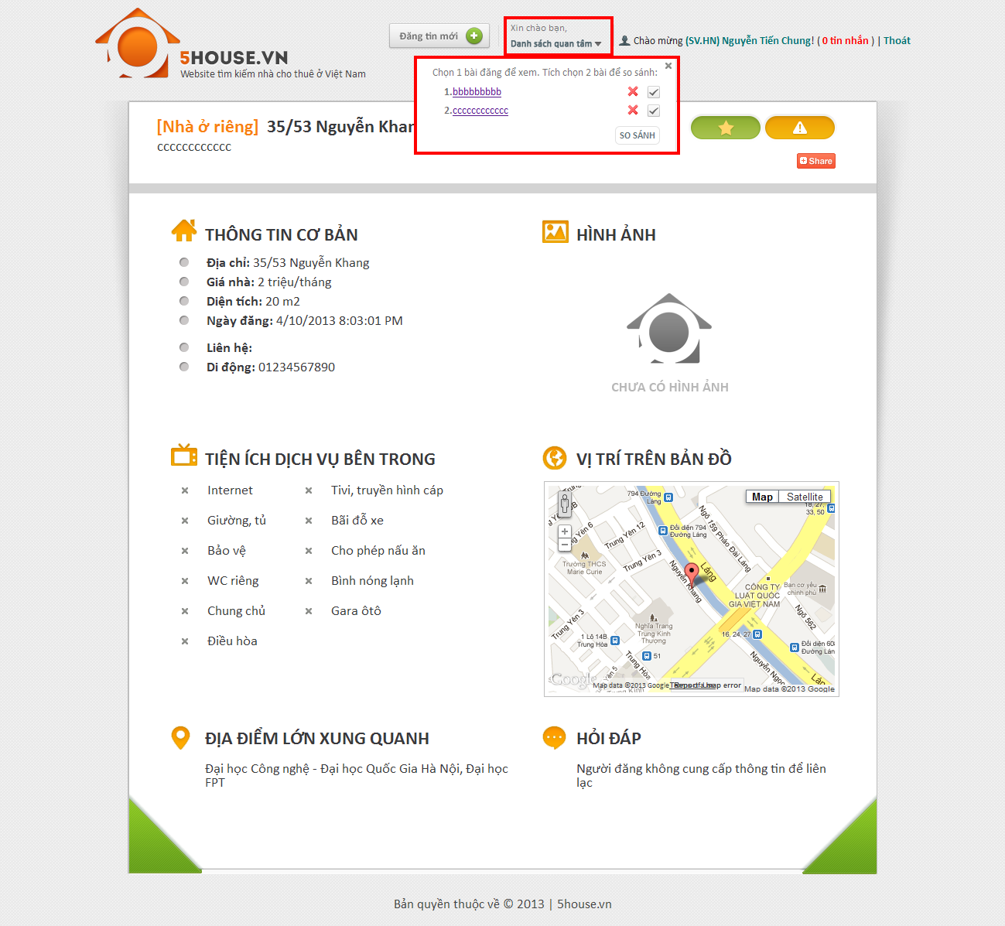

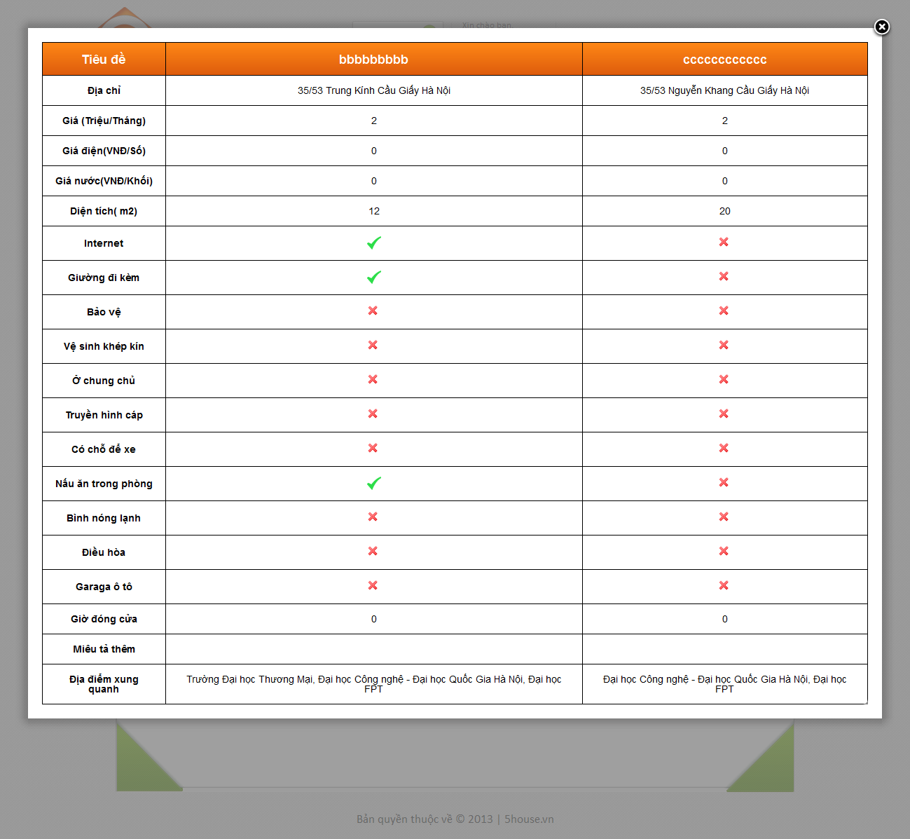

### Manage post

* Go to User Control Panel
* Click on “Quản lý bài đăng” button

**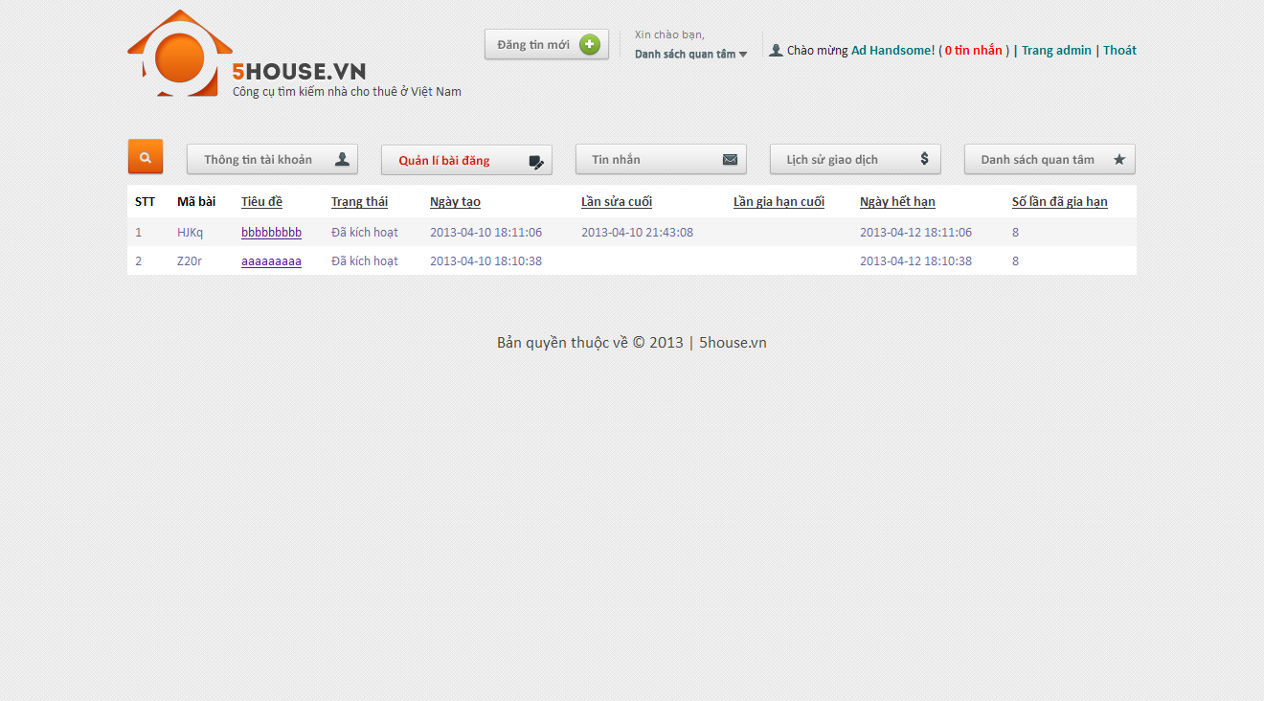**

### Manage payment

* Go to User Control Panel
* Click on “Lịch sử giao dịch” button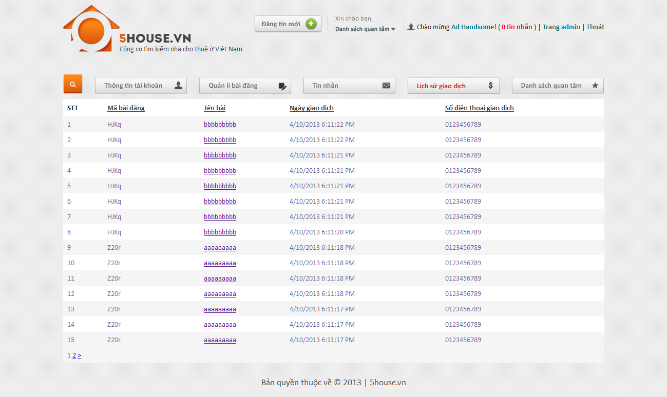

See Appendix for more detail.

# Appendix

## References

[1] Microsoft, ' ASP.NET MVC Framework ',

<http://www.asp.net/mvc/whatisaspmvc>

[2] MSDN, ' UML Class Diagrams: Guidelines ',

<http://msdn.microsoft.com/en-us/library/dd409416.aspx>

[3] MSDN, ' UML Sequence Diagrams: Guidelines ',

<http://msdn.microsoft.com/en-us/library/dd409389.aspx>

[5] Wikipedia, ' V model software testing'

[6] Wikipedia, ' System Testing'

[7] Wikipedia, ' Intergration Testing'

<http://en.wikipedia.org/wiki/Dependency_injection>

<http://xomtrosv.com>

<http://nhatroviet.com>

<http://padmapper.com>